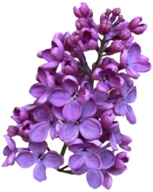REGISTRATION FOR MEMBERSHIP - FIVE HILLS GARDEN CLUB
2016-2017
Name _____________________________________________________
Spouse’s Name_______________________________________________
Address ___________________________________________________
Phone _____________________________________________________
Cell-Phone __________________________________________________
E-Mail _____________________________________________________
Birthday (Month & Day) ________________________________________

ACTIVE MEMBERSHIP: Check one
CLASS A ($40)
___________ Current Member, continuing
___________ Former Member, rejoining by application
___________ New Member, joining by application
CLASS B ($50)
___________ Current Class B Member, continuing
___________ Class A Member, applying (in writing) for transfer to class B

ASSOCIATE MEMBER ($20)
___________ Current Associate Member, continuing
___________ Class A or B Member, applying (in writing) for transfer to
Associate
I agree to abide by the By-Laws of the Club and to pay the year’s dues (stated above) by the first of April. Please make checks out to Five Hills Garden Club.

Signature: _____________________________________
Please mail this application, with a check made out to
Five Hills Garden Club to: Colette Fauteux, 10708 Ames St. Fairfax, VA 22032 (703) 352-2570

