G

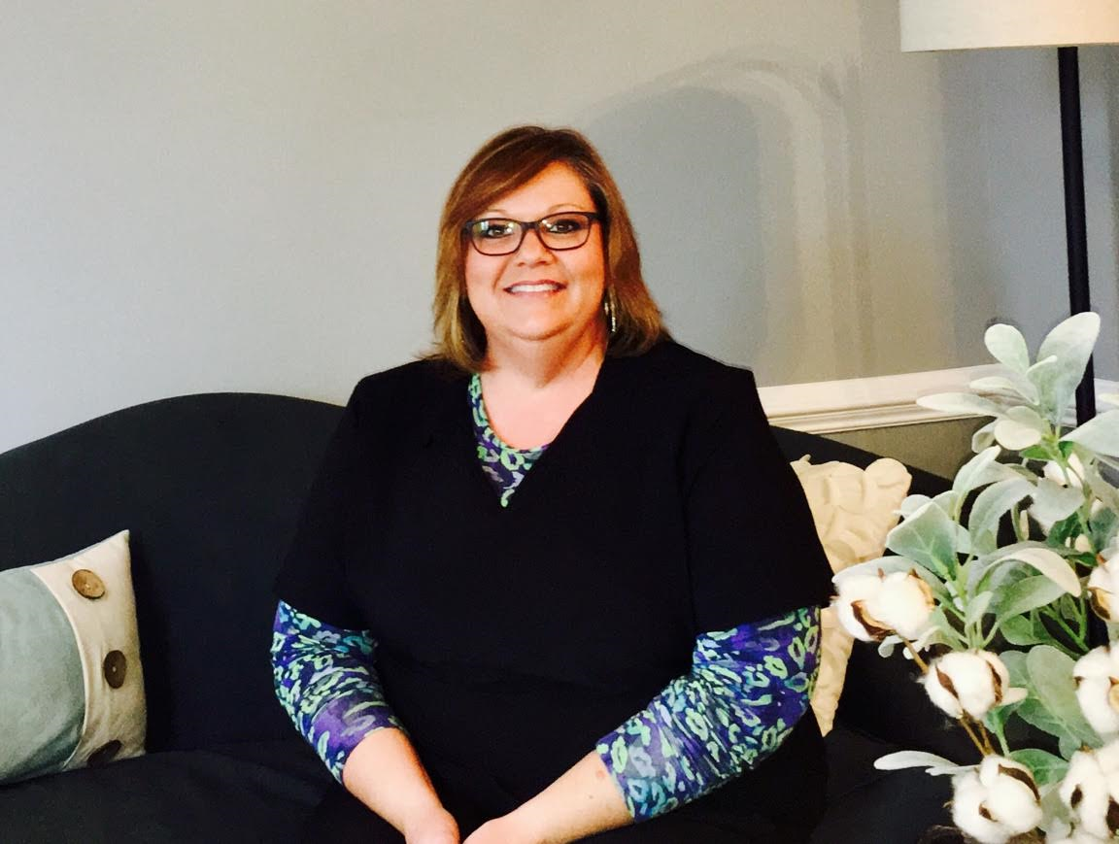**Crystal Burgess, Front Office**

A native of Spartanburg, Crystal has been a figure in the local dental community for 20 years. CP&DI feels very lucky to have scooped her up and have her voice be the first that you and your patients hear when contacting our office. She is committed to the very best in patient care. Whether it’s directions to the office or determining insurance benefits, Crystal has it covered. When Crystal is not at the office you will find her with her daughter, three sons, two beautiful granddaughters, and two fur-babies.

Fun facts: Crystal is a biker chick that loves to ride her Harley!

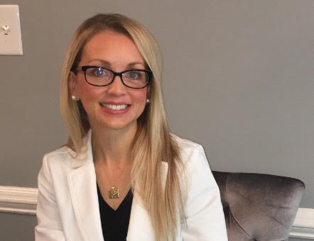**Shawna Baxter, DMD**

It was love at first sight when Dr. Baxter first visited the Upstate of SC. She knew immediately that this would be her forever home. Originally from a small town north of Seattle, Dr. Baxter attended the University of Washington for her undergraduate degree. She then made her way to Arizona for dental school where she was part of the inaugural class at Midwestern University. Finally, she finished her education by completing residency at the University of Pittsburgh. When she’s not treating patients, Dr. Baxter enjoys spending time with her new puppy. She loves working out and being outdoors as much as she loves a lazy day cooking and watching movies.

Fun facts: Dr. Baxter is an Ironman triathlete.

**Spring 2017**

**Volume #1**

**Who** are we?

Carolina Periodontics and Dental Implants.

**What** are some of the services that we provide our patients?

Periodontal treatment

Frenectomy

Tooth exposure

Crown lengthening

Soft tissue grafting

Ridge augmentation

Implant placement

3D imaging

**When** are we in the office?

Office hours (alternating Mondays and Fridays to conveniently serve our patients).

Monday 9am-6pm

Tuesday 7am-4pm

Wednesday 9am-6pm

Thursday 7am-4pm

Friday 7am-4pm

**Where** are we located?

Westgate Executive Center

233 E Blackstock Rd #D

Spartanburg, SC 29301

**Why**?

“The mission of Carolina Periodontics and Dental Implants is to compassionately treat every patient as if they are an extension of the family. We are committed to providing the highest quality care by working together with you and your patients to effectively restore and maintain their best periodontal and implant health through conservative yet thorough treatment.”

**How** can we be reached?

Phone: #864-586-5004

Fax: #864-576-3181

Email: frontdesk@carolinaperioandimplants.com

Website:

www.carolinaperioandimplants.com

**Additionally**

CP&DI is offering complimentary consultations to allow you and your patients a chance to get to know us!

**JOIN US: For an open house Tuesday May 16th from 5:00-7:30pm. Come check out our new digs and enjoy some snacks and beverages!!!**

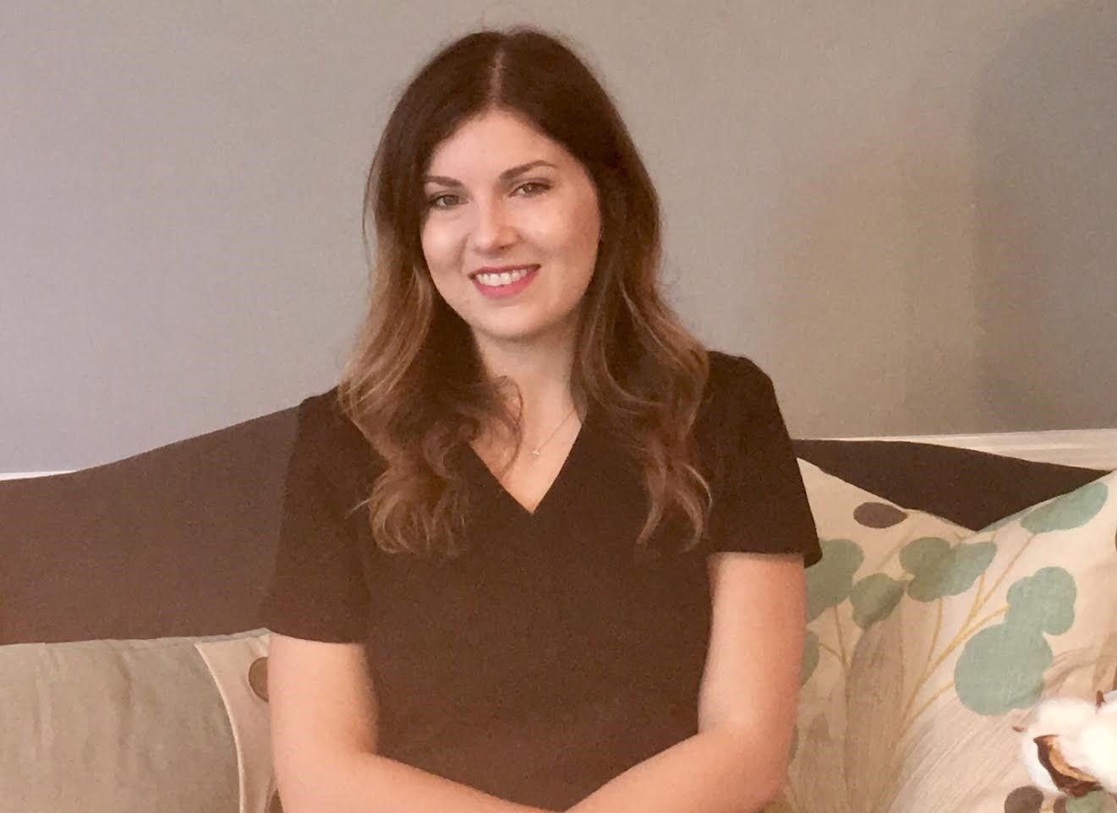

**Amelia Wilson, Back Office**

Also a southern girl, Amelia was born and raised in Augusta, GA. Fortunately, for CP&DI, she recently relocated to Spartanburg and joined our team. With previous experience in oral surgery, Amelia’s favorite part of dentistry is building relationships with her patients and helping them achieve the healthy smile that they have always dreamed of. Patients of all backgrounds feel at ease in the presence of Amelia’s calm and caring demeanor. In her spare time she loves to be with her family, friends and two fur-babies.

Fun facts: Amelia has never missed a season of the Bachelor!

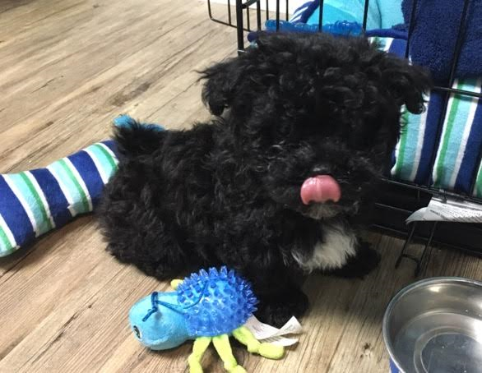**Gumbino, Office Pup**

The newest addition to the CP&DI team is a 3 month old, four and a half pound, fluffy Peekapoo. While he is currently mastering being a puppy by greeting patients with kisses and tail wags, he looks forward to future training that will allow him to comfort even the most anxious of patients that sit in our chair.

Fun facts: Gumbino loves chasing his tail and snacking on cucumbers!

