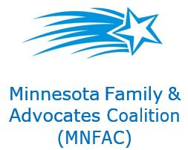 Advocacy 101

- You are the expert when it comes to your loved one.
  - Don’t need to be an expert in the topic, just an expert in your child
  - The legislators work for YOU

- It is important to continually educate yourself and the community, but you don’t need to know everything to advocate.
  - It’s common to feel some fear or apprehensiveness
  - It’s not unusual to feel overwhelmed by the complexities
  - It’s ok to not know everything and all the details
  - Working in pairs or a small group is even better
  - See MNFAC “Ways to Get Connected” handout
  - MNFAC Facebook page minnesota families and advocates coalition- mnfac for the latest information. Our new website is www.mnfac.org

- Advocating
Effective Means of Communication
  - Email
  - Letter
  - Phone Call
  - Face to face meeting
Basic considerations & understanding
- Non-adversarial – the tone should be educating
- Use an engaging picture of your loved one to personalize your story
- Your story should be short, personal, and include an action for the legislative person
Follow-up
- Always send a personal thank-you by email or preferable a handwritten message. Include your email on all correspondence.

