“2-Day Mixology Course”
Learn bartending history and modern methods from the professionals!
The 2-Day Mixology is an opportunity for talented bartenders, experienced bar Chefs and beginners to introduce themselves to the fascinating world of mixology. You will learn about the origins of bartending, remarkable modern day products, techniques and cocktail recipes used by bartenders today. After your course, you will have a brand new outlook on the craft and will be able to wow your customers with your knowledge and skills.

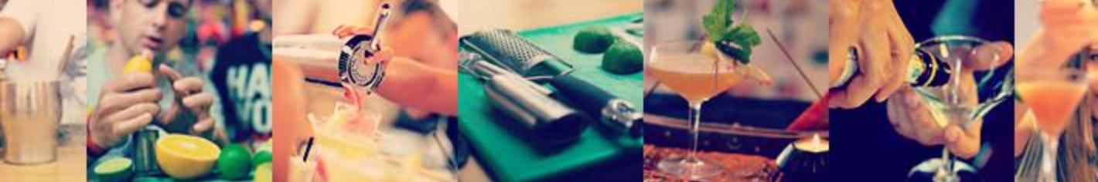

3 Reasons to Book Now
Looking for that boost of bartending knowledge? Look no further, the 2-Day Mixology is for you! Here are three simple reasons to book now:
- Learn brand new, innovative and exciting twists on classic cocktails
- Focus on the history of cocktails and bartending from punch to Tiki!
- Learn to make homemade products and turn great drinks into absolute perfection

BOOK NOW
Tel. 70088818
ihm.pafos@gmail.com

Download the “2 – Day Mixology Course” Curriculum
www.ihmcy.com

Course Curriculum - 2-Day Mixology

Day 1 (6hrs)

The Journey of the Bartender – from Past to Present
Learn about the history of the bartender, how the industry and the crafts-men have been changing and developing the profession over the years. In addition, you will discover the importance of ingredients, techniques and equipment in making quality cocktails
Pre-Prohibition and Prohibition Eras
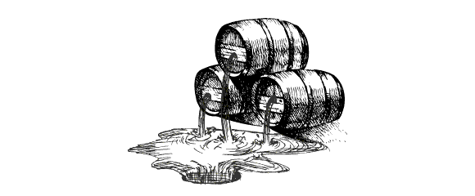
Prohibition changed society’s position on alcohol and we still feel the effects today. The bar industry changed during this period, many classic drinks were invented in the time leading up to prohibition, you will learn how to make these and taste them! You will learn:
- The industry before, during and after prohibition
- Which cocktails were invented in ‘The Golden Age’
- The history of these cocktails, when they were invented and who invented them
Methods / Techniques and Equipment
Some drinks need to be crafted in certain ways to taste absolutely perfect, one of the most well-known examples of this is James Bond’s famous quote ‘martini shaken not stirred’. We will teach you all the different methods, techniques and types of equipment needed to make drinks, along with the explanations. You will learn:
- Why some drinks are shaken, stirred or rolled
- Which methods are most suitable for different drinks
- Some of the equipment used in the industry’s history and equipment that is used today
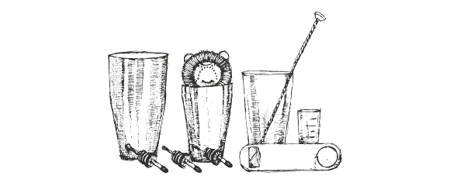
- Different mixing techniques
- Different ways to shake a drink, types of shakers, why they affect the cocktails that we drink
- How to stir a drink properly
- Different types of bar spoons and equipment
Cocktail Categories and Families
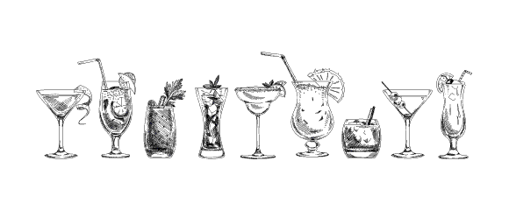
To fully understand and appreciate a drink you must taste it! Learn about the cocktail categories and families and then get your taste buds tingling with a tasting session!
- Understand the history of these drinks, when they were invented, recipes, typical ingredients, equipment used to make them etc
- Innovative twists on classic drinks
– Cocktails from a certain drink family / category such as a cobbler, a fizz, a sour, a flip and many more.

Day 2 (6hrs)

Product and Ingredient Master Class
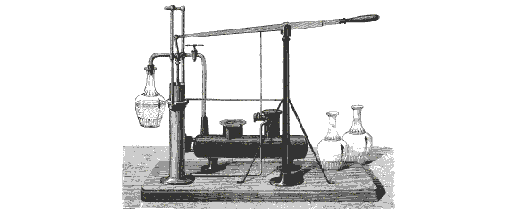
To know what is actually going inside the cocktail, you need to understand how it came to be. Learn about:
- The origin of certain products
- How certain products change entire drinks
- The ingredients of these products
- Some homemade products

Hands-On Training
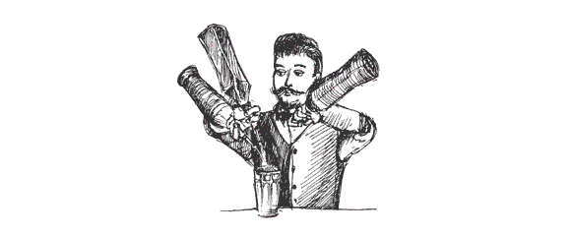
Now you can put your homemade knowledge into practice by making some of these exciting ingredients from scratch. This is how you will become more knowledgeable, we want to give you hands-on training
- Create your own products such as purées, foams, syrups and cordials etc
- Understand the quality of a cocktail
- Learn the importance of the appearance of cocktails

Mystery Box
Your skills will be put to the test, as you will be given a Mystery Box filled with different ingredients, requiring you to be imaginative and conjure up a well-balanced cocktail! The Mystery Box is an enjoyable challenge for everyone, it requires you to think on your feet and use all of your cocktail knowledge.

