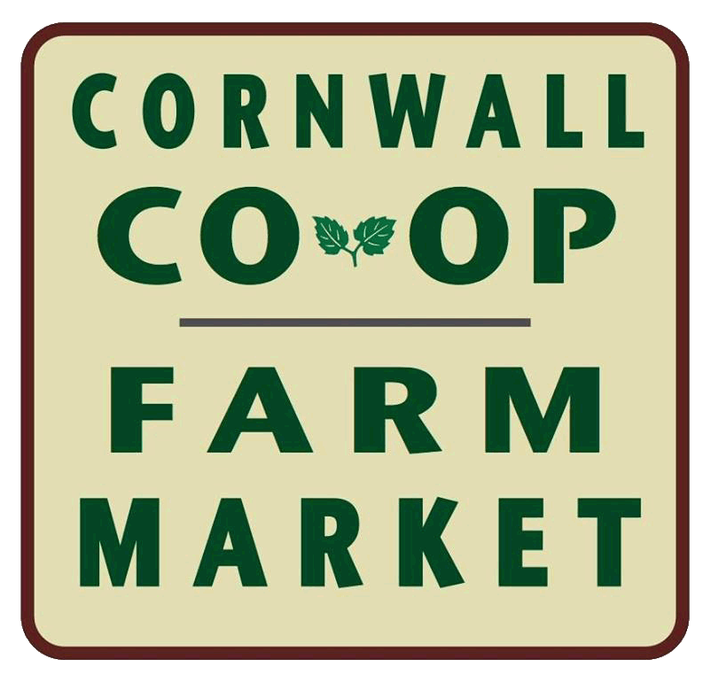
Cornwall COOP Farm Market

2017 Application

Season runs from May 20th to Oct 21st, 2017

April 2017

Name: __________________________________________________________________

Farm/Business Name: ________________________________________________________________________

Home Mailing Address: ____________________________________________________

Farm/Business Address: ________________________________________________________________________

Phone: Home: ____________ Cell_______________ Other __________________

Email

Produce Growers Please list produce you grow and plan to bring to market. Continue on back if needed.

NON-Produce List items which you would like to bring to the market. Continue on back if needed.

2017 Fee of $ 100 to be paid prior to opening day. Checks made out to Cornwall CO-OP Farm Market.

Mail or Deliver to Treasurer, Pat Bramley
PO Box 2
Cornwall Bridge CT 06753

Please note the State of Connecticut Department of Agriculture Farm Fresh Division is recommending each farmer/vendor to obtain a $300,000 product liability insurance policy. Town of Cornwall owner of lot requires a Certificate of Insurance(COI) to be mailed or handed in by opening day, May 20th, 2017. Mail to the Treasurer, address above.

COI for Cornwall COOP Farm Market: Town Green, Pine Street, Cornwall, CT 06753

I have read and understand the by-laws of the Cornwall COOP Farm Market and understand that when I become a participating vendor I will abide by these rules and regulations. Failure to do so on my part may result in the loss of my market privileges and/or membership in the Cornwall COOP Market.

___________________________________ __________________
Signature Date

