Landscape Bed and Border Guidelines

In order to give the homeowner a better idea of what the Architectural Control Committee might approve, these guidelines will help with completing your application. An application to change the exterior of buildings and landscapes is required. If you have not received previous written approval, please submit now for completed or proposed changes. Each application will be reviewed and voted upon by the Committee. Should you not agree with a decision by this Committee, you may appeal to the Board of Directors in the time period required for their final decision.

Driving through the neighborhood, the Committee members observed several flower borders that are unsightly and need to be removed. The Board has decided to place a moratorium on fines for landscape issues for 30 days. If improvements have not been completed within that time period, warning and subsequent fine procedures will be initiated. Those beds with weeds and grass intrusion must be brought up to standards of the neighborhood. This means all intruding grass and weeds must be removed, then new mulch applies. Edging materials are not required if regular use of a string trimmer trenches the border. If you chose to use rock or decomposed granite for beds, walkways or replacement for grass, those areas must be kept weed free at all times. Lawns, even with weeds, must be kept mowed and removal of weeds will be necessary if they are unsightly or unmowed.

In general, it will be considered for approval for you to use commercially available metal or fiberglass edging, mortared square edge rock (level on top), mortared brick or concrete edging. If the edging is not mortared, it must be interlocking style to discourage intrusion by grass. To give assistance in your application for flowerbed borders, the following images are ones the ACC would consider as meeting the standards of the community, if installed and kept in good condition. Other products may be considered, but should be similar in construction.
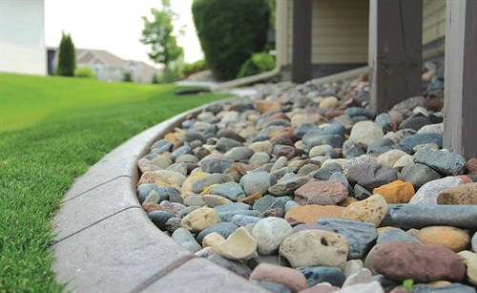
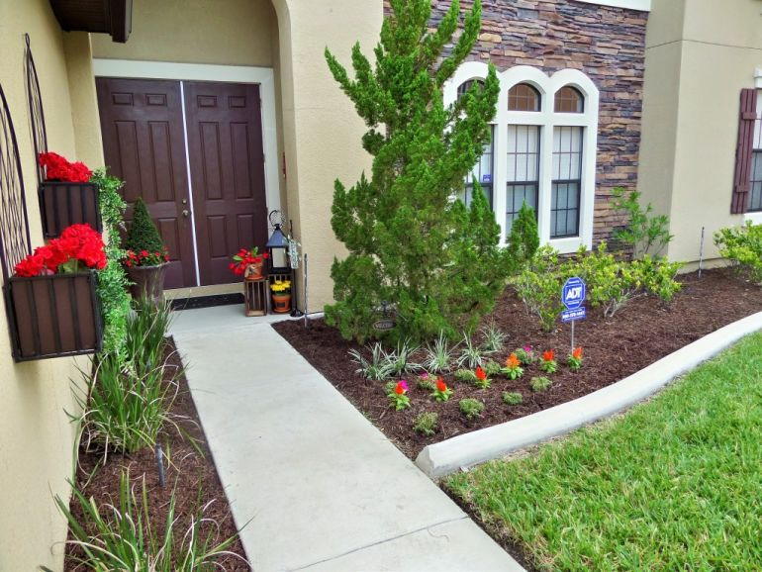
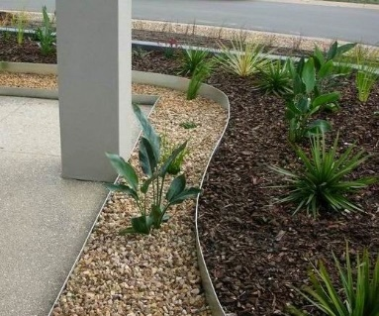
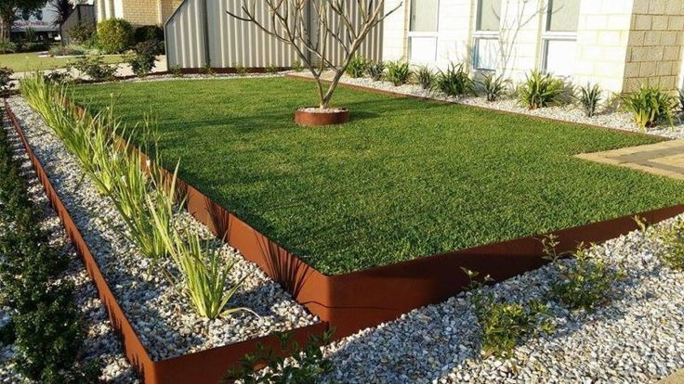

Page 2 of suggested borders to be submitted for approval.
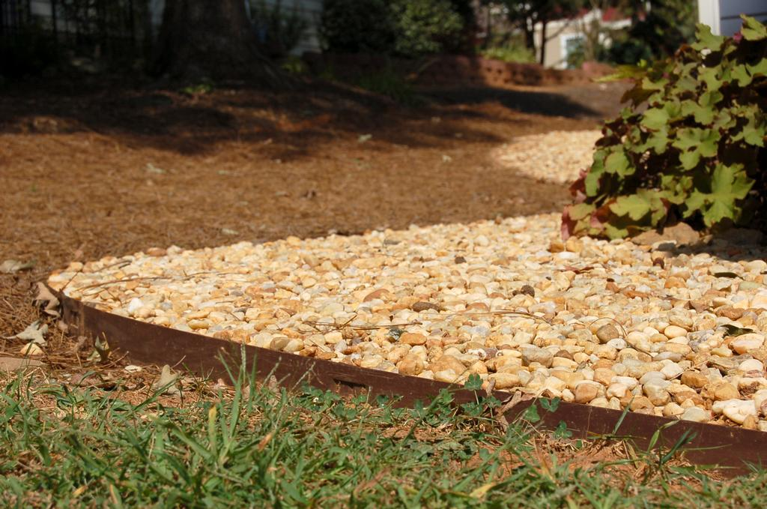
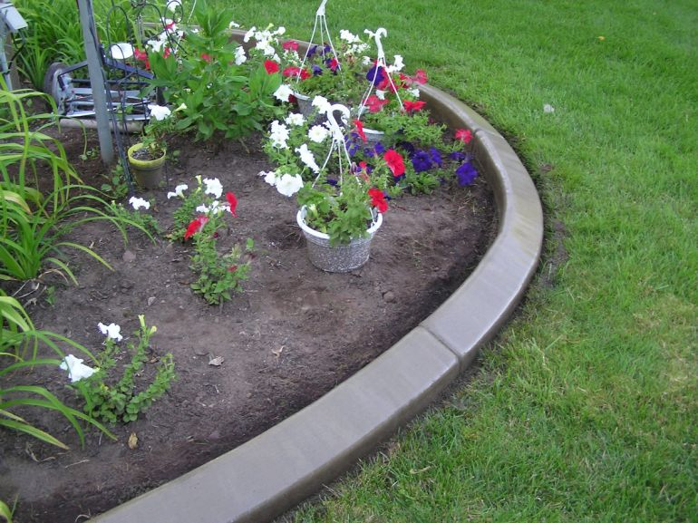

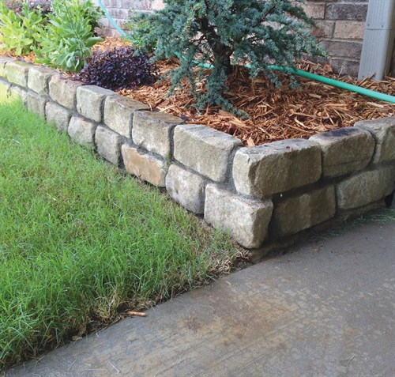
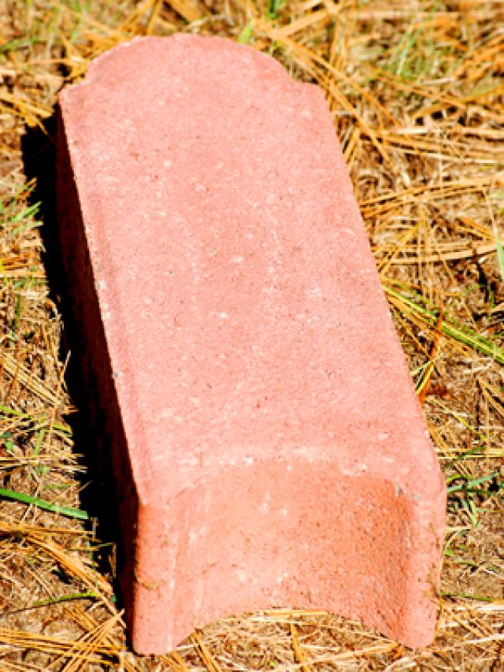

n
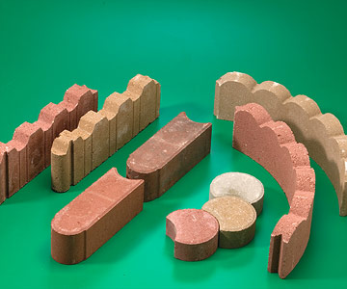

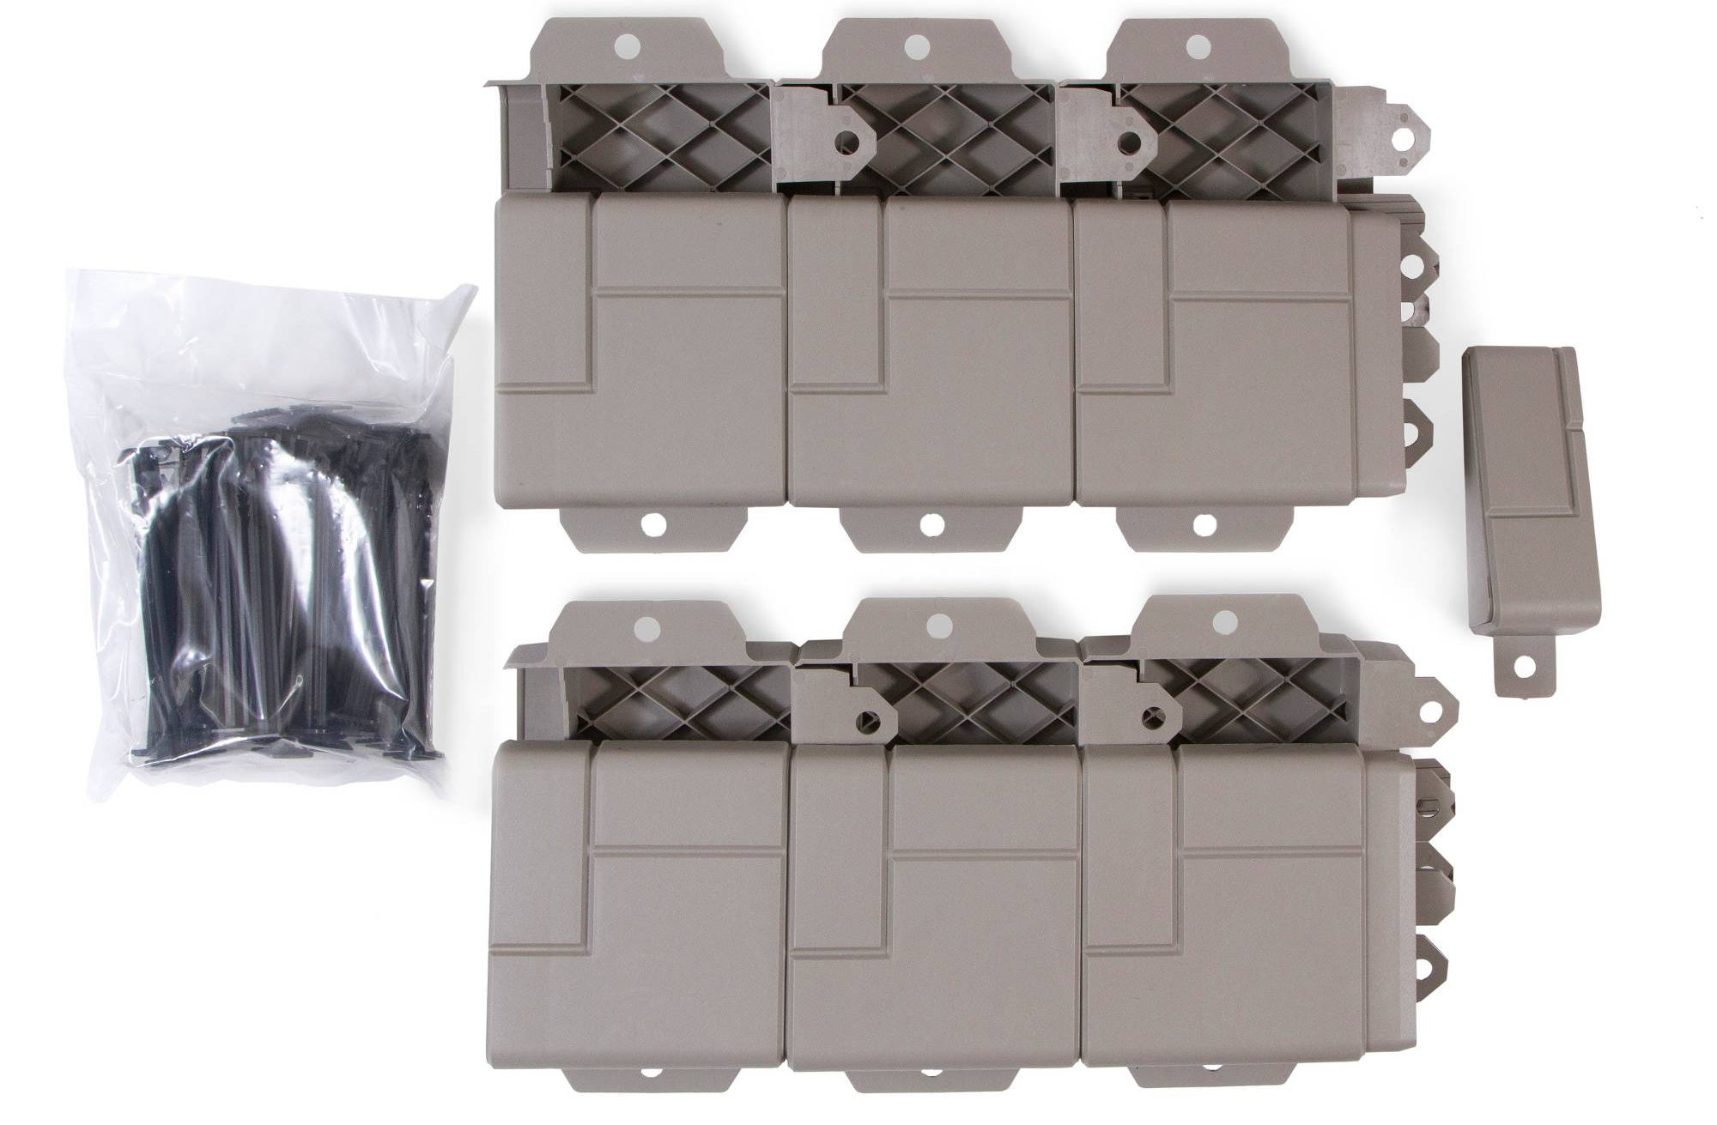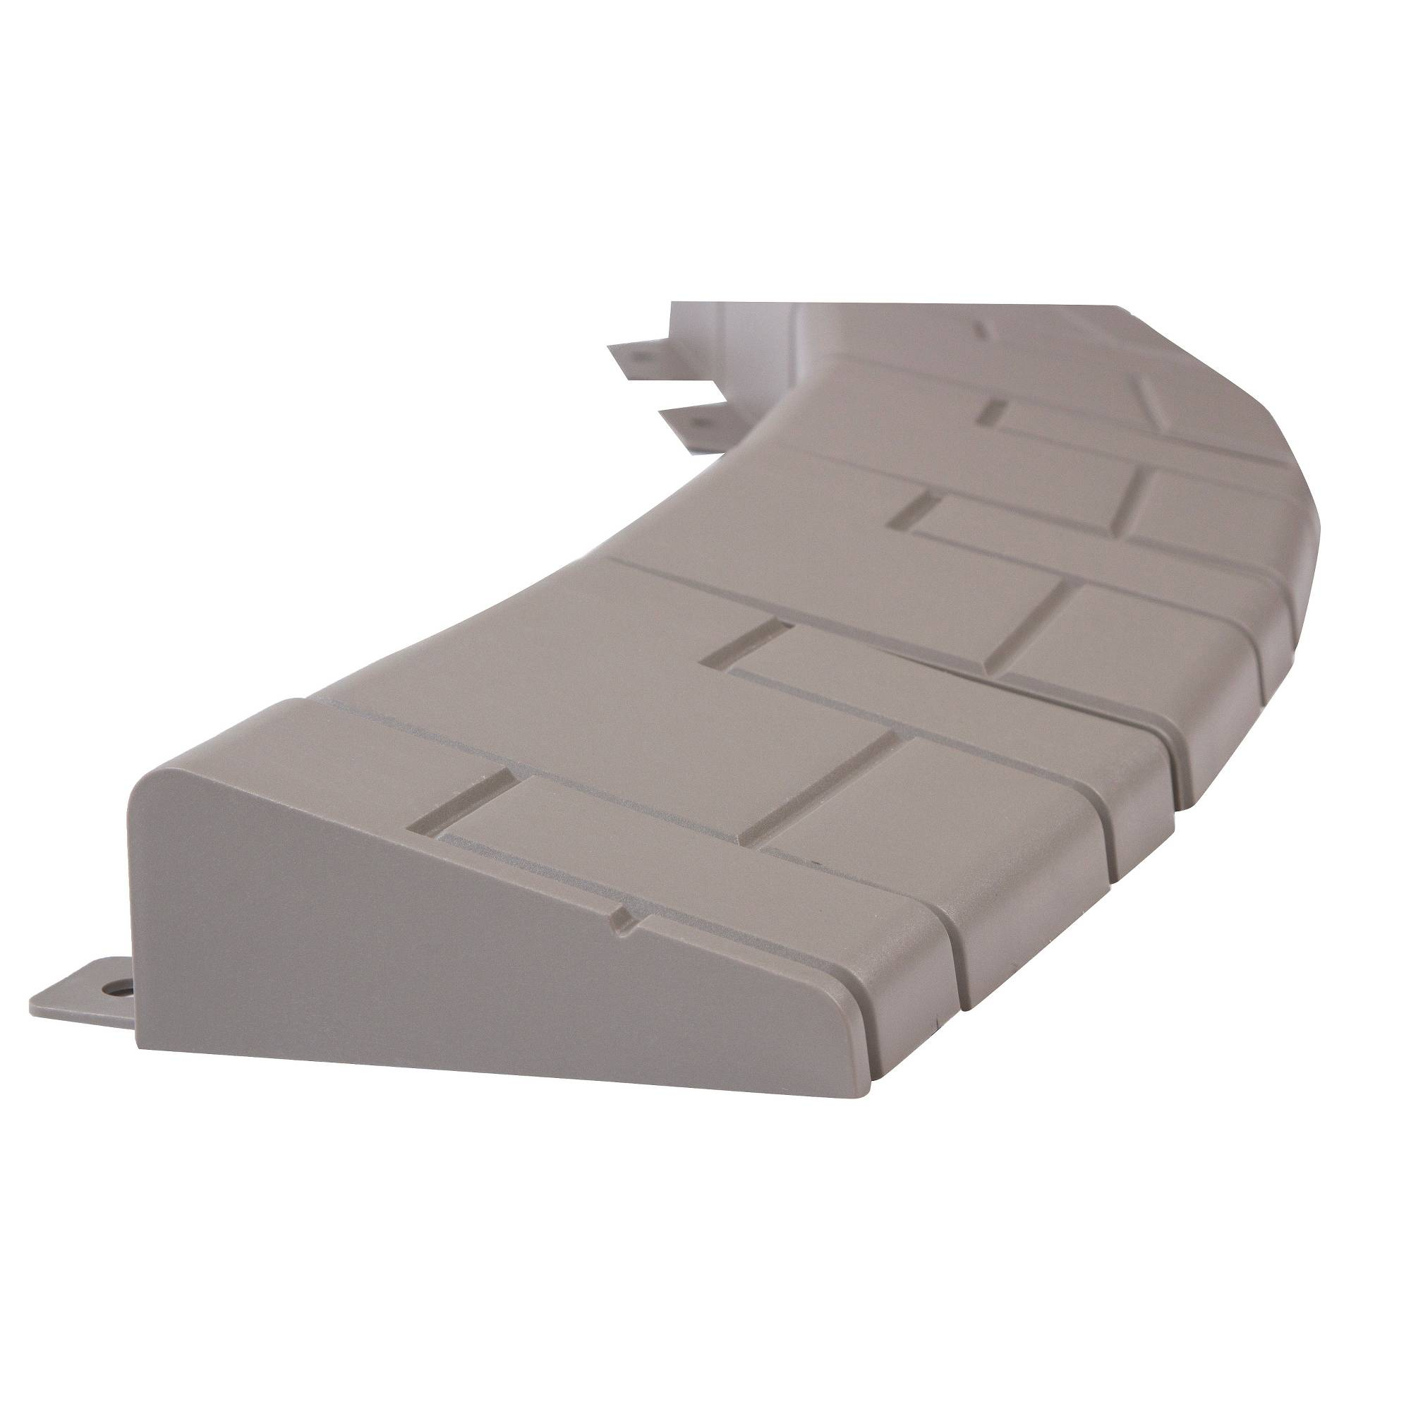

Note the INTERLOCKING features required.
The following images are examples of edging that would not be approved and if you are currently using these products, you should remove them immediately and apply for new edging approval on the ACC form. Loose or even mortared “found” rock is not allowed unless you have applied and received official approval from the previous ACC committee. Not verbal approval by builder or board member!
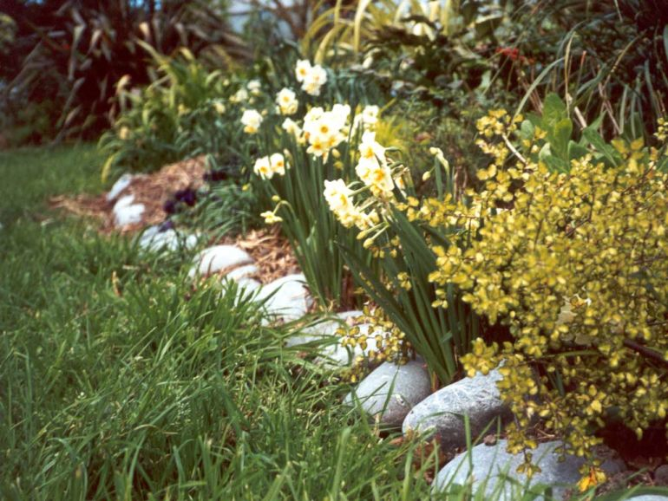
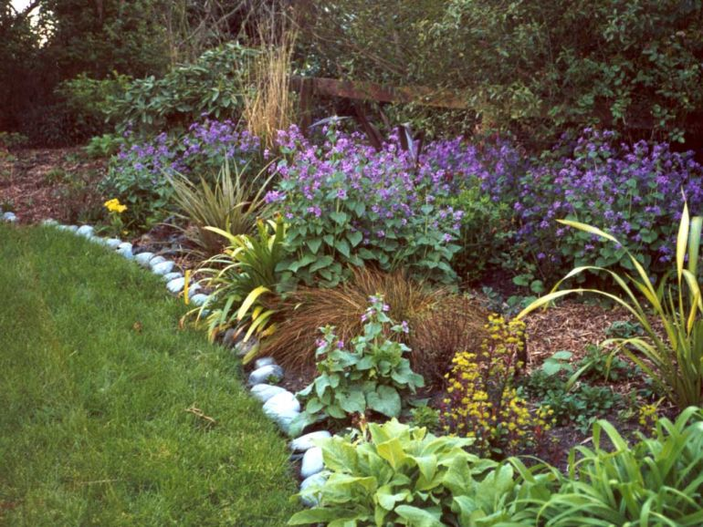

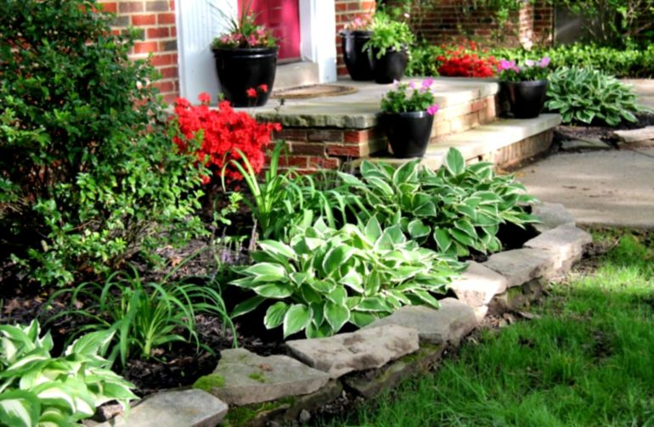
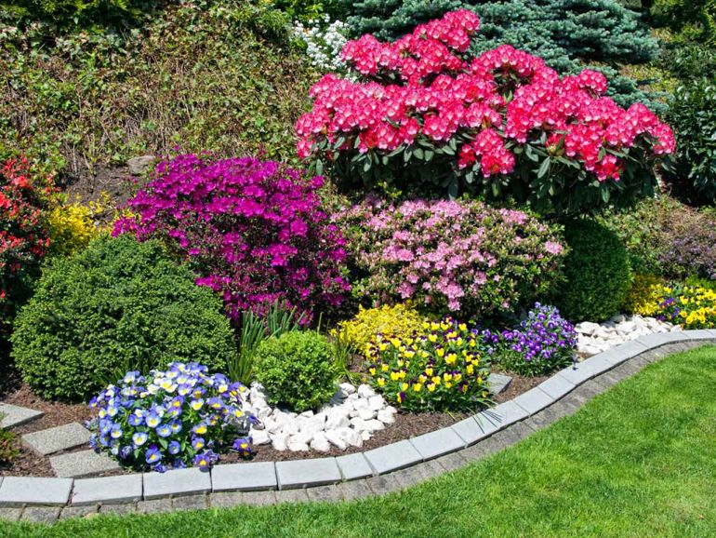

Un-mortared Stepping Stones

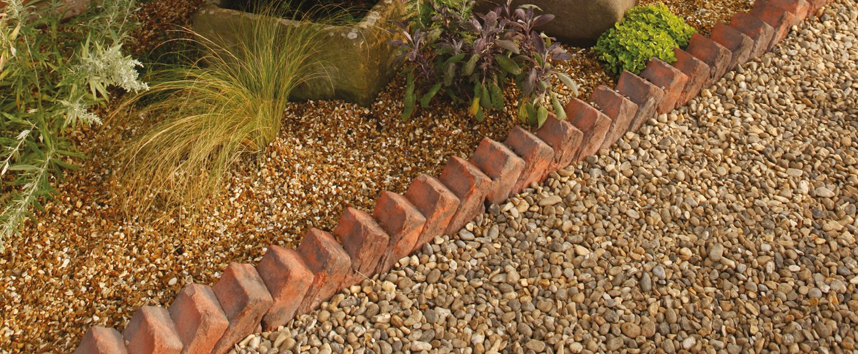
Loose stacked bricks without mortar.
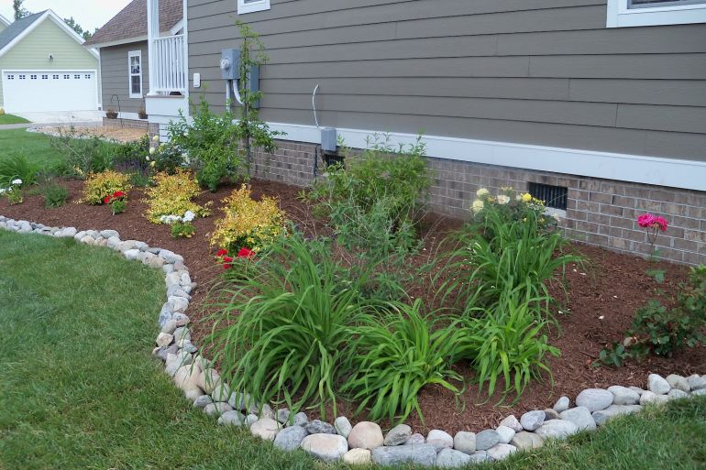

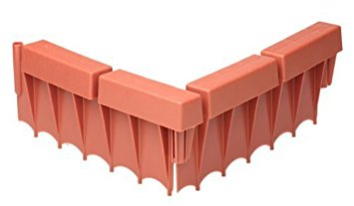
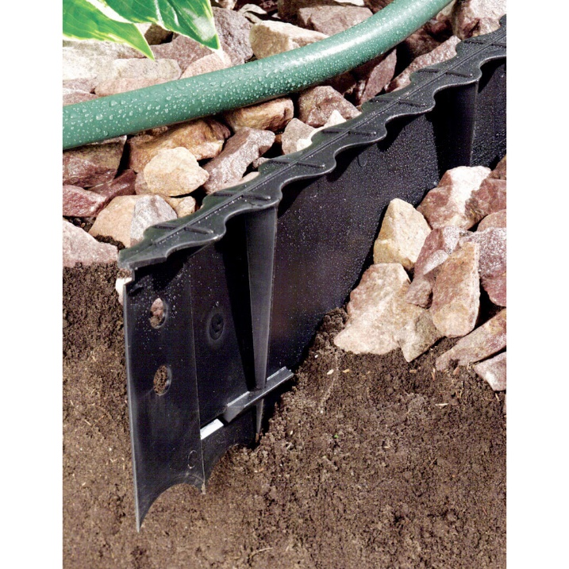

The Board has asked for specific details why flexible rubber or plastic edging should not be allowed. Experience by professional landscapers explain that this type of material requires constant attention to repair lifting out of the soil. Many different moldings have been tried to reduce this lifting and even large spikes inserted into the soil cannot stop the lifting. We appreciate all the nice landscapes, but remember you must have written approval for new installations or review of existing landscaping installed without ACC approval.
