Waynesburg Memorial Sales
  - BASIC MONUMENT STYLE GUIDE:
Why purchase a monument?
Making a decision about a monument is tough. It involves thinking about a loved one who has passed or may pass and can be an emotional experience.
Choosing a monument can help settle the emotions and reflect on your memories. A monument can be designed to reflect all the special qualities of that loved one, and can materialize all the positive, good memories you have.
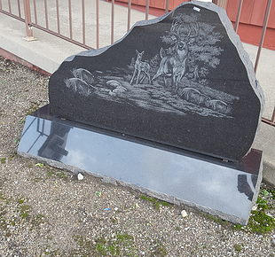

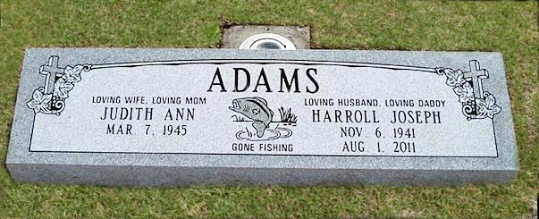
Grass or Flush Markers:
A grass or flush marker is a marker that sits flush to the ground. These markers are generally 24” x 12”, but may be larger or smaller depending on personal preference.

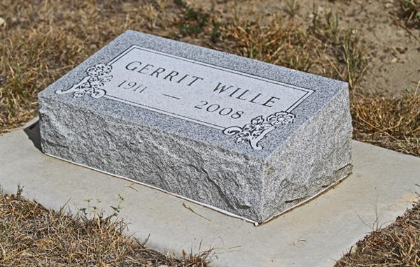
Bevel or Hickey Markers:
Beveled markers have a beveled or slanted surface where the back of the stone is a few inches higher than the front. They are generally 8” high and have a 1 ½” drop back to the front.

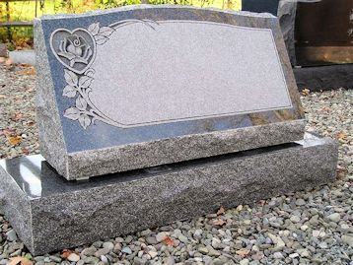
Slant Markers:
Slant markers are cut with a slanted face and are taller than the bevel marker. They may have one or two names and are generally 1’2” high and 10” or 12” wide.

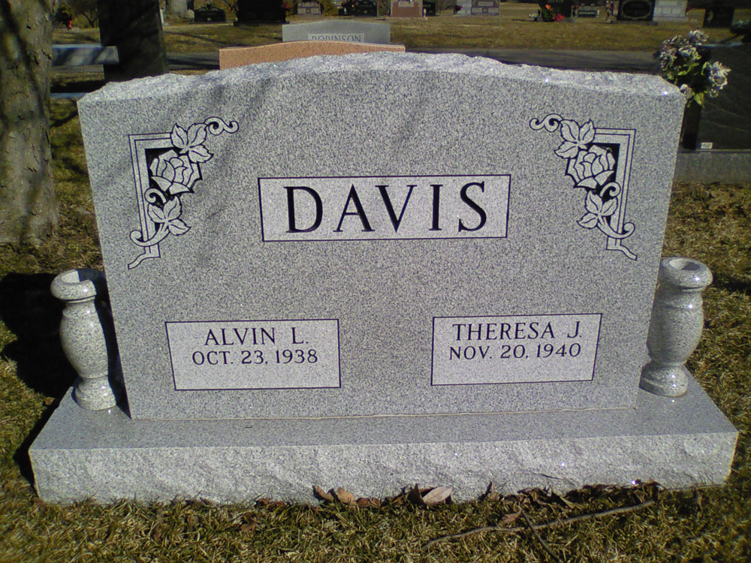
Upright Monuments:
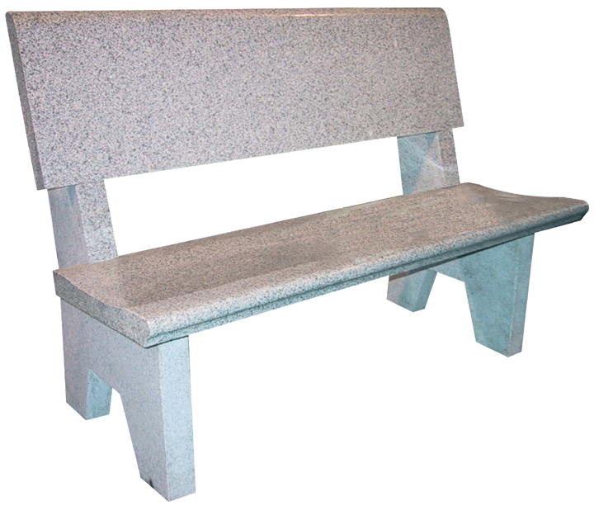
Upright monuments consist of a die and base. The die is the top part of the monument that sits on the base. The tops are usually serpentine, oval, or straight; however, other styles and custom shapes are available at an additional cost. The base is the lower part of the monument and usually has a polished top and rock sides.

Benches:
Benches are an ideal choice in areas where people pass or gather. They are an excellent option in areas such as parks and other public places where typical monuments may not be suitable.

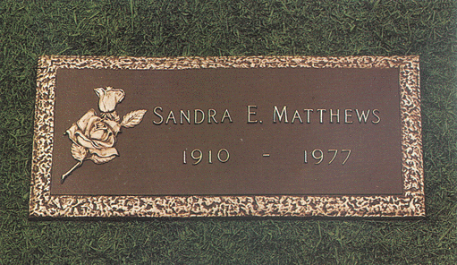
Bronze Markers:
Bronze markers are flush to the ground and rectangular in shape. They are usually installed on a concrete pre-cast or granite surround. Some cemeteries specifically require bronze markers.
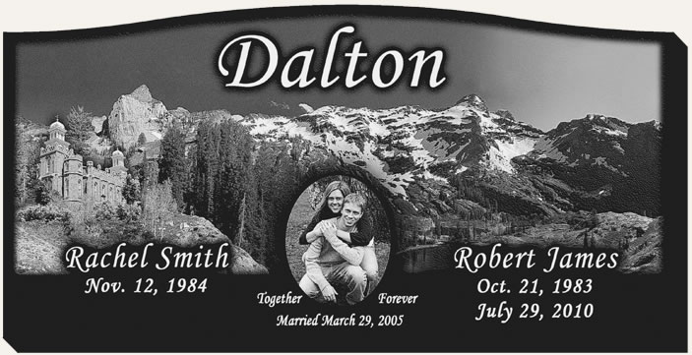
“When someone you love becomes a memory, that memory becomes a treasure…”
CARVING TYPES & TECHNIQUES:
Laser-Etchings:
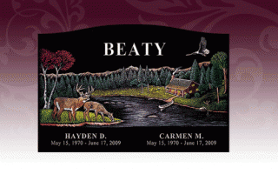
Etching is a method of applying a carving to the surface of our black granites. All etchings are carved from a design in the design booklet or from a family portrait. Laser-etchings are black and white.

Diamond-Etchings:
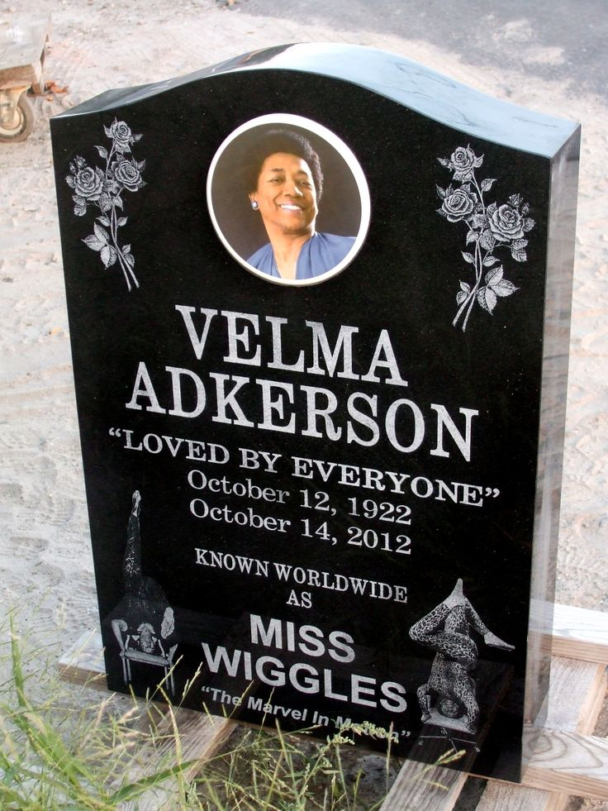
Diamond etchings are hand done by our artist. The artist cuts through the polished granite surface using a diamond-tipped instrument. We are capable of creating almost anything from large scenes to portraits and floral designs. Diamond etchings can be done in color.

OTHER OPTIONS:
Cameos:
Cameos are a simple and unique addition to any monument style. Cameos are ceramic portraits that are attached to the he adstone. They come in color or black and white.

