Event Vendor Concession Contract

(Please fill out and scan back)

The parties to this contract are U.R.E., LLC FOR MARICOPA MUSIC & BEER FESTIVALS (hereafter "Host") and ____________________________________ (hereafter "Vendor").
Whereas, Host is hosting an Event known as the 2nd ANNUAL MARICOPA MUSIC & BEER FEST to occur at @ UltraStar Multi-tainment Center at Ak-Chin Circle 16000 N Maricopa Rd, Maricopa, AZ 85139 on APRIL 6, 7 & 8, 2018, and has the right to license NON FOOD concessions to vend at and during the Event, and
Whereas, Vendor desires to vend (NAME OF CONCESSION)___________________ at and during said Event, and
Whereas, Vendor has paid Host the sum of $________________ for a space to vend at and during said Event, Now, therefore, the parties agree as follows: No refunds after January 1, 2018. Vendor Day Choices April 6___, April 7___. April 8 ____ x on choices.
1. Paid Vendors shall have access to the event venue location agreed upon by the parties no less than Three hours before the Event's commencement to setting up Vendor's vending station, goods, and other things necessary and reasonable to vending at the location.
2. Vendor shall not vend any goods or services other than those described herein at and during the Event without the Host's & Venue Sponsors written consent. This includes NO bottled water, NO Alcohol and NO Food Items unless they are agreed upon desserts. Additionally: NO WEAPONS, DRUGS OR Drug Paraphernalia IS TO EVER BE SOLD.
3. Vendor's vending station shall be no larger than 10 x 10 feet or taller than 6-8 feet; shall be clean and orderly; and shall comply with all applicable laws and regulations, and must supply its own outlet devices, and additional generators, other than those supplied at Venue.
4. Vendor's staff may announce the availability of the goods to be vended only while they are within the confines of the vendor's location.
5. Vendor's staff shall be clothed and groomed in a clean, neat fashion and shall conduct themselves in an orderly fashion.
6. No loud music, noise, or sound amplification devices shall be used by vendor's staff at the location.
7. Vendor shall have access to the location for up to Three hours after the Event's conclusion to dismantle and remove all things brought to the location by Vendor. Vendor shall leave the location clean of trash and substantially in the condition it was before Vendor occupied it.
8. Vendor hereby agrees to indemnify and hold harmless the Host against any damages or claims that may arise in connection with Vendor's presence at the Event and Vendor's activities of any kind.
9. Vendor agrees to promote the event as much as possible via their website and social media pages.
10. URE offers the Vendor industry exclusivity unless Vendor agrees otherwise. Ex. One Banking Company, One Shoe Company, etc.
11. URE will announce Vendors specials via Social Media and at the Event Stage.
12. Licenses & Permits: Vendors are responsible to have these submitted to URE in a timely fashion and must have them at their Vendor stations at all time and for inspection.
In witness to their agreement to the terms of this contract, the parties affix their signatures below:
____________________________________ _________________________________

AGREED TO AND ACCEPTED BY:

For Vendor: For THE U.R.E., LLC FOR MMF2:

______________________________ Chrystal Allen-O’Jon
(Name) (Name)
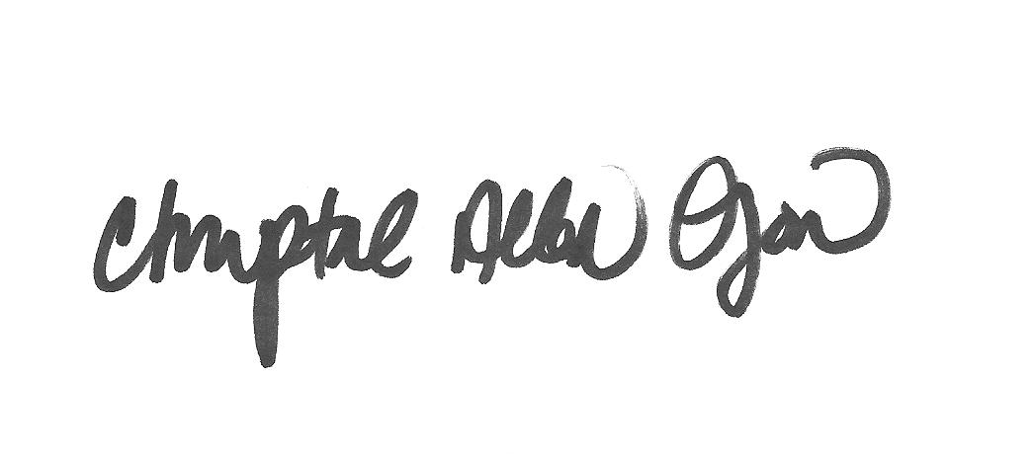

______________________________
(Signature) (Signature)

______________ ______________
(date) (date)

Federal I.D. No.: 01-0924395

