2nd Annual Maricopa Music Fest
aka MMF2
Hurry to secure your spot NOW!

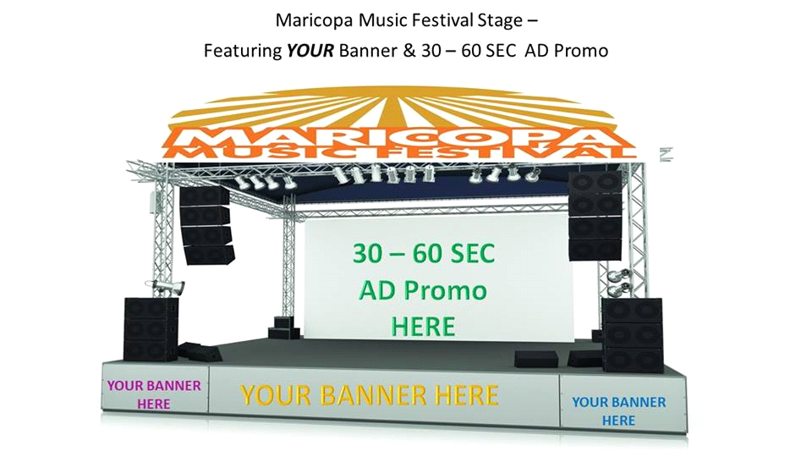

Greetings,

We are pleased to invite your organization to be an “Exclusive” Industry Partner at the 2nd Annual Maricopa, AZ Music & Beer Festival – featuring a Saturday Car Show. The event is slated for April 6, 7 and 8, 2018. For a quality event, we plan early.

A full suite of fun filled family activities will be available at the event location, Maricopa, AZ. Along with Music for all ages, there will be Bowling, Laser Tag, Bounce Houses, Face-Painting, a Ferris-Wheel, Festival Contests and Stage Give-A-Ways.

Additional
The Crowning of Music Fest King & Queen. Chosen for their Community involvement.

The objective of the Music Festival is several-fold. 1. To unify the community through music; 2. Support our local military families via onsite support programs; 3. Collect food for our local Food Bank Centers; 4. Showcase local and major bands; 5. Introduce local businesses and vendors to our residents and neighboring communities.

The MMF2 festival will feature 4-5 bands a day, one of which will be a major artist. Ambrosia is the first confirmed band with more coming.

Additionally, a once a month “band search” will be held at Ultra Star, where winning bands will perform at the Maricopa Music & Beer Fest. To build event momentum – all the promotion avenues will include your logo and link. Your sponsor logos included!

Advertising
Our ad outreach will be to: HeyMaricopa TV (20+k reach to local residents), targeted Facebook Ads to include Chandler, Phoenix, Tucson, and surrounding areas, InMaricopa Newspaper (+other local newspapers), as well as Ad’s with New Times Magazine/Online will reach thousands. Some ad’s will be posted in Spanish and English. Your sponsor logos included!

Music Line-Up Proposal
Friday Night 1 – EDM, Hip Hop, Rap & Reggae Featuring Major Artist.
Saturday Day 2 - R&B, Rock, Country, Pop, Latin, Native American, featuring Major Artist.
Sunday Brunch (Focus on Our Older Community) Day 3 – Gospel, Jazz, Blues, Blue Grass, featuring Major Artist.

Your Sponsor Logo's on Stage!

As our Sponsor, your organization will benefit in a few ways:
Corporate Partner/Sponsor $10k
(Includes Vending Space)
1. Photo opportunities with Bands, City Officials & Military Families
2. Generation of revenue (direct sales before during and after the event)
3. PR, Social Media, Stage & Web Placement
4. Cross Promotion on Tickets, Flyers, Stage Banner Placement, Product Placement
5. Inclusion on all upcoming music festivals
6. VIP Seating
7. Text Promotion Campaigns run before, during and after the music festival
8. Live streaming inclusion

Local Business Sponsors $5k
(Includes Vending Space)
1. Generation of revenue (direct sales before during and after the event)
2. Marketing of products/services (promotions, hand-outs, emails, program ads, etc.)
3. PR, Social Media & Stage Placement
4. Text Promotion Campaigns run before, during and after the music festival

Small Business Sponsors $2k
(Includes Vending Space)
1. Generation of revenue (direct sales before during and after the event)
2. PR & Social Media Placement

Vendors $100 a day. Returning vendors receive a discount (You provide your table & chairs).

Needed: Stage Prizes
(3) $100 Gift Certificates each day.

Sincerely,

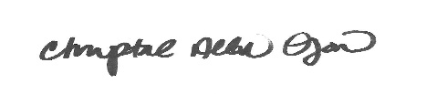

Chrystal Allen-O'Jon, Founder/Producer MMF2, Music@Maricopamusicfest.us
Powered by: URE – Urban Royalty Entertainment
chrysallenojon@aol.com – Cell 615-569-9138

Kent O'Jon, Finance VP., kentojon@gmail.com
Esmeralda Compian, Asst. Producer, esmeraldab733@gmail.com
Family Business: http://www.ojonenterprises.net
Event Site: http://maricopamusicfest.us

Prior Event Music Fest 2014 Facts

- 15 local bands performed – one day event
- 68 local vendors
- Kids face painting & bounce houses
- 3k audience
- Radio Ads
- Newspaper Ads
- Targeted social media ads
- Utilized local volunteers – Boys Scouts, Girl Scouts etc.

Prior Sponsors: Ace Hardware, Discount Cabs, Freeway Chevrolet, Guitar Center, Papa John’s Pizza & More.

Event Music Fest 2018 Goals
- 3-day event
- 4-5 bands a day with a major artist each day – Ambrosia and more!
- 100 Vendors
- Event vendors
- Face painting / contests
- 3-4k audience each day
- Radio Ads
- Newspaper Ads
- Targeted Social Media Ads
- Simultaneous events – Best Festival Wear @ Lux Lounge
- Best Car Show Prizes and Contest Presented at Lux Lounge
- To be the “Coachella” of Maricopa, AZ

Major Artist Line-up Band Goal – To pull all ethnicities, all three days. In current talks with Ambrosia, they have agreed to perform. We will add 2-3 more major headliners to draw an audience cross-section.

Inclusion goal – Bands that draw the Old-School R&B crowd, who tend to come for the nostalgia experience.

