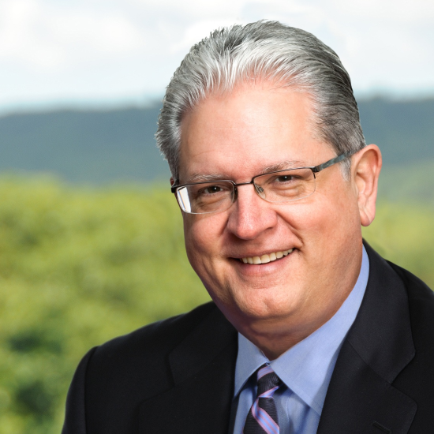
David W. Neu
Co-Founder of the Neu Family Foundation and Former Executive
AmerisourceBergen Drug Corporation

David Neu is the former president of AmerisourceBergen Drug Corporation and Good Neighbor Pharmacy, one of the largest global pharmaceutical sourcing and distribution services companies, helping both healthcare providers and pharmaceutical and biotech manufacturers improve patient access to products and enhance patient care. Mr. Neu recently retired after thirty-four years where he held several executive leadership roles – to include the president of the retail division for legacy company Bergen Brunswig, senior vice president of operations, retail sales and marketing.

Mr. Neu has served on the board of directors of the National Association of Chain Drug Stores (NACDS), and is the former chairman of the Healthcare Distribution Management Association (HDMA). Mr. Neu is currently serving as a board member for Cristo Rey High School of Philadelphia, and The People’s Portfolio, a national organization committed to fighting discrimination and human rights. Additionally, Mr. Neu is a member of the Sidney Kimmel Cancer Center Advisory Council.

David and his wife, Esperanza, co-founded the David and Esperanza Neu Charitable Foundation in 2010 and were recognized as Philanthropists of the Year in 2016 by the Association of Fundraising Professionals of Greater Philadelphia. Committed to supporting causes related to health and education, they have partnered with several universities to establish scholarships for students in need. Mr. Neu enjoys collaborating with high-impact agencies to make a difference in the community.

In 2013, Mr. Neu received the Alumni of the Year Award from Pepperdine University where he earned a Masters of Business Administration Degree.

