About 10 and Under Tennis:
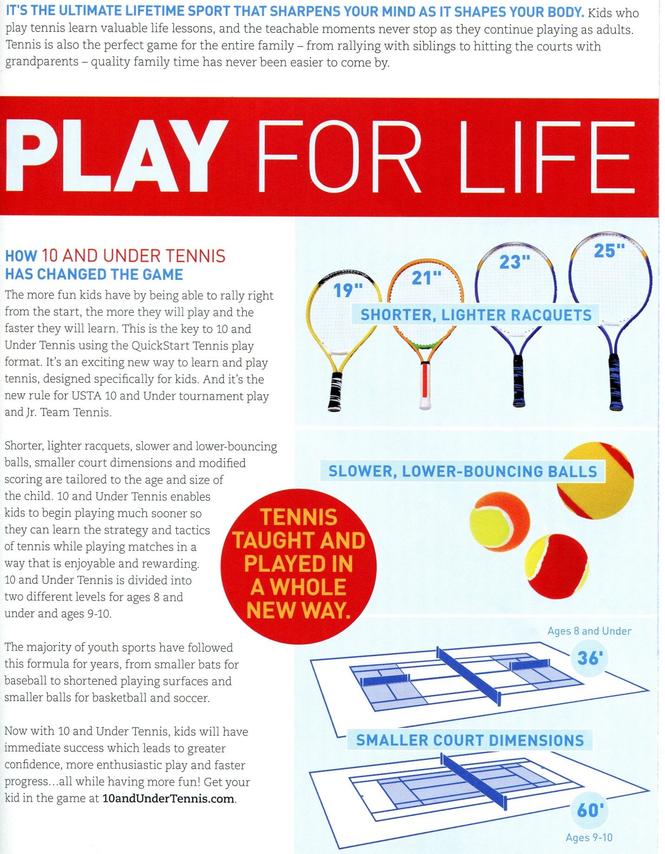
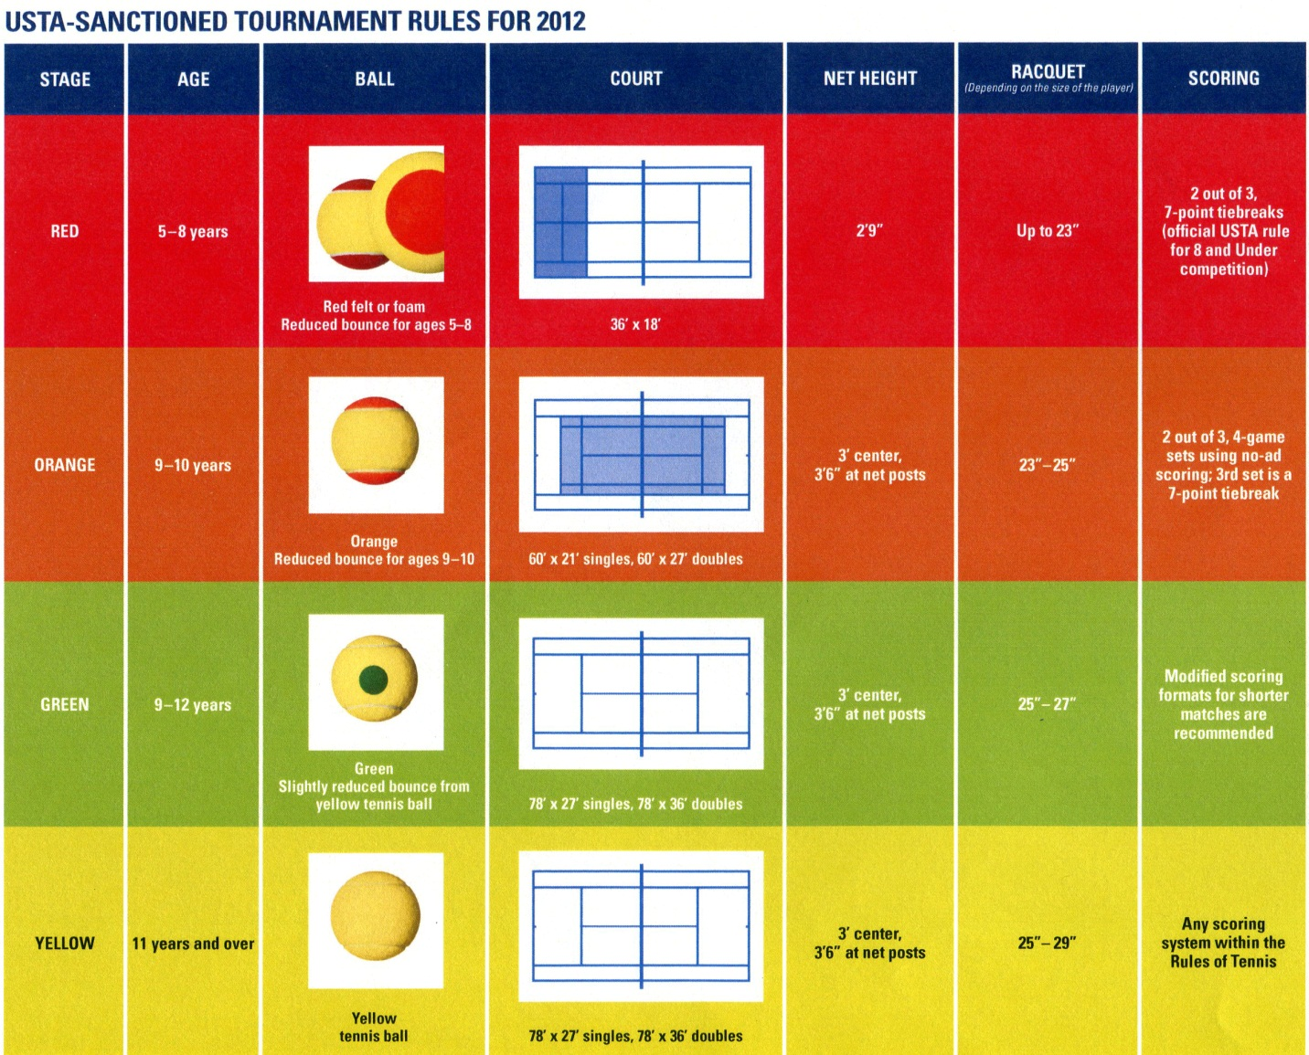
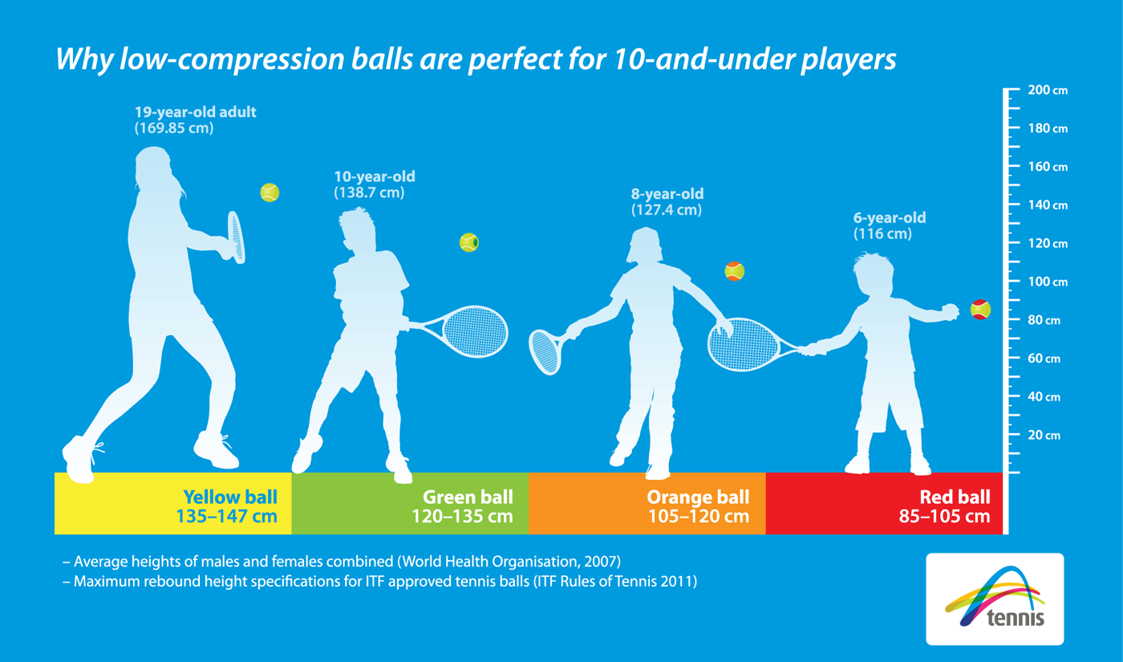

Junior Racquet Sizing Guide:
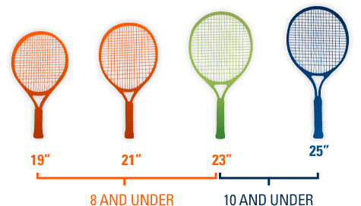

Junior racquets can be purchased at places like Your Serve, Serious Tennis, PGA Tour Superstore, Dick’s Sporting Goods, Sports Authority, Target and Wal-Mart. They start at around $20 and used ones from Play It Again Sports are just fine.

