DESIGNER DOOR PANEL INSTALLATION INSTRUCTIONS
FOR PRETRIMMED PANELS
Thank you for your purchase of another Quality RodDoors Products. We understand that you have a choice and you chose us. It is now our turn to return the favor by providing you with valuable savings in time and money.
Our commitment to your project doesn’t end with this sale. Repeat customers are our best salesmen, and the best way to put someone on our team; is to deliver great products that we can all truly believe in.

Pretrimmed Designer Door Panels
TOOLS REQUIRED (not included)

Utility Knife Pliers
Sanding Block (with 80 grit paper)
Drill and 1” bit to drill holes for window and door handles
High Heat Resistant Contact Cement Spray Glue (RodDoors Glue Cheese or 3M Spray 90 is recommended)
ABS pipe glue (black) for retention clips (optional) NOTE: do not use universal or PVC glue.
Silver Sharpe

PANEL SYSTEM PARTS (INCLUDED)

(2) Designer Door Panel
(1) Bag:

Instruction Sheet Dualloc Tabs (30 pieces)
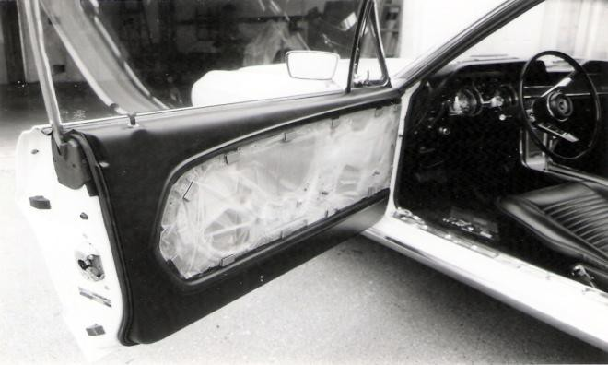

Blaine Roberts-Customer Service Representative
Phone 1-530-828-9426
Fax 1-530-896-1513
www.roddoors.com
- The Plan-Remove any door hardware
(handles, knobs, armrests) and the existing door panel. Clean door of all dirt, grease, oil and wax.
TIP: Start on the passenger door first. Two reasons, First by the time you get to the Driver’s door you should be pretty good at this. Second, your more likely to complete the job if you have to finsh the driver’s door last.

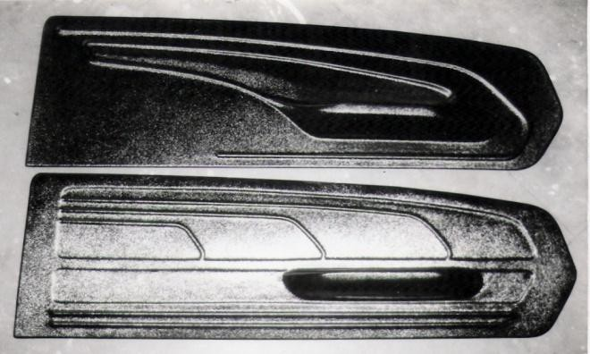fabric is smooth all around, and then move onto larger flatter areas.

- What we started with.
The designs we had to choose from.
Note: While trim to fit panels can be used on many vehicles .We have direct pretrimmed panels readily available. We recommend pretrimmed panels because it gives us the chance to address many issues that may exist with your car or truck.
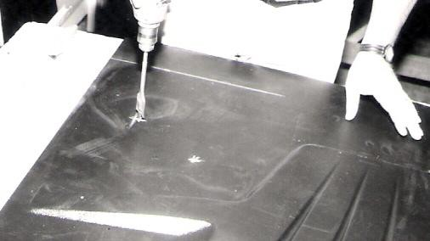
- Drill the necessary holes, and then check for fit. Original holes locations are marked on all pretrimmed door panels. Just find the mark and drill out the proper hole. Or if you’re using power windows don’t even bother drilling out the hole as the fabric will cover up any mark on the panel.
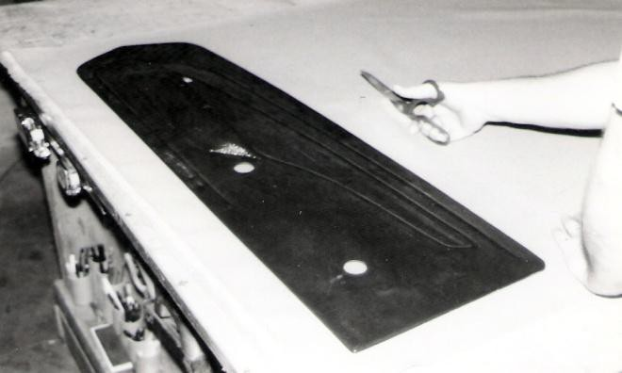
- Over sizing the fabric for the panel.

Covering the Panel
Lay out the material and cut to size allowing a 2” overlap all around the panel. In a well ventilated area, spray glue the back of the Designer Door Panel and the back of the upholstery fabric. Work only 2 sq. ft. area at a time. Let dry for 10-15 minutes. Start at the tallest part of the panel, lying on your work bench that is most always going to be the armrest. Work the armrest until the
TIP: If you’ve never tried this before, use a scrap piece of fabric and plastic and work with it till you get a good idea about how long to let the glue dry, variations with time occur due to temperature and humidity. Example: The colder it is the longer it will take for the glue to “tack-up”. What you’re looking for is to be able to put your hand directly onto the glue and not have it come off onto your hand, but not have it as dry as your hand doesn’t lift the material off the bench.
Note: If you don’t let the fabric dry long enough you run the risk of the glue bleeding though the fabric when you press it onto the panel. This is especially true with woven fabric.
Note: Don’t try to cover too large an area at one time. You run the risk of working too long in one area and not having the proper tack when you get to the rest of the panel. 2 Sq. Ft. at a time is a good size to work with each time. If the glue has dried too long you can always peal back the fabric ½” from where you got good adhesion and respray the glue to both the fabric and panel again, wait for it to tack and then press the fabric back onto the panel.
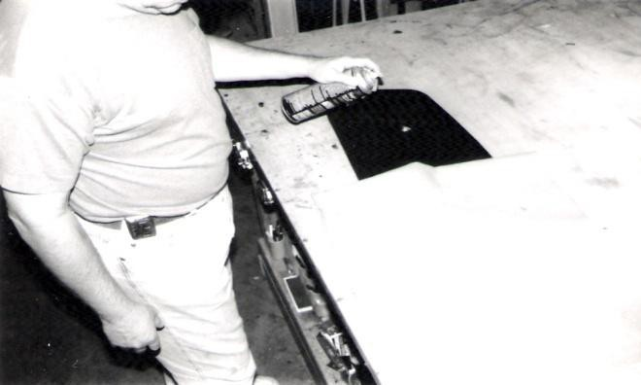
- Gluing the fabric to the panel armrests first
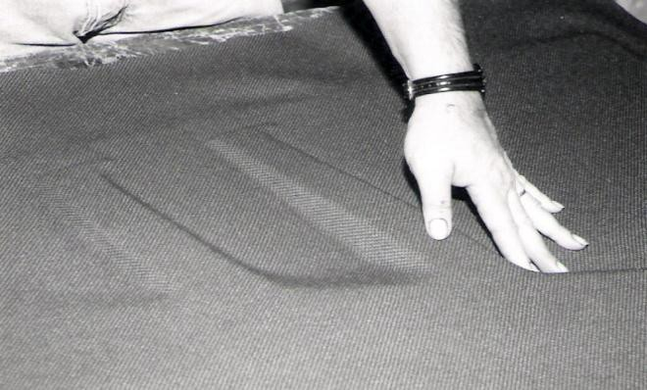
- Pressing the fabric tight to the panel. TIP- you want 100% coverage. Failure to press the fabric completely will result in draping fabric later.

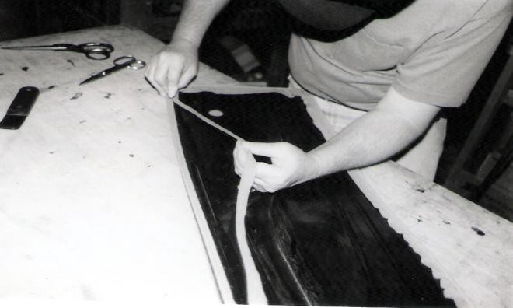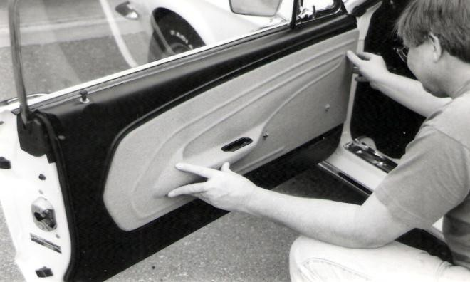

- 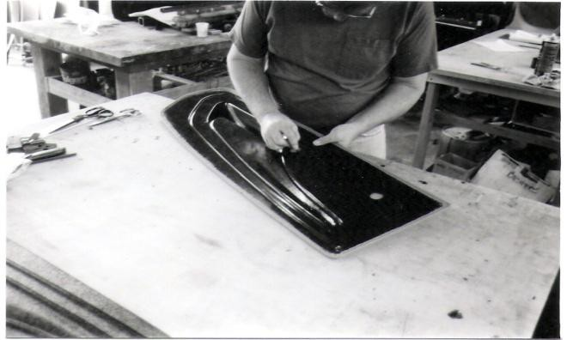Trimming the panel and cutting off the selvage.

- 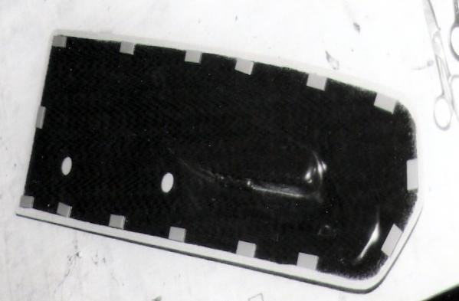Cutting x’s through the material for the handles.

- 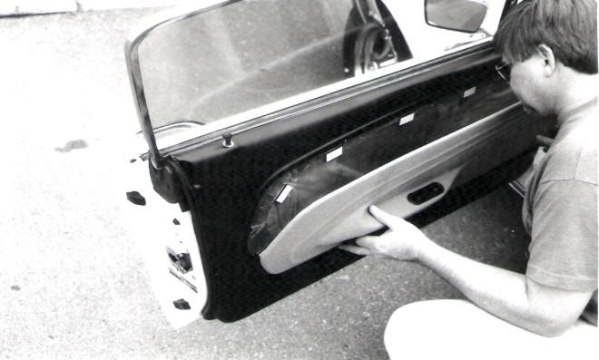Dualloc tabs places around the Panel

- Align the panel with the door.
- Pressing the panel in place attach the door pull and
handles and we’re done.

TECH TIPS

Carpeting the Panel

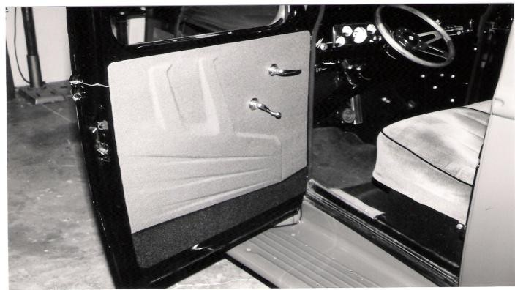
If you wish to apply carpet to the bottom of any RodDoors Panel System you can. BEFORE covering the panel, Use your Silver Sharpe to draw a line onto the panel, (this line is where the fabric and the carpet will butt up to each other on the panel). Play with this a while, redefining what you’re trying to accomplish, fine tuning the break line over and over till it looks right. Remember that where the line ends at the edge of the panel, the line should be as close to perpendicular to the edge as possible.
NOTE: Don’t be too smart and draw extremely sharp lines, like zigzags. This will expose the base plastic, as the fabric will not be able to fold around the panel to cover it completely. Also, no radical points, points are hard to cover, and result in potential snags and reduce the lifespan of the fabric on the panel as the fabric will fray and look terrible in a very short time.
THE RULE is points should be no sharper than 3/8” radius and nothing sharper than over 80 degrees.
Cut and break apart the panel. Sand the breaks smooth; remove
¼” of plastic and the molded in return on that part of the panel to be covered in carpet. The carpet will fold under the panel (not along the break, the 3 sides only) the molded in return is not needed as the carpet will cover the return to the door. You should choose an unbacked low pile carpet to cover the panel and reduce panel bulk. Cover the bottom panel with carpet first. Test for fit. A good fit has an even 1/16” gap along the break. Any necessary trimming on the upper panel must be done now. Cover the top portion of the panel with fabric.

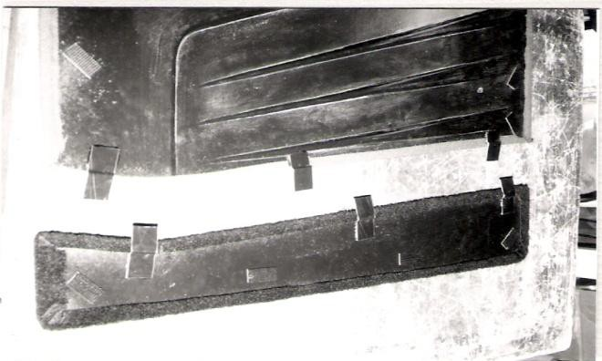
Glue on Carpet Tabs with ABS glue staggered across the panel as shown above. Install as previously directed. TIP: ABS glue only. We also like it a little on the thick side so we open a new medium body can and let it sit open for ½ hour to set it up a little. This also may prevent an accident if new glue should run across the panel to the front side ruining your new cover. Again, it has happened to us, we don’t want it to happen to you.
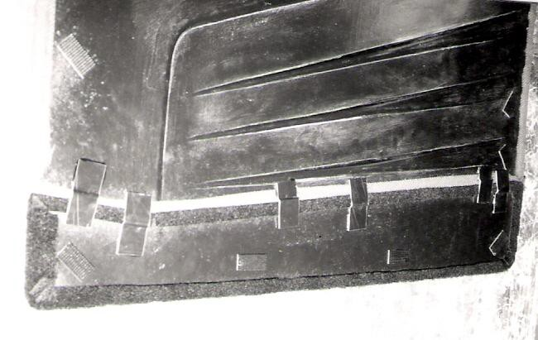

Two-Toning- or How to Use a Contrasting Fabric Color without Sewing
Cutting the Panel Apart
- Choose and mark the dividing line then score and break panels apart. Run the utility knife along the mark until the material is cut 50% through. Cover the panels separately. NOTE: Fabrics wrapped around a panel will add 1/8” (1/16” per side) to the height of the panel; this can be removes by block sanding the two pieces prior to covering this also insures that you will end up with a perfect fit when done.
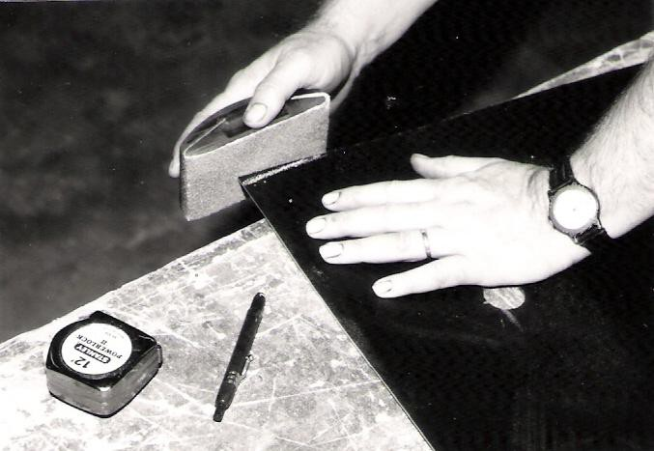
- reattach the panels by using upholstery tabs and ABS pipe cement (see carpet) upholstery tabs will be permanently attached to both panels.

Applying Plastic onto the Panel
An extra layer or detail can be achieved by cutting out any design that you may want out of ABS plastic covering it separately then gluing the insert onto the panel. If you’re applying the insert to the panel, cover the panel first. Mark where the insert is going to be placed and mark that around location with masking tape. Come ½’ inside the tape marks and cut away the material to reveal the ABS plastic. Cover the Insert and trim away the selvage on the back side. CAREFULLY apply a little ABS plastic pipe cement to the exposed area on the panel and align and place the insert on top. Apply a little pressure with some weights and let dry overnight. Once dry remove the weights and the masking tape and your ready to install the panel onto the door.

On Trim to fit Panels align panel on door until armrest is in the most comfortable position regardless of where the panel fits on the door. Even if your panel is short on the bottom of the door, there will always be extra material at the top that can be cut off and reglued to the bottom of the panel to make it fit.

Which Fabric work Best? Ultra leathers, Tweeds, or contract fabrics work best. Leathers need to be of that European Glove leather kind. The fabrics that work best have a four-way stretch. The thinner the backing the more successful you’ll be. Some of the most radical panels, and the stiffest fabric have been used successfully, by gluing the fabric to the panel, slitting the fabric along the top of the armrest (where your elbow hits), cutting an armrest cover out of scrap plastic, covering that with ¼” RodFoam then fabric, and gluing the armrest pad to the panel with ABS plastic Pipe cement.

Mistakes Happen? If you trim the panels too short, it’s not fatal; you don’t have to buy a new panel. Just glue the panels back together with ABS plastic pipe cement. Glue a backing strip (2”x length of cut) behind the panel to reinforce the butt joint, let the panel dry overnight, then trim to the larger size. Don’t worry about how much that backing strip will keep the panel off the door because the strip is less than the thickness of the Dualloc Tape that hold the panels to the door.

Wrinkled Fabrics? Pull it back off. The worst thing that can happen is that the glue would come off of one side. So if you get a wrinkle, pull it back reglue both sides, let it dry and then work the fabric in a different direction to get the wrinkles out.

Can you Use Foam? Yes, foam is great for providing a little padding on top of the armrest, or to create a quick and easy detail on a panel. We offer RodFoam for this very application.
RodFoam is made from the same high density closed cell foam used by professionals, with the added bonus of having a high temperature adhesive added to the back side. Remove the liner on the foam and apply it anywhere you want on the panel. TIP: never cover a panel completely with foam; it washes out the look of the panel. Foam should only be applied where you may rest your arm, for detail or where you may rub against the panel and want a softer less hard panel.

Dualloc Tape? Is supplied in a mixed strength combination, one side has dense mushroom heads, the other less dense. This combination is suitable for almost every application; however, there will be times when this combination is just not enough. Designed for lateral strength Dualloc does not do well when it is called upon to hold a panel tight to a door that has a large curve to it, pulling the tabs apart and loose from the door.

Solution 1; Pull apart the tabs and mate the densest tabs together for a stronger bond.

Solution 2; On the Door side drill a 1/8” through the middle of the tab attached to the door and either screw through the tab or pop rivet the tab in place.

Solution 3; Glue upholstery tabs to the back of the panel only where you find that the Dualloc is just not doing the trick. The tabs should be within ½” from the edge of the panel. Slip a wire Xmas tree or Chrysler clip under the center tab of the upholstery clip. With the panel in place mark where the wire clip will need a hole. Remove the Panel and drill a ¼” hole in the door. Reinstall the Panel, Good Job!

For additional Instructions and TECH TIPS or to order visit us at www.roddoors.com

