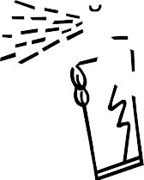
I
BLAINE ROBERTS
1616 NORD AVE #A
CHICO, CA 95926

530-828-9426

539
530-896-1518 FAX
WWW.RODDOORS.COM

INSTALLATION INSTRUCTIONS FORD TRUCK ’48 – ’52 HEADLINER
(THE NORTON)

TOOLS REQUIRED: (NOT INCLUDED)
Utility Knife ABS Pipe Glue Tape Measure
1 Can Spray Adhesive Sand Block (80 grit)

LAY OUT ALL PIECES: (INCLUDED)
1 Headliner
- Quarter Panel Set

- Locate the bracket in the center of the inner roof panel and measure the length of both “A” and “B” as shown on the sketch below. “A” is from the header panel to the center of the hole in the bracket. The purpose of these measurements is to enable you to locate the bracket hole after the headliner is in place.
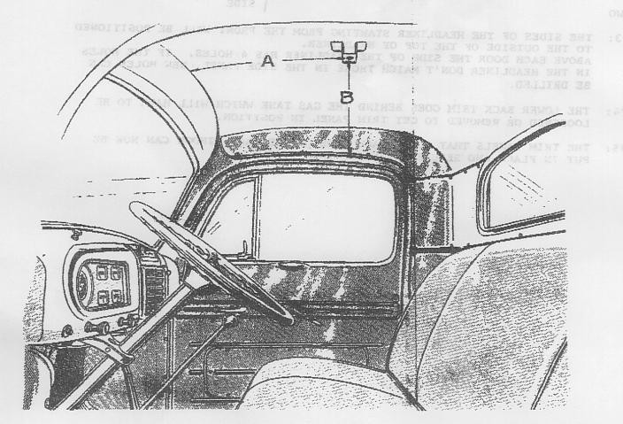
- Start at the front with the headliner going between the header panel and roof panel. Working from front to back, position the sides of the headliner over the doors and toward the back. At the back, the headliner will be positioned behind the rubber seal of the upper back window.

1
(over)

- The side of the headliner starting from the front will be positioned to the outside of the top of the headliner. Above each door the side of the headliner has 4 holes. If the holes in the headliner don’t match the holes in the side panel, new holes can be drilled.

- The quarter panels that go on each side of the back window can now be put in place and secured either with trim screws or the tabs on the back of the panels.

- Once you’re happy with the fit, you’re ready to upholster the cover with fabric. To ensure the entire panel is covered allow 2 extra inches of fabric around the entire panel. Use only a high temp contact spray adhesive (RodDoors Spray Glue Cheese or 3M Super90). Start in the center; spray both the back of the fabric and the front panel, 2 square feet at a time. Take your time. If the fabric has a grain or pattern keep it straight on the center of the panel.

- To fill in the newly discovered bare spot that is sitting below the rear window and above the center panel, simply trim a piece of fabric 4” x 36” and glue it directly to the steel, slipping it underneath the rubber and draping it behind the Rear Cab Cover Center Panel.

- Reinstall the panels into the truck and attach as before.

Thank you for choosing RodDoors!! www.roddoors.com

