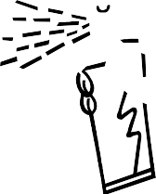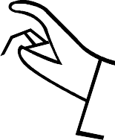

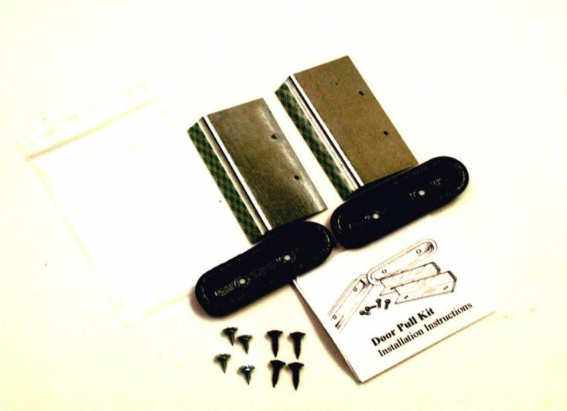
Installation Instructions Door Pull Kit RD-1002/1010
BLAINE ROBERTS

1616 NORD AVE STE A
1616 NORD AVE # A

CCH

CHICO,CA 95926

CHICO, CA 95926

PH 530-828-9426
530-828-9426
Fax 530-896-1518

FX 530-896-1518 WWW.RODDOORS.COM
www.roddoors.com

Install the Door Pull after the RodDoors panel has been trimmed to fit and mounted to the door and before the fabric has been attached. Find the appropriate location for the pull; the best locations are flat horizontal surfaces (armrest area.)
Mark the location and drill two 3/4" holes through the RodDoors panel; always undersize the hole. It's much easier to make a hole larger than to make it smaller. Use a utility knife to enlarge the hole until the door pull fits tight to the panel. Should the hole be too loose, it may still be OK, as the fabric will be tucked into the hole once the armrest is covered.
Screw the 4" bracket to the door pull while it is in the panel using LONG SCREWS. Remove the green and white tape backing and press the RodDoors panel onto the door. Press the door pull and bracket firmly against the door, unscrew the pull from the bracket and remove the panel from the door. The double stick tape is for alignment only. Roll up the window (if installed) and drill a small hole through the bracket and into the door. Screw the bracket to the door using the chrome SHORT SCREWS. Use the short screws on the door so they will not scratch the window glass!
Test for fit, attach fabric, mount the door panel back onto the door, and screw on door pull. At this point it may be necessary to re-drill the holes in the metal brackets to get a tighter fit. (Do this with a 1/8” by 6” drill bit to avoid possibly marring the fabric). And attach all the other door hardware.
NOTE: If there is no support for the bracket, a metal strap will have to be attached to the door as well (strap not provided.
Thank you for choosing RodDoors!
www.roddoors.com

