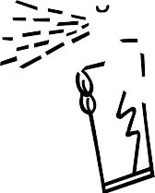

BLAINE ROBERTS

1616 NORD AVE # A
CHICO, CA 95926

530-828-9426

Tools required: (Not included)
1 Can Contact Cement Spray Glue

Lay out all pieces: (Included)
1 Danno headliner
1 Bag Dualloc Tabs

Installation Instructions
’67-'72 Chevy Truck
The Danno Headliner

Clear a workspace and assemble all tools needed to complete the installation.

- After testing for fit, you're ready to upholster the headliner with fabric. To ensure the entire panel is covered, allow 2 extra inches of fabric around the entire panel. Use only a high temp. Contact spray adhesive (RodDoors Spray Glue Cheese or 3M Super 90). Start in the center: spray both the back of the fabric and front of the panel, 2 square feet at a time. Take your time. If the fabric has a grain or a pattern keep it straight on the center of the panel.

- Any wrinkles can be removed by lifting the fabric away from the panel and re-gluing the panel and fabric; working the fabric in a different direction the next time.
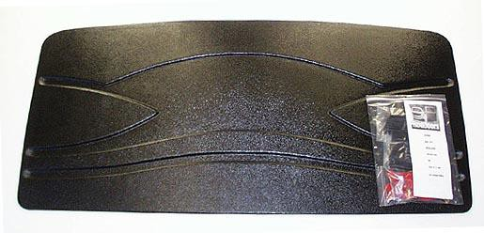

Note:
Use all Dualloc tabs provided in the installation kit.
- Peel off the red liner from the Dualloc Tab and stick in place on the headliner (10-15 pieces) in the center and the remaining pieces along the edge inner lip of the panel. Press headliner on to the roof; use a piece of PVC pipe to hold it in place for a couple of hours until everything cures.
Thank you for choosing RodDoors
www.roddoors.com

