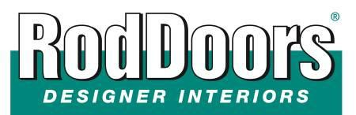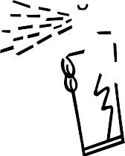
1616 Nord Ave # A
Chico, CA 95926
530-828-9426 cell
530-896-1518 fax
www.roddoors.com

Installation Instructions
'47 -'55 Chevy Truck the Eureka Gas Tank Cover

Tools required: (Not included)
Utility Knife ABS Pipe Glue Tape Measure
1 Can Spray Adhesive Sanding Block (80 grit)
Lay out all pieces: (Included) 2 Pre-trimmed Corner pieces 1 Pre-trimmed ABS center
1 Universal Panel 44”x 26.5” INSTALLATION KIT

- Test each corner for fit to ensure that the CORNERS and CENTER fit correctly.

- If you are using the tank cover without a gas tank in the truck (IT’S POSSIBLE) you may decide that you want a little more support. If this is the case, braces can be formed from ¾” plywood, angle iron, or MDF pressboard. The areas that need the most support in directly under the package tray area, this is especially important if installing a radio or CD player onto the flat of the package tray.

- Apply the Foam Edge Tape to the backside of the cover at the top edge and down the sides on the back edge only.

- Using additional Dualloc Tabs every 6”-8” test for fit and install the cover into the car. If any gaps are present use additional Foam Edge Tape to fill in those gaps. Protrusions can be handled by carving away the foam in that area.

- Once you’re happy with the fit, you're ready to upholster the cover with fabric. To ensure the entire panel is covered, allow 2 extra inches of fabric around the entire panel. Use only a high temp contact spray adhesive (RodDoors Spray Glue Cheese or 3M Super 90). Start in the center: spray both the back of the fabric and front of the panel—2 square feet at a time. Take your time. If the fabric has a grain or a pattern keep it straight on the center of the panel.

- On the back of the panel, glue the fabric over the edge tape and trim to within ½ “ to ¾” of the edge.

- Reinstall the panel into the car and press in place.

Thank you for choosing RodDoors
www.roddoors.com

