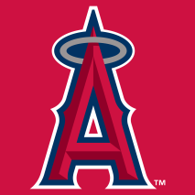  Angels  Noah Avery  Micheal Blackmore  Luke Evans  Eve Harris  Ayden Maidment  Quinn Osmond  Jake Park  Zachary Parsons  Maddox Quinton  Camryn Thorne  Aaliyah Best  Hudson Bursey  Nolan Crane  Felicity Pelley  Alexis Spurrell  Aiden Thorne  Hayden Vokey | 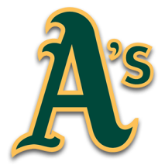  Athletics  Oliver Ackerman  Cole Bambury  Daniel Bryne  Blake Everly Duncan-Kennedy  Rory Hann  Eve Harris  Reed Morrison  Isabelle Nyberg  James Primmer  Luke Spurrell  Addison Wells  Lily Bailey  Maxwell Benoit  Mark Harris  Ben Paul | 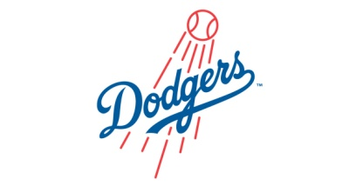  Dodgers  Joel Baggs  Kalem Bolt  Paige Howse  Owen Meade  Oliver Pelley  Madison Penney-Ryan  Nate Piercey  Joel Russell  Nathan Tarrant  Emily Best  Evan Fillier  Andrie Lorenz Ocampo  Reid Spurrell | Giants  Cameron Bailey  Dawson Bryant  Hunter Brazil-Gray  Riley Hancock  Kenzie Matthews  Ewan Morgan  Isaac Power  Matthew Sibley-White  Nya Stanley  Joshua Wiseman  Mya Farrell  Chase Harris  Logan Moores  Raya Pond

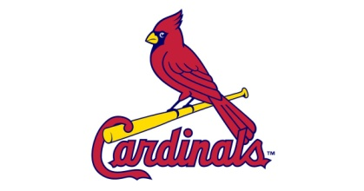  Cardinals  Gavin Baggs  Riley Baker  Cole Brooking-Marsh  Jackson Furlong  James Hancock  Noah Hemeon  Nathan Hemeon  Cameron King  Gracie Prince  Raine Rogers  Cody Simms  Dalton Templeman  Leland Webster | 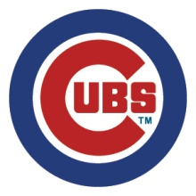  Cubs  Jack Avery  Sam Bennett  Peter Bennett  Carter Bryant  Jaxon Clouter  Jagger Hann  John Lynch  Grace Moores  Gabriel Rose  Layla Stanley  Chayse Sweetland  Jackson Vardy | 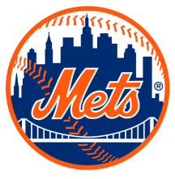  Mets  Jordan Avery  Maddox Barrington  Nicholas Blackmore  Jayden Drover  Ryan Harris  Maddox Jones  Robert Paul  Brynne Power  Ryder Hickey  Andrew Taylor  Colson Vivian  Joshua Wilcox

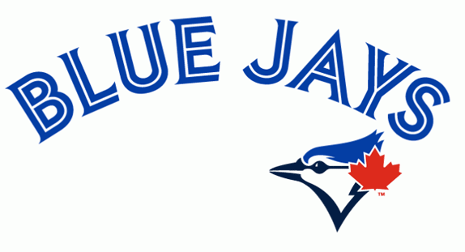  Blue Jays  Dylan Bambury  Alicia Barnes  Jacob Chard  Jeffery Critch  Isaac Harnum  Jada Harnum  Cole Holloway  Alexis Jones  Russell Monk  Katie Power  Hayley Soper  Shane Soper  Henry Spurrell  Mark Spurrell  Taylor Welsh | Orioles  Grady Baker  Jackson Barrington  Harley Burry  Brady Coady  William Crocker  Parker Emberly  Peyton Farrell  Ava Gaulton  Jacob Harris  Brooklyn Jefford  Evan Mullett  James Park  Sophia Penney  Jake Tilley  Jaxon Wicks | Rays  Elliott Bailey  Christyn Davis  Logan Eddy  Lexie Ellis  Nathan Fillier  Ethan Glass  Christopher Harris  Gavin Keats  Riley Kelly  Rebecca Lambert  Liam Penney  Devon Price  Robert Stanley  Owen Verge  Ashton Webster | 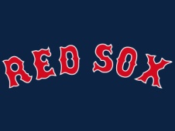  Red Sox  Aaron Avery  Jay Avery  Aiden Bryant  Brooke Cooper  Mackenzie Hookey  Megan Hookey  William MacDonald  Keegan Morgan  Merkuria Norris  Gavin Parrott  Micah Rose  Abigail Skiffington  Brody Spurrell  Tristan Spurrell  Gavin Stanley | 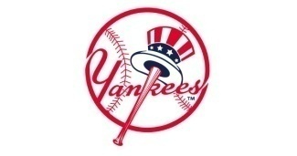  Yankees  Aiden Avery  Lily Bennett  Chase Drover  Jenna Hiscock  Joey Jacobs  Maiya Laite-Baggs  Rylee Leonard  Shawn Loveless  Ethan Mackey  Riley Norris  Nicholas Reid  Emma Rogers  Lily Spurrell  Parker Spurrell  Logan Sullivan

Astros  Lucas Baker  Matthew Clarke  Jenna Dawe  Lucas Frampton  Dylan Holloway  Katelyn Jefford  Kaden Lambert  Ethan Mackey  Jared Rideout  Gabrielle Robbins  Joshua White  Leah Wiseman | 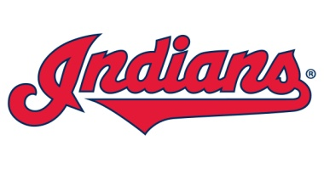  Indians  Mark Butt  Claire Newman  Thomas Evoy  Lucas Haynes  Ava Ivany  Braden Keel  Matthew MacLean  Garrett Pitts  Alexander Power  Joely Power  Christopher Rose  Katelyn Wiseman | 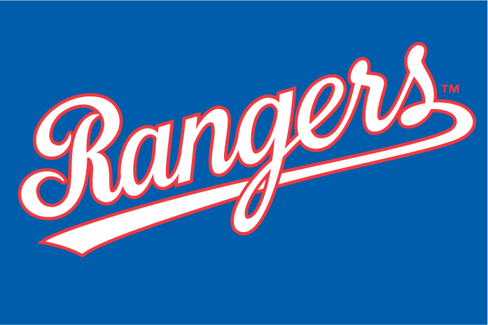  Rangers  Harmoni Avery  Jasmine Avery  Damian Bladen  Adam Currie  Gabe Greening  William Holloway  Kyle Lambert  Jillian Pardy  Adam Penney  Noah Price  Jessica Short  Ryan Smith  Evan Kent | Tigers  Georgia Bolt  Lucas Bryant  Carson Dover  Benjamin Harris  Jillian Harris  Tyler Humby  Alex Mackey  Kyle Penney  Chloe Pitts  Taylor Reid  Kyle Spurrell  Skylar Thistle

Nationals  Nathan Baker  Melissa Barnes  Mark Boutcher  Madison Clarke  Ashley Healey  Cassidy Ivany  Landon King  Emily Norris  Aaron Ocampo  Will Robbins  Avery Smith  Raquel Stoyles  Evan Tucker  Tyler Wiseman | Pirates  Joseph Blackmore  Maggie Burt  Emma Evoy  Cole Harris  Jayden Holloway  Lucas Jefford  Mackenzie Martin  Alyssa Oldford  RJ Rose  Brett Smith  Sam Walsh  Jada Webster  Joshua Wiseman | 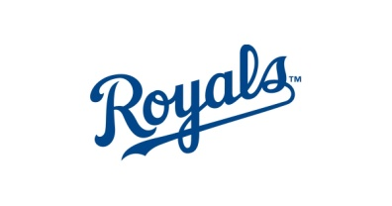  Royals  Nathan Bladen  Holly Butt  Paige Flemming  Liam Hogan  Brandon Holloway  Maria Holloway  Jesse Mackey  Emily Mullett  Samuel Pike  Andrew Pitts  Marcus Rideout  Riley Rowe  Riana Simmonds  Ethan Tracey

