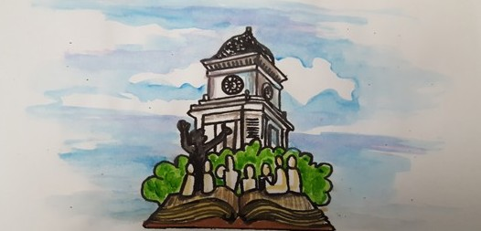
STORYTELLING RESOURCE PLACE
Membership Application

Name:______________________________________________________________________
Address:____________________________________________________________________
Email______________________________ Cell phone number________________________

Membership
Annual membership ($25) first 100 members included in publicity as founding members of SRP
Donor Level ($50 and above) includes membership. either as a onetime donation or a monthly support amount.

Areas of Interest:
Discovering new collections to join this gathering of resources
Helping us find an appropriate location in downtown Jonesborough
Joining the fundraising to add to our start up fund.

