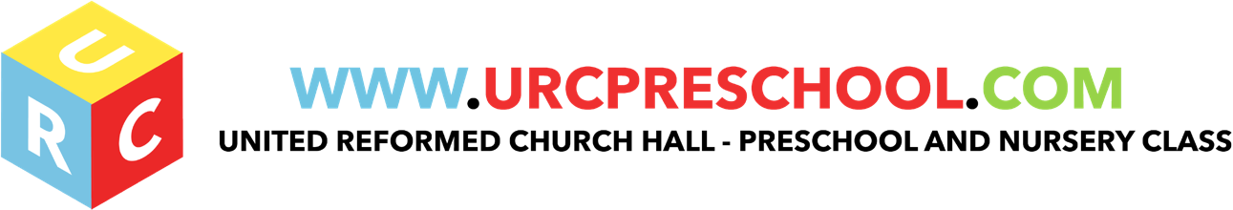

Employment Policy

The URC Pre-School will endeavour to appoint the best person for each job without bias on the grounds of age, gender, religion, sexuality, class, family status, means, ethnic origin, culture or belief.
Posts are advertised and all applicants are judged against explicit and fair criteria.
Applicants are welcome from all backgrounds and posts are open to all.
The applicant who best meets the criteria is offered the post, subject to references and checks by the Criminal Records Bureau. This ensures fairness in the selection process.
All job descriptions include a commitment to promoting equality and recognising and respecting diversity as part of their specifications.

Families

The URC Pre-School recognises that many different types of families successfully love and care for their children.

Valuing diversity in families

- We welcome the diversity of family lifestyles and work with all families.
- We encourage children to contribute stories of their everyday life to the setting.
- We encourage mothers, fathers and other carers to take part in the life of the setting and to contribute fully.
- For families who speak languages in addition to English, we will develop means to ensure their full inclusion.
- The Pre-School offers a flexible payment system for families with differing means.

The Curriculum

All children will be respected and their individuality and potential recognised, valued and nurtured. Activities and the use of play equipment offer children opportunities to develop in an environment free from prejudice and discrimination. Opportunities will be given to children to explore, acknowledge and value similarities and differences between themselves and others.
The curriculum offered in the setting encourages children to develop positive attitudes about themselves as well as to people who are different from themselves. It encourages children to empathise with others and to begin to develop the skills of critical thinking.

Our environment is as accessible as possible for all visitors and service users. If access to the settings is found to treat disabled children or adults less favourably then we make reasonable adjustments to accommodate the needs of disabled children and adults. We do this by:

- making children feel valued and good about themselves and others
- ensuring that children have equality of access to learning
- undertaking an access audit to establish if the setting is accessible to all children
- making adjustments to the environment and resources to accommodate a wide range of learning, physical and sensory impairments
- making appropriate provision within the curriculum to ensure each child receives the widest possible opportunity to develop their skills and abilities, e.g. recognising the different learning styles of girls and boys
- positively reflecting the widest possible range of communities in the choice of resources
- avoiding stereotypes or derogatory images in the selection of books or other visual materials
- celebrating a wide range of festivals
- differentiating the curriculum to meet children’s special educational needs
- helping children to understand that discriminatory behaviour and remarks are hurtful and unacceptable
- ensuring that the curriculum offered is inclusive of children with special educational needs and children with disabilities
- ensuring that children learning English as an additional language have full access to the curriculum and are supported in their learning; and ensuring that children speaking languages other than English are supported in the maintenance and development of their home languages

EYFS key themes and commitments

A Unique Child | Positive Relationships | Enabling Environments | Learning and Development
1.3 Keeping safe | 2.4 Key person | 3.4 The wider context

Last Reviewed: May 2019

