Wisconsin Adult Center
  - July 2017 262-695-9472 1275 E. Wisconsin Ave. Units A&B Pewaukee WI, 53072
JUly Birthdays
RT- July 5
MK- July 14
DS- July 24
RV- July 28

REMINDER:
The Wisconsin Adult Center will be closed on July 4th in honor of our nations independence. Enjoy the day!
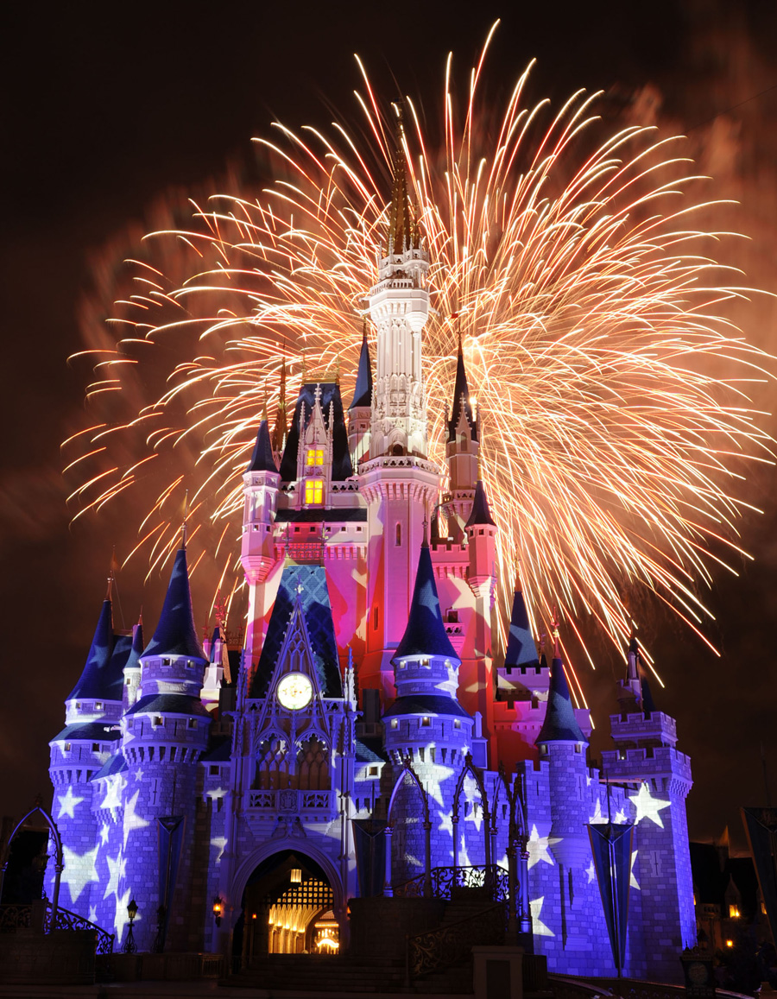
Happy Independence Day!!

Fun Times!
You know what they say- time flies when you’re having fun -that’s exactly how we feel at The Wisconsin Adult Center. We cannot believe June has passed us by already! We kept ourselves busy with plenty of creative craft projects, trips to fun places, and ended the month with a yummy ice cream social!
Try to be a rainbow in someone’s cloud. ~Maya Angelou~

New and Old Favorites
The members at WAC enjoy many outings and activities at the center. Living Melodies provides music therapy every week. The sessions include a sensory group and also a jam band. This has been a long time favorite of our members. Donna Lexa Community Art Center comes once a month and provides 2 sessions of art therapy for our members. We love seeing their creativity in action! One of the new favorites is once a month manicures at Paul Mitchell in Waukesha. Three members a month get a discouted rate and a little pampering. Such a treat! We will continue to look for new and exciting opprotunities for the gang. We are always open to suggestions.

JUly will be hopping!!
We have a lot in store for July! From Mondays at the movies, to our Friday community walks, we plan to keep busy. We will be learning about different country’s through ‘arm chair vacations’, celebrating National French Fry Day (yes, that’s a thing!), with fries from Five Guys, doing some cool science experiments and art and crafts projects, and finishing the month with a center cookout. We are getting the most out of July!

Until next month!
Enjoy your summer!
Lindsey, Chrissy, Tina, Rita, Kristi and Karlie

