The Color Golden
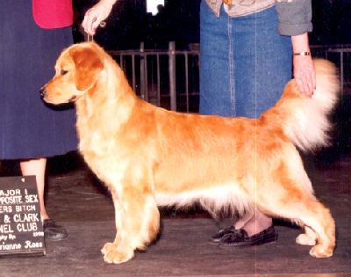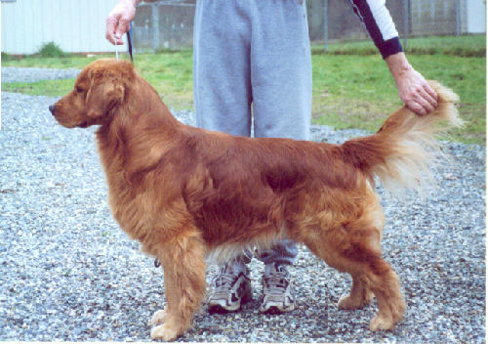
I wish I had a dollar for every prospective puppy person who begins our first conversation by saying, "I'm looking for a red puppy..." or "I'm looking for a white puppy." Not only would I be rich, I could hire someone to recite my philosophy on what the "gold" in "Golden Retriever" actually means...which isn't very much when you're searching for a good dog. Not very much at all.
Of course, it's really not the puppy person's fault. A breed named for its color will automatically make people think that the color is more important than anything else. Let's see what the Golden Retriever standard, as defined by the Golden Retriever Club of America and approved by the American Kennel Club, has to say about color:
"Color -- rich, lustrous golden of various shades. Feathering may be lighter than rest of coat. With the exception of graying or whitening of face or body due to age, any white marking, other than a few white hairs on the chest, should be penalized according to its extent. Allowable light shadings are not to be confused with white markings. Predominant body color which is either extremely pale or extremely dark is undesirable. Some latitude should be given to the light puppy whose coloring shows promise of deepening with maturity. Any noticeable area of black or other off-color hair is a serious fault."
As you can see, the approved Standard for coat color gives a lot of room for shades of gold. In fact, the only things that are discouraged are extremely pale and extremely dark. Unfortunately, shades of gold aren't black and white, and what some people consider "extremely pale" or "extremely dark" really are not...in fact, not even close. I've chosen a few pictures to illustrate my point.
Some people in the Golden world would consider this dog white:
And she is, for all intents and purposes, a very light-colored puppy when compared to a darker Golden:
However, when you compare her to a dog that is really white...
...it becomes obvious that she is not white at all. Her coloring is of a significantly warmer hue, with lovely gold undertones. She is well within the range of acceptable Golden shades.
Conversely, some people would classify this dog as Red, comparing it to an Irish Setter in color.
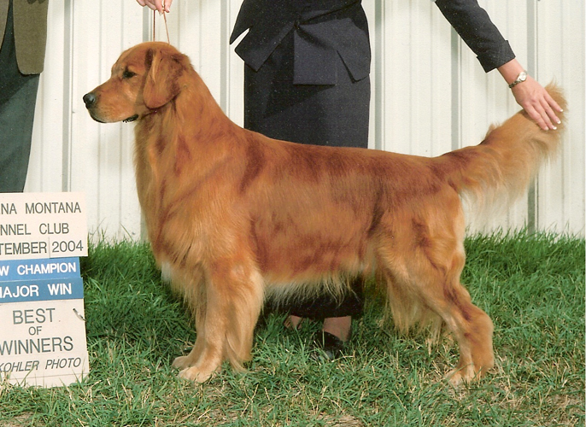
Not surprisingly, if you compare it to a dog with light coloration it does appear to be quite dark:
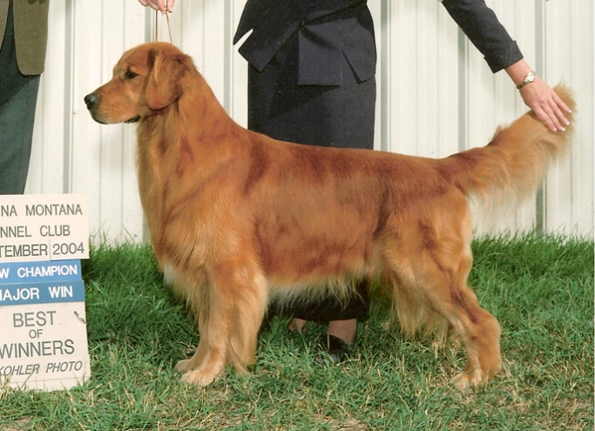
However, if you compare him to an Irish Setter, the contrast is even more striking:
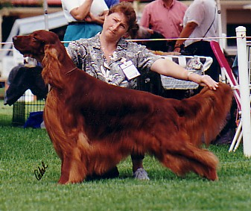
The Golden Retriever is a much lighter color, and does not have a "predominant body color" that is very dark, as this beautiful Irish Setter does. His whole coat has an underlying variation of golden tones, certainly within the parameters of the Golden Retriever Standard.
So lighten up (or darken down!), y'all! Each beautiful shade should bring a different smile to your face. They all bring happiness to my heart.
** attention: bold, centered, don't-miss-this text **
If anyone tries to sell you a bill of goods suggesting that "rare white Goldens" or "British creams" are worth $2000 or more because of their color, RUN don't walk to another breeder. This person is trying to capitalize on a current fad, and is NOT telling you the truth.
RUN AWAYYYYYYYYYYYYYYYYY!

Back to the Prospective Puppy Parent...
It's completely normal to have a preference, of course. My favorite shade is what I think of as wedding band gold:
However Summer (pictured above) is the only dog I've ever owned that had this color, and I've owned quite a few Goldens over the years. The reason she is the only one is that I know that color has so little bearing on the quality of the dog. Color is definitely NOT the reason to pick a puppy, whether you are looking for a Best in Show dog or a Best Friend. And it certainly isn't the first bullet point you choose when speaking with breeders.
I strongly suggest that people looking for a new family friend establish a list of criteria for themselves to help determine whether a particular puppy is right for them. The list will no doubt vary from person-to-person, but should be considered in order of importance. Such a list might look like this (only an example of the possibilities; not a blueprint or recommendation):
REQUIREMENTS FOR MY NEW PUPPY
1. Ethical breeder, with ties to national and local dog clubs that have a Code of Ethics.
2. Sound temperament, parents with sound temperaments.
3. Healthy parents, including appropriate clearances and information on longevity.
4. Special qualities (activity level, ability to compete in a specific area, etc.)
5. Early stimulation, training and socialization by breeder.
6. Gender
7. Size
8. Color
9. etc.
Each one of these items could have 10 sub-items, and there are other considerations as well, but you get the idea. Color should be so far down the list that it is one of the last things you consider -- perhaps when trying to choose between two puppies -- certainly not the first.
The next phone call I get from a potential puppy parent that begins with, "Hi. I'm looking for a conscientious breeder who is sincerely interested in breeding the best dogs they can," I will fall to my knees in thanks. It could happen! It really could! I happily await the day.
~ Deborah Blair-Muzzin
February 2007
Note: Every dog on this page, with the exception of the Irish Setter, was either bred and/or owned by me. I really do like all the colors of the rainbow.

