"I Only Want A Pet..."
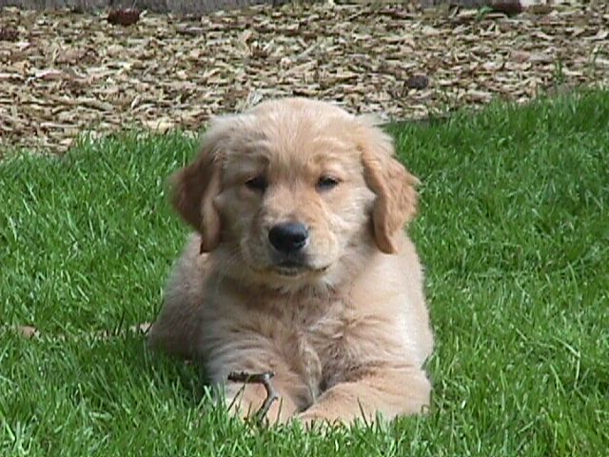
One of the more common e-mail or phone messages that I receive from people includes the sentiment, "I know you breed show dogs, and maybe you won't even talk to someone like me, but we're looking for a Golden Retriever, not to show. We only want a pet...."
I have wondered for awhile why people do that, and I started asking questions to find out. Here are some of the things I've discovered.
Concern Over Price
Many prospective puppy owners who want a well-bred, attractive Golden think that breeders charge more for puppies that are going to be shown and bred. I guess that might still be true for some breeders, but I personally quit charging a different price over 10 years ago, and the reasoning is simple. I want all of my puppies to be pets...whether they are shown or not. That basic premise means that each puppy is just as valuable as the next. Occasionally I will ask either for a puppy back (if the bitch gets all of her clearances, becomes a champion, etc.) or for one stud service (same requirements for a dog) from a show prospect puppy, but actually to this date I have never actually asked or received either. All puppies are worth the same price and hopefully are treasured equally. It's just that simple.
Concern Over Quality
Another question I've heard quite a bit is, "What's the difference between show quality and pet quality?" Now I am sure each breeder will answer that question very differently, but my honest answer is: "Not much."
I once heard a field trial guy say that if you want a great dog, you should examine the father and mother of the litter you are interested in, make sure they are everything you would want to take home in as many ways as possible -- the look, the temperament, the birdiness, the soundness -- and then take a quick look at the puppies, close your eyes and reach in and grab one. I love the idea of that, even though I know that in conformation you can't really do that. Nevertheless, for someone wanting a really nice pet puppy, that just might work as well as any other way of picking a new pup.
We show people are a nit-picking obsessive bunch. You would not believe what we go through to choose a puppy for the ring. Suffice it to say that there is not one inch of a puppy that is not scrutinized. We look at the nose color, the eye shape, the ear set, the thickness of the ear leather, the coat, length of neck, post-sternum, shoulder layback, bone, body depth, topline, length of loin, tail placement, rear angles, hocks, feet, pigment, attitude, movement...and that's not all. Now most people probably can't even read that list and get through it, but we conformation nuts look at a puppy five times a day, examining each little bit of a puppy. It's really pretty crazy.
So when I get to the point where I'm choosing one puppy over another, it is the sum of each of those items PLUS it's something I can only define as the whole picture. No puppy is perfect. Yet we try incessantly to find the very closest puppy to perfection that we can -- all the while knowing that the puppy is a potential step in a breeding program. You'll often hear me say, "One man's pick is another man's throw-away." That's because no breeder is at the same stage in the development of their lines, and no breeder needs the same thing from a potential show/breeding prospect.
This is all a long-winded way of saying that the puppy you get -- even if it wasn't 1st, 2nd or 3rd show pick, is probably going to be a beautiful example of the breed. In fact, it's a good bet that your puppy will end up being the most beautiful and intelligent dog in the world. Of course it will. It's your dog.
Concern Over My Attitude
People seem to think that since I breed Golden Retrievers that have become champions, show dog hall of fame dogs, etc., that this is where the value lies in my puppies. Let me state this very clearly.
Although I show dogs, and I take huge pleasure and pride that I breed dogs worthy of awards, that really isn't where the joy comes from in breeding a litter of puppies. The first enjoyment comes in watching a mother dog that I love give birth and become a warm, nurturing caretaker of her kids. Then there is tremendous happiness watching those babies grow, taking their first steps, starting to bark and wag their tails, exploring, expanding their horizons. And then the puppy party, with all the prospective puppy parents coming to meet the babies and the mom. Watching the delight on the kids' and adults' faces as they take home the best puppy in the world. Seeing how a puppy can fill a void in someone's life, or give them something extra to love. Then there's Christmas! Getting all the photos of the dogs in Santa hats. Or summer! With pictures of the water and boats and hikes and birthday parties. This, and this alone, this pure joy in feeling like you added value to another person's life -- this is the most amazing feeling that I've ever had (except having my own kids). It is just the best.
I think many breeders feel the same way that I do. Breeding good dogs is difficult, expensive, heartbreaking, physically taxing, and is a commitment to the puppies you bring into the world for life. The reason you keep doing it is because of the love for the dogs themselves and this sense that you did something good for the world by placing the puppies in loving, wonderful homes. Really, for me, that's what it is all about.
So when someone calls me and says, "I don't know if you ever sell puppies to people who don't want to show...I only want a pet," my answer is hurray! Every one of my puppies is a pet, if I'm lucky. Every one is the prettiest, smartest, coolest, most amazing dog ever. That's what it's all about.
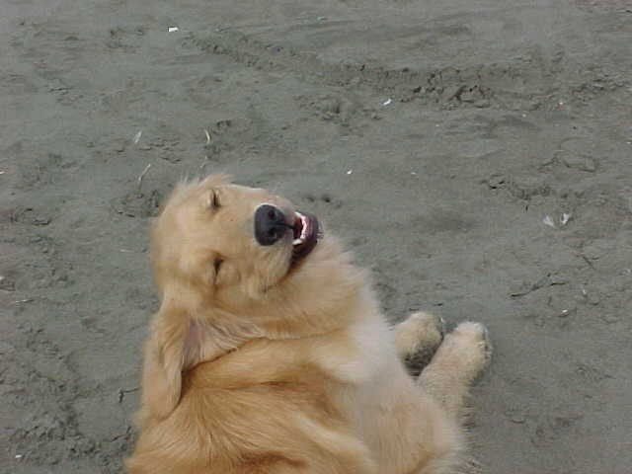
Deborah Blair

