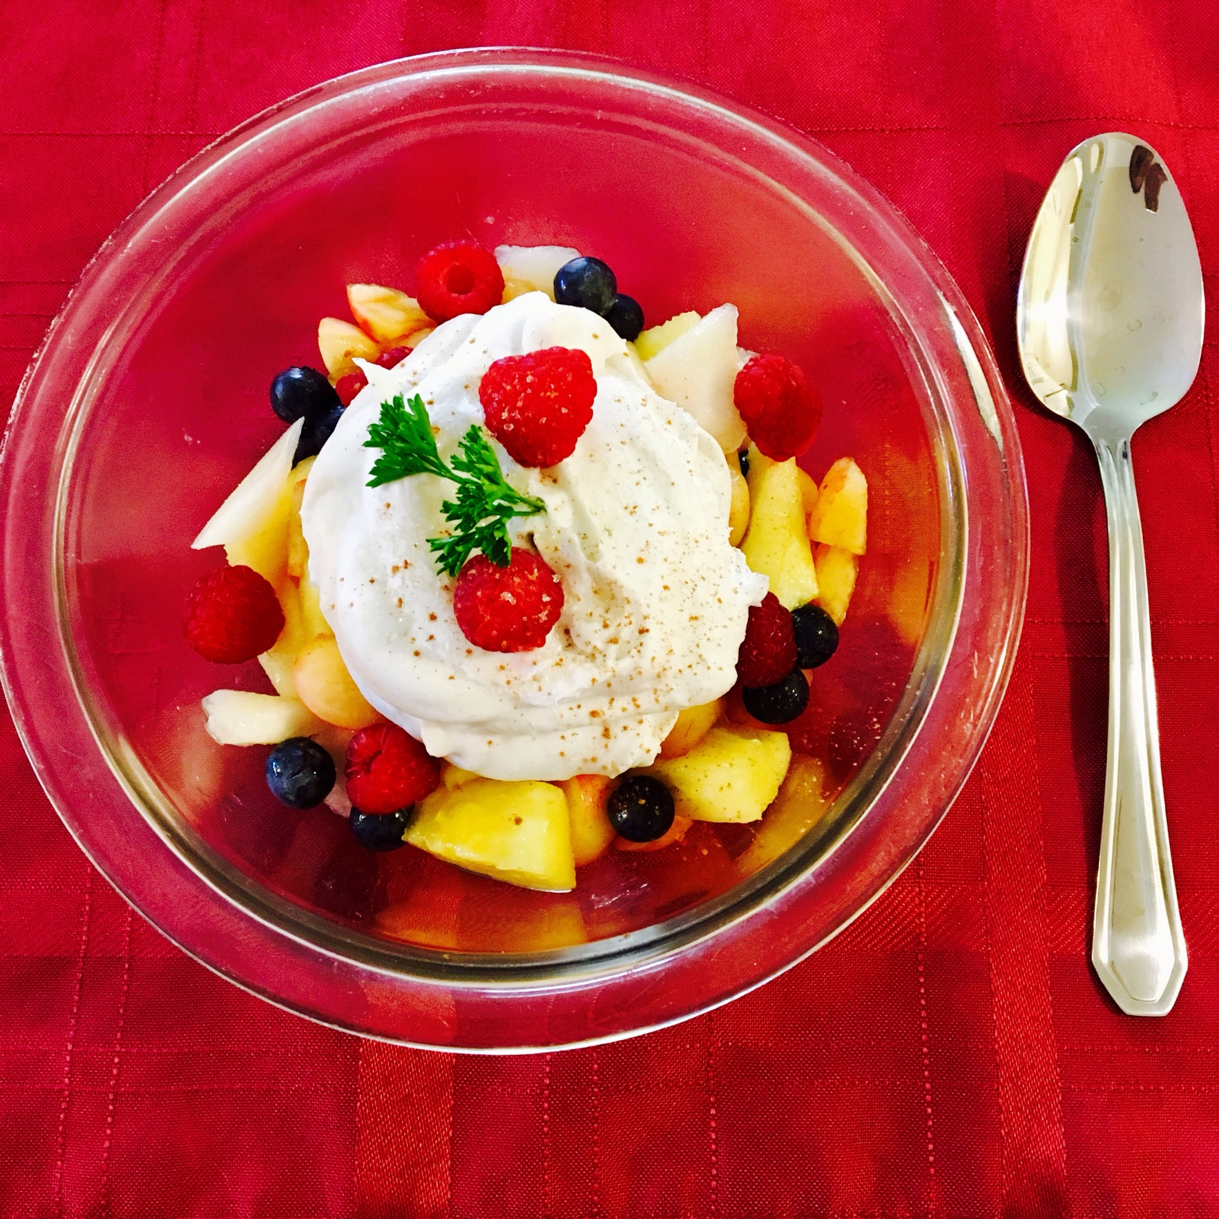
Summa Fruit Salad with Coconut Cream Whipped Topping
3 servings

Ingredients
15 Rainier Cherries
1 Fresh Peach skinned (optional) and cut into small pieces
1 Fresh Nectarine skinned (optional) and cut into small pieces
½ Cup of fresh cut pineapple chunks
A handful of fresh blueberries
A handful of fresh raspberries
1 Cup of coconut cream that’s been in the refrigerator in the can for at least 24 hours.
2 Tbsp. Organic Cane Sugar
1 tsp. Pure Vanilla Extract

Directions
Before you start, place your mixing bowl for the coconut cream whipped topping in the freezer along with the hand mixer attachment so they can be nice and cold. Keep the cream in the refrigerator until you are ready to mix it. While they are chilling, place your cut up fruit along with the blueberries into your serving bowl and give them a good mix. Place a couple of raspberries on top and set aside. Take out your bowl with the attachment and the cream. Place the attachment in your mixer, and place your cup of coconut cream into the chilled bowl. Beat on medium for about 4-5 minutes. Add the 2 Tbsp. of sugar and the extract and mix for about a minute or two more. The sugar granules will gradually dissolve. Using confectioner’s sugar will offer easier blending as far as the mixing goes, but the organic cane sugar offers a delectable taste. Take out 3 small bowls or one medium bowl and put your fruit in it. Spoon the whipped topping over the fruit. Place the remaining raspberries on top and sprinkle with cinnamon if desired and a pinch of the sugar. You can also add a piece of mint or parsley to top it all off. This salad is so easy offers a cool and refreshing taste that’s so welcoming in the the summer heat. Enjoy!

