Coconut chia blueberry smoothie
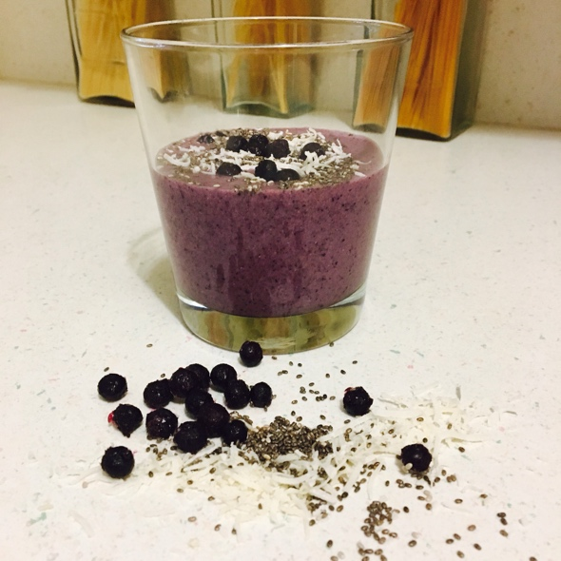
SHOPPING LIST
1 can full fat coconut milk
Frozen blueberries
Chia seeds
Fresh or frozen pineapple
Raw honey
Walnuts(optional)
Lemon (fresh)
Superfood green powder(optional but good to have)
Cinnamon powder
Ginger powder

Ingredients
1 can of full fat coconut(using just the cream, but reserve the liquid)
1 cup frozen blueberries
1-2 Tbsp. Chia seeds depending on your desired consistency. I like mine thick
1 scoop superfood green powder(optional, but will give you a boost)
½ tsp cinnamon powder
½ tsp ginger powder
1 Tbsp walnuts(optional)
1 Tbsp raw honey
Place all of your ingredients into a blender and set setting for smoothie. Place top on(I know it's a given but sometimes we're in a hurry), and blend for about 30 seconds to a minute. Add a Tbsp at a time of coconut water liquid that you reserved if it is too thick. Pour into glasses and enjoy.
It makes about 3 8oz. Servings

