Muswellbrook Preschool Kindergarten Inc. - Sowerby Street.

ABN: 516 770 731
“Learning to play: Playing to learn”

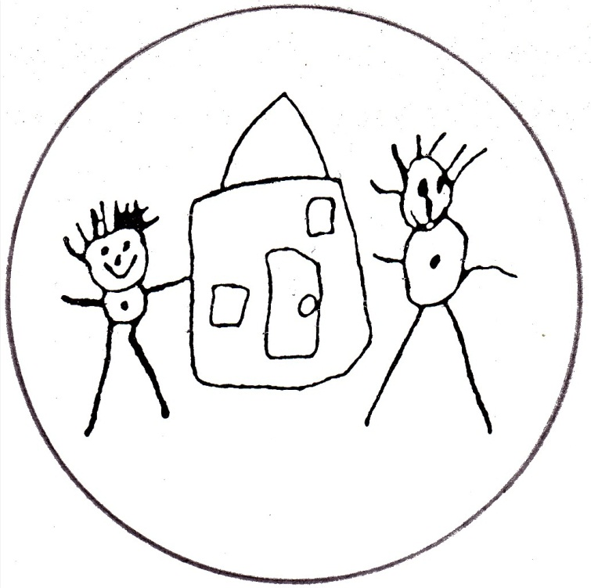

CODE OF CONDUCT

Our Code of Conduct establishes a standard of behaviour to be followed by everyone who has any involvement with Muswellbrook Pre School Kindergarten. This Code of Conduct defines how individuals should behave towards each other, towards the children in their care and towards individuals and other organisations in the community.

The Committee and Nominated Supervisor have a duty of care to the children attending the service and must ensure “that every reasonable precaution is taken to protect children being educated and cared for by the service from harm and from any hazard likely to cause injury” (National Law: Section 167).

The National Quality Standard requires that “educators, coordinators and staff interactions are respectful and ethical” and that “professional standards guide practice, interactions and relationships” (National Quality Standard: 4.2 and 4.2.1).
Employers also have a legal responsibility to provide, as far as is practicable, a safe workplace that is free from discrimination, bullying and harassment.

Muswellbrook Pre School Kindergartens community will work together in the best interests of the children and families and will act in a manner that will enhance the standing of the early childhood sector. This involves a full understanding of the role, responsibilities and obligations combined with community involvement and collaborative decision making.

Muswellbrook Pre School Kindergarten Policies and Procedures

The Pre-school has policies and procedures in place as required by the Education and Care Service National Regulations (Part 4.7 Division 2) and compliance with these policies and procedures is a requirement. Copies of these are available for both staff and parents at the Preschool.

Interactions with Children

- All interactions with children will be respectful giving the children a positive self-image. They must allow for children to develop an understanding of self and others, experiment with social skills and enhance intellectual growth.

- All children will be treated with respect and consideration. All children should have the opportunity to participate in all activities provided.

- Respect for childrens ethnicity and cultural differences will be maintained at all times.

- Children will be guided towards positive and responsible behaviour. The dignity and rights of each child will be maintained at all times.

- Child management techniques will not include physical, verbal or emotional punishment, including punishment that humiliates, frightens or threatens the child.

- Children will not be isolated for any reason other than illness or accident.

- Children will be given emotional support at all times and will be provided with support in learning experiences.

- It is not acceptable for anyone to touch children inappropriately or unwarrantedly. Conversations that are of a sexual nature, sexual behaviour involving obscene gestures and providing sexual publications, are considered reportable behaviours to the NSW Ombudsman.

Staff, volunteers and families
- Adults will conduct themselves in a professional manner in their relationships with children and their families, including no overstepping the boundaries into personal contacts outside school, unless the child is already known to them in another capacity.

- The safety and welfare of the children in our Pre School is paramount

- To arrive at the Pre School on time, comply by our dress code and participate in an induction process

- To be familiar with our policies and procedures and ensure they are followed.

- To have looked over our allergies and care plan folder so you are aware of those children who you may need to be sensitive to.

- Respect other colleagues and actively support them.

- Be polite and well-mannered and have regard to all those who access the Pre School

- Fulfil your responsibilities and duties to the children to the best of your ability.

- Be attentive in work health and safety matters and reporting any issues to Pre School management.

- Staff are permitted to hold and comfort a child by picking the child up being aware of manual handling and work health and safety.

- Staff are permitted to have a child in their laps for comfort, security and reassurance however not when the staff member is in a leadership role for the group of children (ie storytime)

- Everyone will respect personal space of our parents and other staff members.

Staff and Committee Responsibilities

All staff will aim to provide a high quality Early Childhood programme, which meets the needs of all children within our care and promotes their physical, social, emotional and language development. Staff members should be aware of the individual needs of the children in their care at all times. It is important that Muswellbrook Pre School Kindergarten establish a common understanding of the standards of behaviour expected of all employees and elected Committee, if there is any aspect of the responsibilities below that is unclear it is the employee or Committee members responsibility to obtain clarification.

Convictions
You must advise the President or the Authorised Supervisor of any convictions that have occurred after your initial employment screen has been undertaken.

Gifts

In general you must not accept gifts and benefits from anyone that have more than a nominal or token value. Any gift received over the value space of $30 must be disclosed to the Nominated Supervisor and the circumstances under which the gift was received or given. An example of this may be when each parent in a classroom contributes $5.00 towards a gift voucher for a staff member who is leaving and this would make the value $100 which is over our $30 gift limit.

You must never accept an offer of money, regardless of the amount.

Gifts given to a child enrolled at the Pre-school must not be given on an individual basis except when each child in the class receives a similar gift for the same purpose. Gifts cannot be given to an individual child where the intention is to gain advantage.

Harassment and discrimination
You must not harass, discriminate against, or support others who harass and discriminate against children, committee, colleagues or members of the public. This includes, but is not limited to harassment and discrimination. These can be on the grounds of gender, pregnancy, age, race (including nationality, ethnicity or religious background), political affiliation, marital status, disability, sexual orientation or transgender status.

Neglect

The neglect of any child in your care is reportable conduct to the NSW Ombudsman and may warrant instant dismissal.

An example of neglect that might be considered harmful: an employee failing to uphold their “duty of care” to attend to a child’s basic physical and emotional necessities such as not allowing the child to have access to food, appropriate clothing or medical attention.

W.H. & S
Work Health & Safety is the responsibility of everyone at Muswellbrook Pre-school. Identified minor risks need to be recorded through our safety management systems or if of a more serious nature must be immediately reported to the Nominated Supervisor.

Physical contact

In the course of your employment it is appropriate to comfort a child that is distressed by placing them on your knee and speaking calmly and positively. Staff need to be at all times able to be viewed by another staff member. It is not appropriate for example for a staff member to comfort a child within the outdoor shed or any secluded area of the Pre-school.

Reporting breaches of Code of Conduct
You should report any suspected breach of the Pre-school’s Code of Conduct to the Nominated Supervisor or the President of the Committee, preferably in writing. This must be done with reference to the Complaints Policy.

Unacceptable Behaviour

The following behaviours by children, staff, families and others involved in Muswellbrook Pre School Kindergarten are unacceptable and may result in employment being terminated or enrolment at Preschool declined:

- All forms of bullying (physical, verbal, emotional, social or cyber bullying), including comments, actions or visual displays that are intentional, hurtful and repetitive

- Harassment, including behavior that degrades, demeans, humiliates or embarrasses someone that a reasonable person would know is unwelcome

- All forms of abuse (sexual, physical or psychological), including verbally, in writing or otherwise

- Discrimination against any person or group because of their race, colour, ancestry, nationality or place of origin, ethnic background, religion, age, sex, gender-determined characteristics, sexual orientation, marital and family status, source of income, political belief and physical or mental disability.

- Actions that put another person at risk of harm, including violent physical acts (with or without a weapon) and threatening someone.

Reviewed on 18 July 2013

Approved by the Management Committee on ________________________

Name ___________________________ Name ____________________
Signature ________________________ Signature __________________

Due for review July 2015

