June 2017
Welcome to the June Newsletter!
With the cooler weather now upon us, please remember to pack your child a warm jumper/jacket for outside play, a complete change of warm clothes, slippers for inside if you wish and please make sure everything is labelled!
Term 2 concludes on Friday 30th June and Term 3 will commence on Monday 17th July.
Have you seen our new website? Early this term we launched a new site and hope that you are able to easily navigate your way around it and remind you to keep an eye on it for updates. We also have our face book page which we hope provides you with some interesting reading from time to time. If you have any suggestions for our website or face book page we would love to hear from you.
This Term We Celebrate with
ruth serhan
Ruth is retiring after 23 years with muswellbrook preschool!!!
Ruth started her journey with the Pre School as a Mum, then committee member and progressed onto become a dedicated and loving Educator. Ruth has been on Long Service Leave this term however, we would love to celebrate with Ruth and all our families on a day to be confirmed in Term 3 (keep an eye out for an invitation).
Thank you - thank you - thank you
We raised over $2200 with the recent Pie Drive! Thank you to everyone who ordered and a very special thanks to the lovely ladies who arrived very early to pack the orders!!!
Did You Know???
Late collection fees apply to all families who pick up their children after 3pm and/or 4pm. Current late fees are $5 for the first 5 minutes and $1 per minute after that. If you are late collecting your child, you will be asked to sign a late collection slip and the fees will be added to your account.
Preschool Chatter

Would you like a stall at our upcoming Fete???

Friday 20th October we will be holding a Fete from 5-8pm here at Pre School. All classes will be having a stall which you will be invited to help out with but if you have your own business, hobby, creations etc or know someone who does, we would love to have you attend the fete too!
Stalls will be $25 each and stall holders will also be asked to donate a small item to the raffle on the night.
If you or someone you know is keen, please pop into the office to register your interest.
Keep an eye out for more information as the fete gets closer!

~~~~~~~~~~~~~~~~~~~~~~~~~~~~~~~~~~~~~~~~~~~~~~~~~~~~~~~~~
Book Fair – Term 3…
Monday 7th August to Friday 11th August we will be hosting a Book Fair. All classes will send out invitations early next term to a book week parade – start thinking about a costume!
Fundamental Movement Skills
Fundamental movement skills are the building blocks for the more complex skills that children need to play active games and sports at school or in the community.
You can help by giving your child/ren fun opportunities to learn and practice skills, such as:
* running and jumping * hopping and skipping * dodging and leaping
* side-galloping * catching * balancing
* kicking * overarm throwing * striking a ball with a bat

Pizza scrolls
These pizza scrolls are perfect for kids who are bored of sandwiches. They're a lot cheaper than the bakery versions too!
prep: 0:15 | cook 0:25
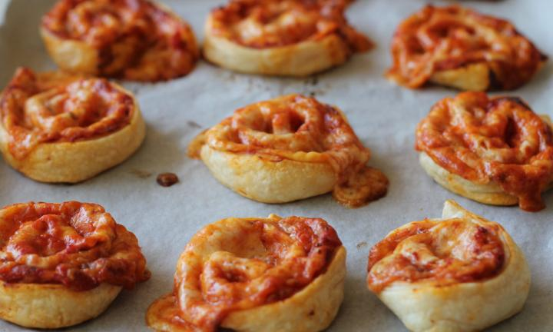
Ingredients
- 2 cups Greek-style yoghurt
- 2 cups self-raising flour
- 1 cup Italian tomato cooking sauce
- 3 cups mozzarella cheese, grated
- 100g bacon, diced
- 1 tbsp. Italian herbs and spices blend
Method
- Preheat oven to 190°C. Line a baking tray with baking paper and set aside.
- In a large bowl, combine the yoghurt and self-raising flour and mix until a ball forms. Turn out onto a floured bench and knead for 5 minutes. Add extra flour if the dough is too sticky.
- Roll the dough into a large rectangle of even thickness using a rolling pin.
- Spread tomato sauce evenly over the entire dough surface.
- Sprinkle bacon and 2 cups of cheese all over the tomato sauce.
- Shake over the Italian herbs.
- Roll the dough into a log, starting at the short side. Slice into 2cm pieces and place cut side up on tray.
- Sprinkle with remaining cheese.
- Bake for 20-25 mins until golden.
Ham and cheese pasta salad
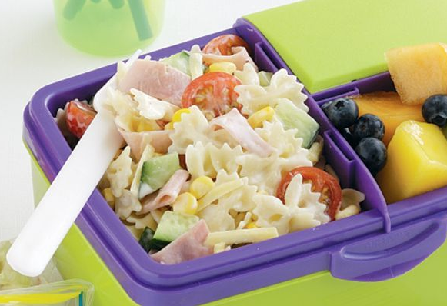
Ingredients
- 200g mini farfalle pasta
- 1 x 310g can corn kernels, drained
- 1 x 250g punnet cherry tomatoes, halved
- 150g ham slices, coarsely chopped
- 80g (1 cup) grated cheddar
- 1 Lebanese cucumber, coarsely chopped
- 125ml (1/2 cup) caesar salad dressing

Method
- Step 1 - Cook the pasta in a saucepan of salted boiling water following packet directions or until al dente. Drain.
- Step 2 - Combine the pasta, corn, tomato, ham, cheddar and cucumber in a large bowl. Add the dressing and toss until well combined. Store in an airtight container.

Did you know Upper Hunter Community Services Inc. (UHCS) run Parenting Programs?
Check out the Upper Hunter Family Support Services webpage page and like their Facebook page to find out about upcoming sessions and other exciting community events.
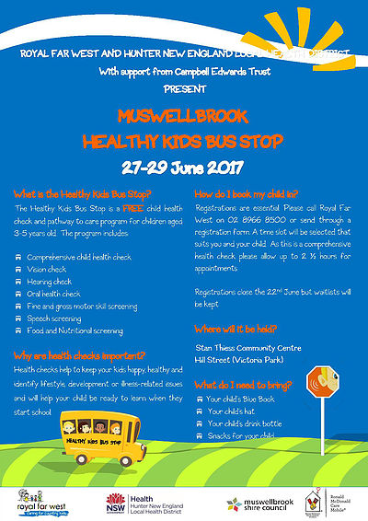
Have You Registered????

