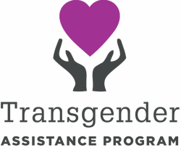

Transgender Assistance Program of Virginia
Volunteer Application

Whether you are transgender or one of our allies, please know we appreciate your involvement and support! Please know all responses remain confidential to TAP Virginia and will not be shared or made public.

Name:
Preferred pronouns:
Email:
Phone number:
Location:

What is the best way to reach you? Email / Call / Text

When are you available?
Weekends only Weekdays only Weekends & some weekdays It depends

Are you interested in staffing a table or working events? Yes / No
Are you interested in helping recruit like-minded volunteers? Yes / No
All volunteers must consent to training before beginning. Do you consent? Yes / No

Everybody's got skills! Do you have non-profit experience or a particular field of interest we should know about? Examples: marketing, fundraising, public outreach, tabling events, organizing groups, I'm good with talking to people, I like social media, etc.

