No-Bake Chocolate Cherry Oat Bars Recipe
By Gretchen F. Brown, RD

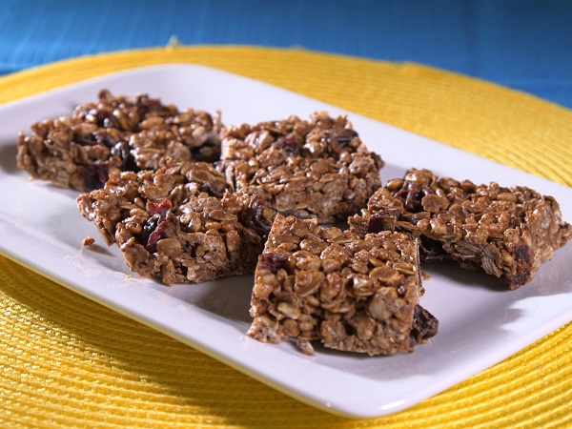

Both crispy and chewy, these bars make a great dessert for little ones. Plus, they are full of whole grains.

Ingredients
2 cups rolled oats
1½ cups rice cereal
½ teaspoon salt
½ cup peanut butter
4 ounces chopped 60-percent cacao bittersweet chocolate, or ¾ cup chocolate chips
¼ cup coconut oil
¼ cup honey
1 cup (about 5 ounces) dried cherries

Directions
- Line a 13-by-9-inch baking pan with parchment paper, leaving a bit of paper to hang over the sides.
- Combine oats, rice cereal and salt in a large bowl.
- Melt together peanut butter, chocolate chips, coconut oil and honey in a saucepan over medium heat, stirring frequently.
- Pour wet mixture over oat mixture. Stir to combine.
- Stir in dried cherries.
- Pour mixture into prepared pan. Press to evenly cover the bottom of the pan.
- Chill for at least 3 hours. Remove from pan using overhang of paper as handles. Cut into 28 bars. Store in the refrigerator.

Cooking Note
- Substitute gluten-free rolled oats and rice cereal, if needed.

Nutrition Information
Serving size: 1 bar
Serves 28
Calories: 141; Total fat: 7g; Saturated fat: 3g; Cholesterol: 0mg; Sodium: 70mg; Carbohydrates: 19g; Fiber: 2g; Sugars: 9g; Protein: 3g; Potassium: 112mg; Phosphorus: 83mg

