Garden Chicken Wrap

Note: Try carrot or celery sticks on the side!
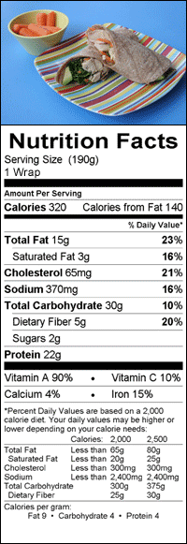
Prep time: 5-10 minutes
What you need:
- 4 whole-wheat wraps (8 inches)
- 2 cups store-bought rotisserie chicken, shredded
- ½ cup shredded carrots
- 1 avocado, thinly sliced
- 1 cup baby spinach leaves
- ¼ cup of your favorite fat-free/low-fat dressing (about 1 tablespoon per wrap)
Equipment and supplies:
- Cutting board
- Sharp knife
- Measuring cups
What to do:
- Place wraps side by side on a flat surface. Divide chicken into four portions (about ½ cup each). Place a portion of chicken on each wrap.
- Top each wrap with carrots, avocado, and spinach. (Have an adult help with the chopping.)
- Drizzle dressing evenly over each wrap.
- Roll each wrap up tightly and cut on the diagonal.
- Serve immediately or wrap tightly in aluminum foil and refrigerate for lunch the next day.
How much does this recipe make?
- 4 wraps
Reviewed by: Mary L. Gavin, MD
Date reviewed: November 2015

