EAST CEDAR GROVE MISSIONARY BAPTIST ASSOCIATION
OF NORTH CAROLINA, INC.

2017 CALENDAR OF EVENTS

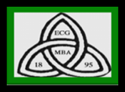
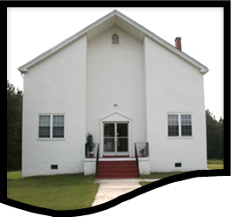

Moderator, Rev. J. Eric Morgan, III, 2013 - 2017
Smith-Thomas Convention Center
2174 Brassfield Road
Creedmoor, North Carolina 27509
eastcedargrove-mba.org
“Using all the Parts to Make the Whole” Eph. 4:11-16
Origin

“On Aug. 10, 1895 at Ledge Rock Baptist Church in Wake County, where Rev. A. B. Wyche was pastor, a resolution was passed in the Cedar Grove Association dividing the Cedar Grove Association into two separate Associations, with the Lynchburg and Durham Railroad as the dividing line” … thus the East Cedar Grove Missionary Baptist Association was born. The mission of East Cedar Grove is “to teach Christianity based on the Holy Bible; preach inspirational sermons for living; encourage wholesome family values; provide leadership training for members and support local and foreign mission.” The goals and objectives of The Association are: to provide the arena and the instrumentality for member churches and auxiliaries to work corporately and cooperatively around the following concerns:1) spiritual fellowship; 2) responding to the needs of members and member churches; 3)religious education in member churches; 4) assistance to persons in member churches who are attempting to peruse Higher Education; 5) concerted action to enhance the quality of life and opportunity for persons in our communities; 6) maintenance and wise use of the Association’s properties and resources; 7) providing Christian and sympathetic assistance and counsel to churches which may seek the same from the Association and 8) to support affiliates that include the General Baptist Convention of NC, the National Baptist Convention, U.S.A. and the Lott Carey Convention. Member churches are to uphold and teach Baptist doctrine, forms of worship and polity. The motto of the Association is “Using all the Parts to Make the Whole.”

The Executive Board 2013-2017
Reverend J. Eric Morgan, III, Moderator
Reverend James Isaac, III, First Vice Moderator
Reverend Ronald Booker, Second Vice Moderator
Deacon Johnny Pettiford, Recording Secretary
Sister Lois Gooch, Corresponding Secretary
Sister Linda Thomas Bradsher, Treasurer
Sister Sharon A. Vincent, Financial Secretary
Reverend Dr. William Richardson, Executive Board Chairman
Reverend Dr. Harold Trice, Vice-Chair Ex. Board
Reverend Shelton Harris, Chair, Trustee Board
Rev. George Crews, III, Pres., Ministers, Deacons & Deaconess Union
Deacon Ronnie Robinson, Chair, Usher’s Department
Deaconess Sarah Johnson, Pres. Woman’s Auxiliary
Reverend Shelton Harris, Pres. Congress of Christian Education
Deacon William Pointer, Chair, Laymen’s League
Reverend Robert Daniels, Chair, Bldg. Committee
Reverend Joyce McDowell Reid, Director of Christian Education
Reverend Joyce D. Clayton, Chair, Advisory Council
~~~~~~~~~~~~~
Note: Rev. J. R. Satterfield, First Elected ECGMBA Moderator, 1895 -1898
Rev. J. Eric Morgan, III, First African Elected Moderator, 2013 - 2017

January 2017

Sun | Mon | Tue | Wed | Thu | Fri | Sat
1 | 2 | 3 | 4 | 5 | 6 | 7
 |  |  |  |  | Woman’s Auxiliary | Woman’s Aux. 1st
New Year’s Day |  |  |  |  | Choir Rehearsal, | Quarter Meeting,
 |  |  |  |  | 6:30 pm, Cameron | STCC, 9:00 a.m.
 |  |  |  |  | Grove Baptist Church
8 | 9 | 10 | 11 | 12 | 13 | 14
 |  | ECGMBA Pastor’s
 |  | Luncheon, 12:00 noon
 |  | Golden Coral, Durham,
 |  | NC, Hwy 55
15 | 16 | 17 | 18 | 19 | 20 | 21
 | M L King Day
22 | 23 | 24 | 25 | 26 | 27 | 28
ECGMBA Mid-Year
Session
Session
 |  |  |  |  |  | Session
29 | 30 | 31
 | Advisory Council |  | Note: STCC
 | Meeting 6:00 p.m. |  | Smith Thomas
 | First Ledge Rock |  | Convention
 |  |  | Center

February 2017

Sun | Mon | Tue | Wed | Thu | Fri | Sat
 |  |  | 1 | 2 | 3 | 4
5 | 6 | 7 | 8 | 9 | 10 | 11
 |  |  |  |  |  | Make-up Date
 |  |  |  |  |  | ECGMBA
 |  |  |  |  |  | Mid-Year Session
12 | 13 | Valentine’s Day 14 | 15 | 16 | 17 | 18
 |  | ECGMBA Pastor’s |  |  |  | Black History & Talent
 |  | Luncheon, 12:00 noon |  |  |  | Show Fun and Food.
 |  | Durham, NC, Hwy 55 |  |  |  | STCC, 3:00 pm, Youth
 |  | Golden Corral |  |  |  | Department
19 | 20 | 21 | 22 | 23 | 24 | 25
 | Presidents’ Day
26 | 27 | 28

March 2017

Sun | Mon | Tue | Wed | Thu | Fri | Sat
 |  |  | 1 | 2 | 3 | Ushers Union 1st 4
 |  |  |  |  |  | Quarter Session (Bus. &
 |  |  |  |  |  | Training) STCC, 10:00 am
 |  |  |  |  |  | Woman’s Aux. Ex. Board
 |  |  |  |  |  | Meeting, 8:30 am
5 | 6 | 7 | 8 | 9 | 10 | 11
 |  |  |  |  |  | Young Adult’s Spring
 |  |  |  |  |  | Workshop, 3:00 pm
12 | 13 | 14 | 15 | 16 | 17 | 18
 |  | ECGMBA Pastor’s
 |  | Luncheon, 12:00 noon
 |  | Golden Corral, Durham,
 |  | NC, Hwy 55
19 | 20 | 21 | 22 | 23 | 24 | 25
26 | 27 | 28 | 29 | 30 | 31
 | Advisory Council Meeting
 | 6:00 pm, Frist Ledge
 | Rock Baptist Church
*STCC (Smith Thomas
Convention Center)

April 2017

Sun | Mon | Tue | Wed | Thu | Fri | Sat
 |  |  |  |  |  | 1
2 | 3 | 4 | 5 | 6 | 7 | 8
 |  |  |  |  | Woman’s Auxiliary | Woman’s Auxiliary 2nd
 |  |  |  |  | Choir Rehearsal | Quarter Meeting, 9:00 am
 |  |  |  |  | 6:30 pm, Cameron Grove | STCC
 |  |  |  |  | Baptist Church
9 | 10 | 11 | 12 | 13 | 14 | 15
 | Executive Board | ECGMBA Pastor’s
 | Meeting, 6:00 am | Luncheon, 12P:00 noon |  |  | Good Friday
 | First Ledge Rock | Golden Corral
 |  | Hwy 55, Durham, NC
16 | 17 | 18 | 19 | 20 | 21 | 22
 |  | CCE Spring Institute | CCE Spring Institute | CCE Spring Institute
Easter Sunday |  | 6:00 – 8:00 pm | 6:00- 8:00 pm, Union Baptist- | 6:00 – 8:00 pm, Union
 |  | Union Baptist Church | Baptist Church | Baptist Church
23 | 24 | 25 | 26 | 27 | 28 | 29
 |  |  |  |  |  | MDDU Meeting,
 |  |  |  |  |  | STCC,, 8:30 am Building
30

May 2017

Sun | Mon | Tue | Wed | Thu | Fri | Sat
 | 1 | 2 | 3 | 4 | 5 | 6
 | Annual Session
 | Planning Committee.
 | Meeting, 6:00 pm
 | Frist Ledge Rock
7 | 8 | 9 | 10 | 11 | 12 | 13
 |  | ECGMBA Pastor’s
 |  | Luncheon, 12:00 noon
 |  | Golden Corral, Hwy 55
 |  | Durham, NC
14 | 15 | 16 | 17 | 18 | 19 | 20
 |  |  |  |  |  | Annual Session/ SeSessSessSession/Oratorica
Mother’s Day |  |  |  |  |  | Oratorical
 |  |  |  |  |  | STCC, 10:00 am
21 | 22 | 23 | 24 | 25 | 26 | 27
 |  |  |  |  |  | Annual Prayer Breakfast
 |  |  |  |  |  | Woman’ Auxiliary 9:00 am
28 | 29 | 30 | 31
 | Memorial Day

June 2017

Sun | Mon | Tue | Wed | Thu | Fri | Sat
 |  |  |  | 1 | 2 | Ushers Union 2nd 3
 |  |  |  |  |  | Quarter Meeting (Bus. &
 |  |  |  |  |  | Training) STCC, 10:00 am ‘aamaama.m.
 |  |  |  |  |  | Woman’s Exec. Board
 |  |  |  |  |  | Meeting, 8:30 am
4 | 5 | 6 | 7 | 8 | 9 | 10
 | Advisory Council
 | Meeting, Frist
 | Ledge Rock
 | 6:00 pm
11 | 12 | 13 | 14 | 15 | 16 | 17
 |  | ECGMBA Pastor’s |  |  |  | Woman’s Auxiliary Banquet
 |  | Luncheon, 12:00 noon |  |  |  | Banquet (Durham
 |  | Golden Corral, Hwy 55 |  |  |  | County, TBA)
 |  | Durham, NC
18 | 19 | 20 | 21 | 22 | 23 | 24
 |  |  |  |  |  | CCE Youth Retreat,
Father’s Day |  |  |  |  |  | 9:30 am
25 | 26 | 27 | 28 | 29 | 30
 | Annual Session
 | Planning Committee
 | Meeting, Frist
 | Ledge Rock, 6:00 pm

July 2017

Sun | Mon | Tue | Wed | Thu | Fri | Sat
 |  |  |  |  |  | 1
2 | 3 | 4 | 5 | 6 | 7 | 8
 |  | Independence
 |  | Day
9 | 10 | 11 | 12 | 13 | 14 | 15
 | Executive Board Meeting | ECGMBA Pastor’s |  |  | Woman’s Auxiliary Choir | Woman’s Auxiliary. 3rd Quarter
 | Meeting, 6:00 pm | Luncheon, 12:00 noon |  |  | Rehearsal, 6:30 pm | .Quarter Meeting,
 | Frist Ledge Rock | Golden Corral, Hwy 55 |  |  | Cameron Grove | Meeting, STCC 9:00 am
 | Baptist Church | Durham NC |  |  | Baptist Church
16 | 17 | 18 | 19 | 20 | 21 | 22
 |  | ECGMBA 123rd Annual | ECGMBA 123rd Annual | ECGMBA 123rd Annual
 |  | Session, Cedar Grove | Session, Cedar Grove | Session, Cedar Grove
 |  | Baptist Church, Rox. N.C | Baptist Church, Rox. N.C | Baptist Church, Rox. N.C.
 |  | 6:00 p.m.- 8:30 p.m. | 3:00 p.m. – 9:0 0p.m. | 3:00 p.m. – 9:00 p.m.
23 | 24 | 25 | 26 | 27 | 28 | 29
 |  |  |  |  |  | MDDU Meeting 8:30 am
 |  |  |  |  |  | STCC
30 | 31

August 2017

Sun | Mon | Tue | Wed | Thu | Fri | Sat
 |  | 1 | 2 | 3 | 4 | 5
6 | 7 | 8 | 9 | 10 | 11 | 12
 |  | ECGBMA Pastor’s
 |  | Luncheon, 12:00 noon
 |  | Golden Corral
 |  | Hwy 55, Durham, NC
13 | 14 | 15 | 16 | 17 | 18 | 19
20 | 21 | 22 | 23 | 24 | 25 | 26
27 | 28 | 29 | 30 | 31

September 2017

Sun | Mon | Tue | Wed | Thu | Fri | Sat
 |  |  |  |  | 1 | 2
3 | Labor Day4 | 5 | 6 | 7 | 8 | 9
 | Advisory Council Meeting |  |  |  |  | Ushers Union
 | First Ledge Rock, 6:00 pm |  |  |  |  | 3rd Quarter Session
 |  |  |  |  |  | (Anniversary Program)
 |  |  |  |  |  | 3:00 pm, STCC
10 | 11 | 12 | 13 | 14 | 15 | 16
 | Executive Board Meeting | ECGMBA Pastor’s |  |  |  | ECGMBA Founders Day
 | 6:00 pm, First Ledge | Luncheon, 12:00 noon |  |  |  | 9:00 a.m.
 | Rock Baptist Church | Golden Corral, Hwy 55,
 |  | Durham, NC
17 | 18 | 19 | 20 | 21 | 22 | 23
24 | 25 | 26 | 27 | 28 | 29 | 30
 |  |  |  |  |  | MDDU Meeting, STCC
 |  |  |  |  |  | 8:30 a.m.

October 2017

Sun | Mon | Tue | Wed | Thu | Fri | Sat
1 | 2 | 3 | 4 | 5 | 6 | 7
8 | 9 | 10 | 11 | 12 | 13 | 14
ECGMBA Pastor’s
Luncheon, 12:00 noon
Golden Coral, Hwy 55,
Durham, NC
 | Columbus Day | Luncheon, 12:00 Noon
 |  | Golden Corral, Hwy 55,
 |  | Durham, NC
15 | 16 | 17 | 18 | 19 | 20 | 21
22 | 23 | 24 | 25 | 26 | 27 | 28
 |  |  |  |  | Woman’s Auxiliary Choir | Woman’s Auxiliary 4th
 |  |  |  |  | Rehearsal, 6:30 pm | Quarter Meeting
 |  |  |  |  | Cameron Grove | STCC, 9:00 am
 |  |  |  |  | Baptist Church
29 | 30 | 31
 |  | Halloween

November 2017

Sun | Mon | Tue | Wed | Thu | Fri | Sat
 |  |  | 1 | 2 | 3 | 4
5 | 6 | 7 | 8 | 9 | 10 | Veterans Day11
 |  |  |  |  |  | CCE Mid-Year Session
 |  |  |  |  |  | STCC, 10:00 am
 |  |  |  |  |  | Trustee Meeting
 |  |  |  |  |  | STCC, 1:00 pm
12 | 13 | 14 | 15 | 16 | 17 | 18
 |  | ECGMBA Pastor’s
 |  | Luncheon, 12:00 Noon
 |  | Golden Corral, Hwy 55
 |  | Durham, NC
19 | 20 | 21 | 22 | 23 | 24 | 25
 |  |  |  | Thanksgiving
 |  |  |  | Day
26 | 27 | 28 | 29 | 30

December 2017

Sun | Mon | Tue | Wed | Thu | Fri | Sat
 |  |  |  |  | 1 | 2
 |  |  |  |  |  | Ushers Union 4th Quarter
 |  |  |  |  |  | Session (Bus. & Repass),
 |  |  |  |  |  | STCC, 10:00 a.m.
3 | 4 | 5 | 6 | 7 | 8 | 9
10 | 11 | 12 | 13 | 14 | 15 | 16
 | Executive Board | CCE Christmas Program
 | Meeting, 6:00 am | (District 4, TBA) 6:30 pm
 | First Ledge Rock | Pastor’s Luncheon, 12:00
 | Baptist Church | Golden Corral, Durham, NC
17 | 18 | 19 | 20 | 21 | 22 | 23
24 | 25 | 26 | 27 | 28 | 29 | 30
 |  |  |  |  |  | MDDU Meeting
 | Christmas |  |  |  |  | 8:30 am, STCC
31

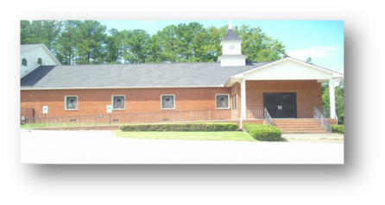
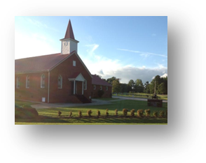
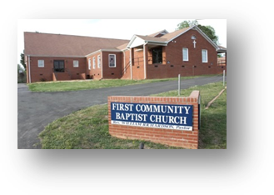
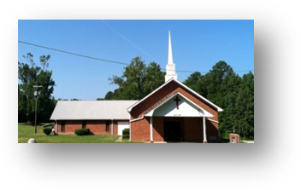
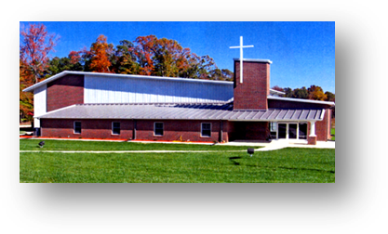
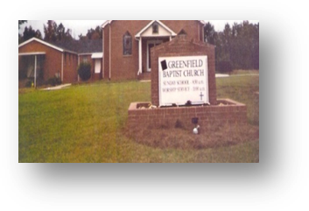
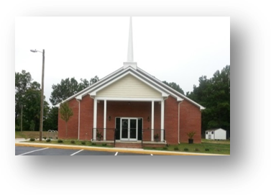
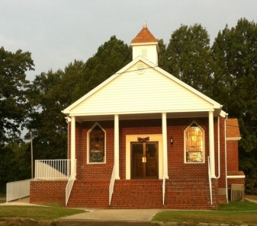
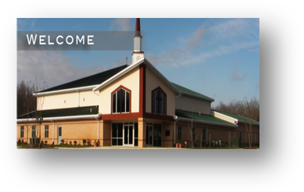
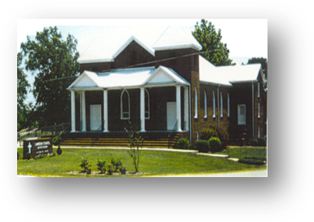
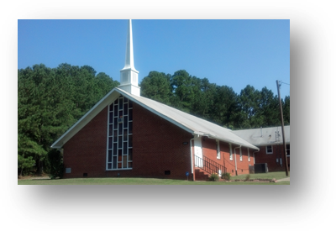
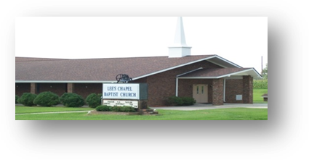
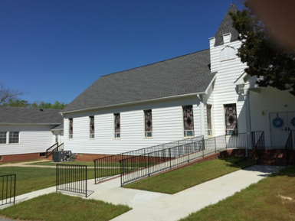
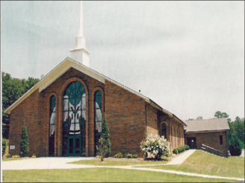
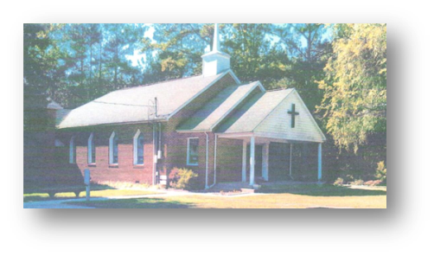
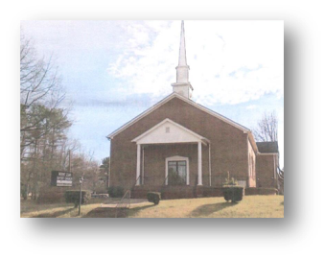
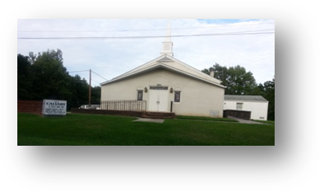
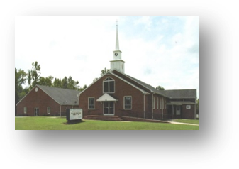
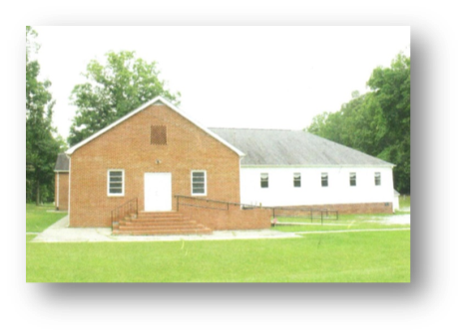
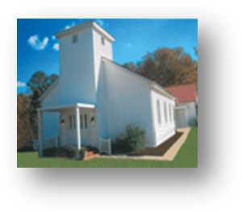
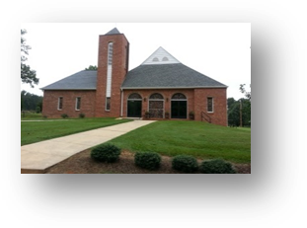
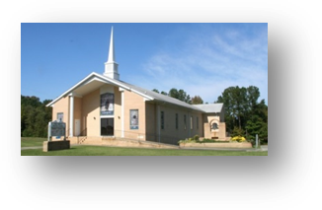
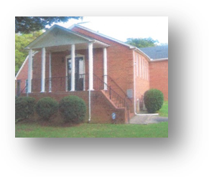
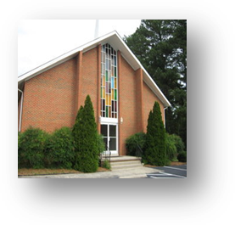
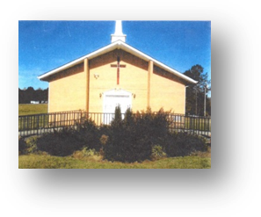
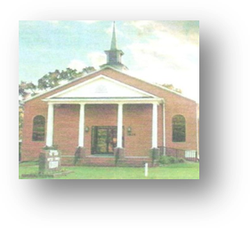
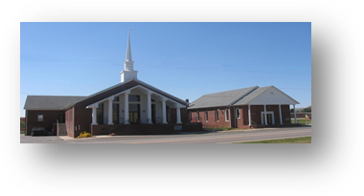
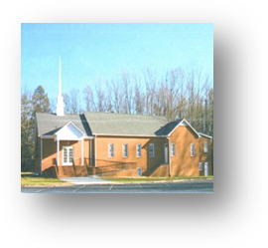
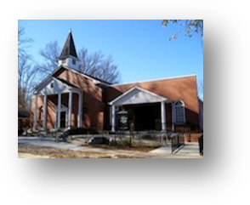
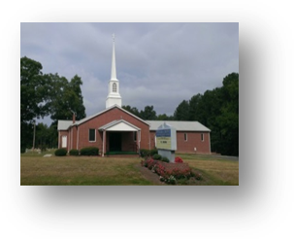
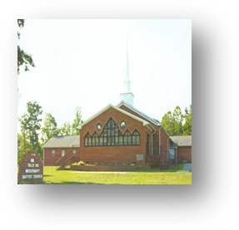
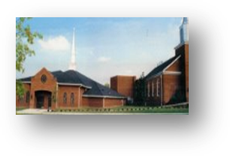
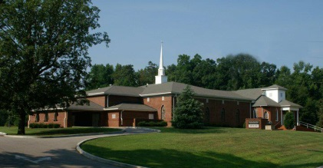
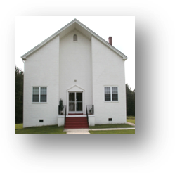
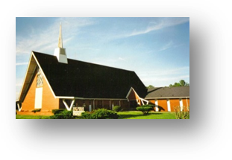
ECGMBA MEMBER CHURCHES
Hhh…

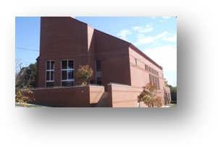

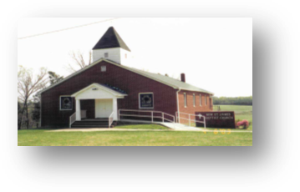
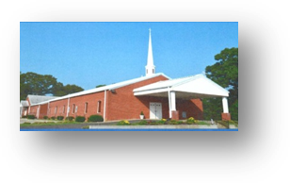
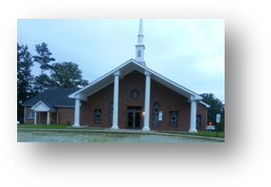
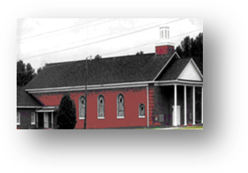
EAST CEDAR GROVE MISSIONARY BAPTIST ASSOCIATION MEMBER CHURCHES

Member Churches Pastors Est. Date & Site
Cameron Grove Missionary Baptist Church Rev. Jessie L. Alston 1901, Durham, NC
Cedar Grove Missionary Baptist Church Rev. Jessie Timberlake, Jr. 1865, Roxboro, NC
First Calvary Baptist Church Rev. Dr. Frederick A. Davis 1884, Durham, NC
First Community Missionary Baptist Church Rev. Dr. William Richardson 1986, Hillsborough, NC
First Ledge Rock Missionary Baptist Church Rev. Sylvester Clay 1975, Durham, NC
Greater Cleggs Chapel Missionary Baptist Church Rev. Louis Cash 1892, Timberlake, NC
Greenfield Missionary Baptist Church Vacant 1887 Creedmoor, NC
Henderson Grove Missionary Baptist Church Rev. Johnnie Bethea 1915, Morrisville, NC
Jones Chapel Baptist Missionary Baptist Church Rev. Ronald K. Booker 1881, Roxboro, NC
Lattisville Grove Missionary Baptist Church Rev. George Crews, III 1879, Hurdle Mills, NC
Lawson Chapel Missionary Baptist Church Rev. Dr. Langston Logan, Sr. 1871, Roxboro, NC
Ledge Rock Missionary Baptist Church Rev. Marcellus Tyrone Moore 1863, Raleigh, NC
Lee’s Chapel Missionary Baptist Church Re. T. E. Taylor 1893, Cedar Grove, NC
Mt. Calvary Missionary Baptist Church Rev. Dr. James Smith 1892, Bahama, NC
Mt. Level Missionary Baptist Church Rev. Dr. William C. Turner, Jr. 1864 Durham, NC
Mt. Vernon Missionary Baptist Church Rev. Dr. J. Eric Morgan, III 1872, Creedmoor, NC
Mt. Zoar Missionary Baptist Church Rev. Norman Davis 1865, Durham, NC
New Calvary Missionary Baptist Church Rev. Dr. E. Nathaniel Wall 1902, Durham, NC
New Hope Granville Missionary Baptist Church Rev. James Isaac, III 1888, Oxford, NC
New Hope Person Missionary Baptist Church Rev. Wilber L. Richardson 1878, Timberlake, NC
New Light Missionary Baptist Church Rev. Gaddis Barnes 1907, Wake Forest, NC
New Red Mountain Missionary Baptist Church Vacant 1874, Rougemont, NC
New St. James Missionary Baptist Church Rev. Lloyd Oliver, Sr. 1870 Timberlake, NC
Oak Grove Missionary Baptist Church Rev. Dr. Charles Bullock, Interim. Pastor 1865, Oxford, NC
Olive Grove Missionary Baptist Church Rev. Mack T. Timberlake, Sr. 1865, Oxford, NC
Orange Grove Missionary Baptist Church Rev. Dr. Herbert L. Dickerson 1880, Durham, NC
Pettiford Grove Missionary Baptist Church Rev. Alvin B. Downing, Sr. 1887, Kittrell, NC
Pine Grove Missionary Baptist Church Rev. Dr. Larry L. McElroy 1870, Creedmoor, NC
Rock Spring Missionary Baptist Church Rev. Haywood Dock, Jr. 1875, Creedmoor, NC
Rogers Grove Baptist Church Vacant 1892, Durham, NC
Shady Hill Missionary Baptist Church Rev. Dr. James Richmond, Sr. 1867, Roxboro, NC
Siloam Missionary Baptist Church Rev. Willie Wayne Johnson 1880, Rougemont, NC
St. John Missionary Baptist Church Rev. Robert Daniels 1910, Durham, NC
Synama Grove Missionary Baptist Church Rev. Lynwood Timberlake 1861, Oxford, NC
Tally Ho Missionary Baptist Church Rev. Moses Fletcher 1863, Stem, NC
Union Baptist Church Rev. Dr. Kenneth Hammond 1897, Durham, NC
Union Chapel Missionary Baptist Church Rev. Dr. Harold Trice, Sr. 1864, Butner, NC
Union Grove Missionary Baptist Church Rev. Rufus Johnson, Sr. 1888, Hurdle Mills, NC
United Christian Missionary Baptist Church Rev. Earl Williams 2002, Creedmoor, NC
West Durham Missionary Baptist Church Vacant 1892, Durham, NC

Rev. J. Eric Morgan, III, Moderator
2174 Brassfield Road, P.O. Box 808, Creedmoor, North Carolina 27522
eastcedargrove-mba.org
919-693-8020

