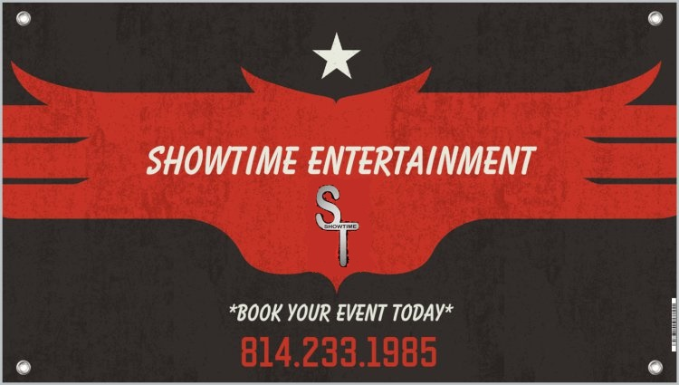

220 School Bus Road
Somerset, PA 15501
Phone 814.233.1985
rsharrold45@gmail.com
www.facebook.com/showtimepartytimebus

*For immediate booking and payment by credit card, please call 814.233.1985*

Client Name:
Client Address:
City: |  |  |  |  |  |  |  | State: |  |  |  |  |  | Zip:
Contact Phone:
Email Address:
Pick up Address/Location:
Event Date: |  |  |  |  |  |  |  |  |  | Pick up Time:
Expected # of Passengers (14 Max): |  |  |  |  |  |  |  |  |  |  |  |  | Scheduled # of hours:
Occasion/Destination:
Estimated # of stops:
Drop off Location:

Trip Rate Quote | $ |  | Total hours: |  | $
Down Payment Received: |  |  |  |  | $
Balance Due |  |  |  |  | $

______________DJ booking discount
3 hours- $375.00
5 hours- $600.00
8 hours- $950.00
10 hours- $1100.00
12 hours- $1300.00
Overtime is usually not a problem; however, a credit card must be provided at the time of booking and you will be charged $130 per hour for time that exceeds beyond the original reservation.

Security Deposit: A security deposit of 50% of the total contract is required to hold your date and is non-refundable.

Balance of contract: The remaining balance of the contract must be paid (1) week prior to the date of service.

Release for Photographs and Videos: I understand that Showtime Entertainment may be taking pictures and video throughout the charter for which I have contracted the party bus. All pictures and videos are the sole possession of the Showtime Entertainment and may be used in advertisements and/or promotions on the Internet and/or print media.

I, __________________________________, have read the attached contract conditions and agree to abide by them. I accept full responsibility for any and all damages or thefts that occur during my rental for all members involved in my event. I agree that if any persons are to be added during the trip, which were NOT part of the original group, can be done so at the discretion of the Contracted Person and/or Driver (not to exceed the 14 passenger limit. No Standees permitted.) I have the right to inspect the bus prior to my trip and report any noticed damage. I have accepted “Showtime Entertainment Services, LLC” in good faith and agree to the above listed price. I agree to pay for all services rendered at least 7 days prior to the time of pick-up, and any additional hours at the trips end. I will personally explain these rules to persons of my group and any added persons during the trip.
This waiver serves to protect “Showtime Entertainment, LLC” against lawsuits.

Signature: ______________________________________Date: _________________
The Showtime Party Bus is equipped with a flat screen SmartTV, am/fm/cd player; mp3, usb and ipod cabled sound system that plays throughout the entire bus. The bus has air conditioning, tinted windows, and L.E.D. lighting. Last but not least, your rental includes a safe, fun, and professional driver. To ensure that everyone has a great time and a safe trip, our guests must abide by our safety rules & regulations listed below.
- We accept only cash or credit/debit card payments (Visa/MasterCard).
- Cancellation policy: Your deposit is non-refundable (50% of the full cost) when you book a party with us. If you cancel 7 days prior to the event, you are not responsible to pay the remaining 50%. If you cancel within the 7 days leading up to the event, there will be no refund. It is common for us to turn away several other parties because your date is already booked.
- If you wish to extend your parties trip, please check with driver on availability. Payment must be made to the driver before extending the trip.
- If your party goes over the prearranged time, you will be billed at $130.00/hr overtime.
- If the party bus is soiled beyond normal conditions, there will be a $75.00 cleaning fee payable to the driver in cash or charged to the client’s credit card.
- If “Showtime Entertainment, LLC “ and its staff has to clean up body fluids of any type, there will be a $100.00 fee payable to the driver in cash or charged to the client’s credit card. The driver will pull over when safe to do so.
- By signing this contract, the client agrees to assume full responsibility for any damage to the interior or exterior of the Showtime Party Bus that is caused by any individual riding in the bus. If any property of the Showtime Party Bus gets stolen by any of the guests at your party, the client will also be held 100% liable for replacement and/or repair costs, collection fees, attorney fees, court costs, loss of Showtime Party Bus service costs, etc. that it takes to rectify the situation. We spend a lot of money to provide a fun transportation environment and would like to keep it that way for our next guest.
- No drugs, no violence, and no weapons of any kind will be tolerated. If any of the above occurs, you will be removed from the bus immediately and the driver reserves the right to terminate the trip, leaving the client to find other transportation and forfeits full fare as a result. “Showtime Entertainment, LLC” drivers and or employees reserve the right to eject any individual(s) whom they deem to be disruptive, intoxicated, to pose a safety threat to themselves or to others, or deemed to be using an illegal substance.
- “Showtime Entertainment, LLC” cannot, by law, supply alcohol to /for clients. Guests must provide their own alcohol. Showtime Entertainment, LLC encourages responsible drinking.
- Pennsylvania State Law requires all guests to be 21 or older to drink alcoholic beverages. The “Showtime Entertainment, LLC” and its employees are not responsible for underage consumption of alcoholic beverages at any time before, during, or after the ride. Driver has the right to inspect Id’s and containers of passengers who appear underage.
- Keep all personal items with you at all times, “Showtime Entertainment, LLC” and it’s employees are not responsible for any lost, damaged, or stolen items nor any articles left on the bus after the ride has ended.
- While the bus is in motion, guests are required to be seated. If you choose to stand or dance, you must hold on to hand rails or seats for your safety. “Showtime Entertainment, LLC" will not be responsible or liable for any injuries incurred during any unsafe practices. By signing up for and participating in the ride, the individual agrees that “Showtime Entertainment, LLC “ and its employees are not responsible for any claims for injuries, loss, damage, death, liability, criminal or civil litigation for the participating individual arising out of or relating to a ride.
- Absolutely *No smoking on the party bus at anytime.*
- No glass containers are allowed on the party bus.
- All carry-on bags are subject to search by “Showtime Entertainment, LLC “and its staff.
- “Showtime Entertainment, LLC” is not liable in cases of unexpected breakdowns, accidents, severe weather or anything that may delay a timely arrival. In the event of cancellation due to mechanical problems, the trip may be rescheduled for a later date. Client will be notified ASAP to let them know of unexpected problems that may postpone/delay trip times.

Signature: ________________________________________________Date_________________
By signing you are in agreement to all rules and regulations.

