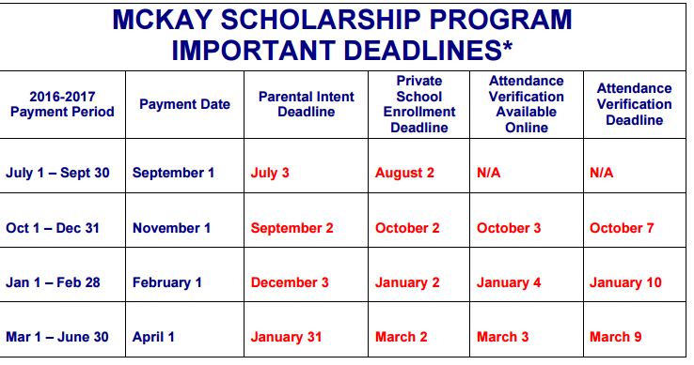
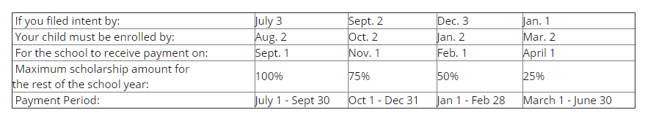

9/1 paid for July 1 – Sept 30
11/1 paid for Oct 1 – Dec 31
2/1 paid for Jan 1 – Feb 28
4/1 paid for March – June 30

