Algiere Chiropractic
Benjamin J Algiere, DC
1171 Main Street, Wyoming, RI
T: 401-539-1171
F: 401-539-4010

New Patient Intake Form
Title: Mr. Mrs. Ms. Miss Dr. Other

First Name Nickname M.I.

Last Name

Address

City State Zip Code

Leave Messages on: (Circle one) Home Cell Work Don’t leave messages
Text Messages OK? (Circle one) Yes/No Email OK? Yes/No

Referred By:
How did you hear about our office?

Home Phone ( ) -
Work Phone ( ) -

Cell Phone ( ) - Email

Date of Birth / /
Sex: Male Female. Pregnant? (Circle) Yes No

Social Security Number: - -
Marital Status: Single Married Other

Employment Status: Employed Unemployed FT Student PT Student Other

---Was this visit related to any (auto accident)/ (personal injury case)/ (workers comp case)?
-----(Yes/No). Please Describe:

Reason For Today's Visit:
Algiere Chiropractic
Benjamin J Algiere, DC
1171 Main Street, Wyoming, RI

Employer Data

Employer

Your Occupation

Spouse Data

First Name Middle Initial Last Name

Home Phone ( ) -
Work Phone ( ) -

Spouse Date of Birth / /

Emergency Contact

Contact Name
Relationship to Patient

Contact Home Phone ( ) - Cell Phone ( ) -

Medical Conditions: (Circle all that apply to you)
Arthritis | Cancer | Diabetes |  | Heart Disease
Hypertension | Psychiatric Illness | Skin Disorder | Stroke
Other | Fibromyalgia | Asthma |  | Osteoporosis

Surgeries: (Circle all that apply to you and approximate date)
Appendectomy Cardiovascular procedure Cervical spine Hysterectomy Joint Replacement Prostate Lumbar spine Gall Bladder Brain Shoulder Thoracic spine Knee
Carpal Tunnel Gastro-intestinal Uro-Genital Hernia
Breast/Gluteal Augmentation
Other . Dates of Surgery

Allergies: (Circle all that apply to you)
Mold Seasonal Milk or Lactose Animal
Chemical
Sulfites Wheat/Glutens
Other
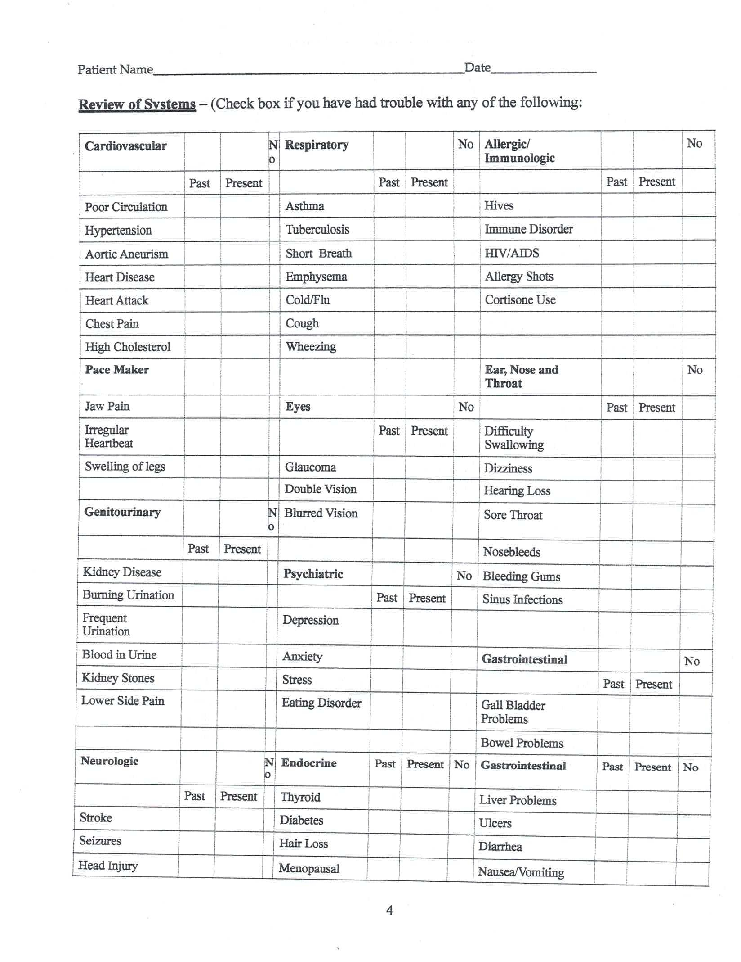
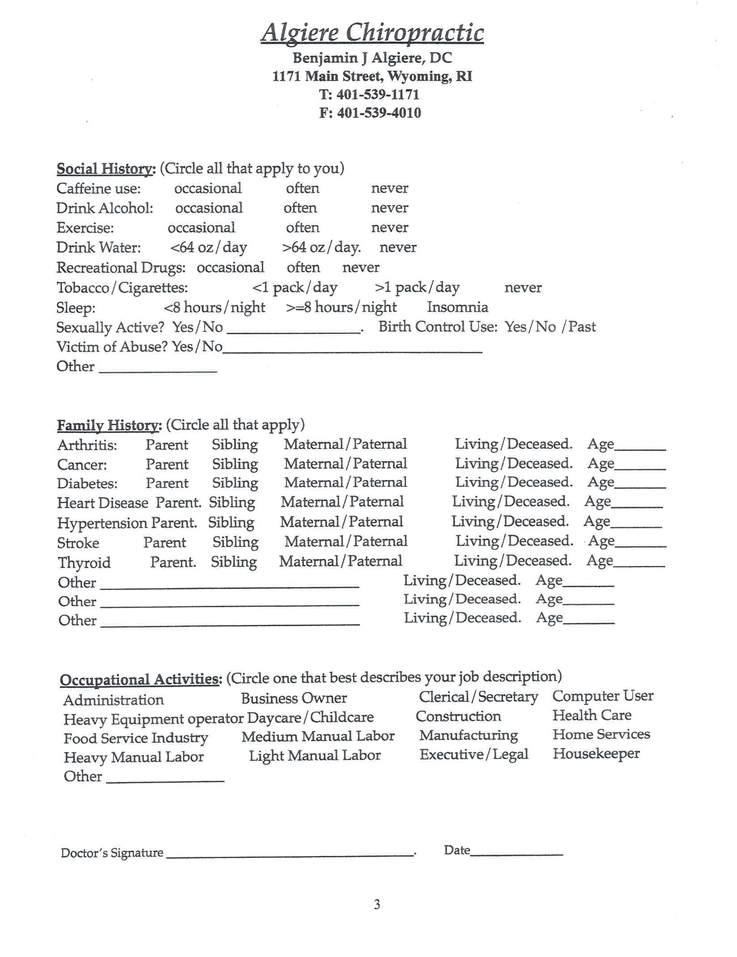
Patient Name Date

By Using the key below, indicate on the body diagram where you are experiencing the following symptoms:
N=Numbness B=Burning S=Sharp T=Tingling A=Dull Ache
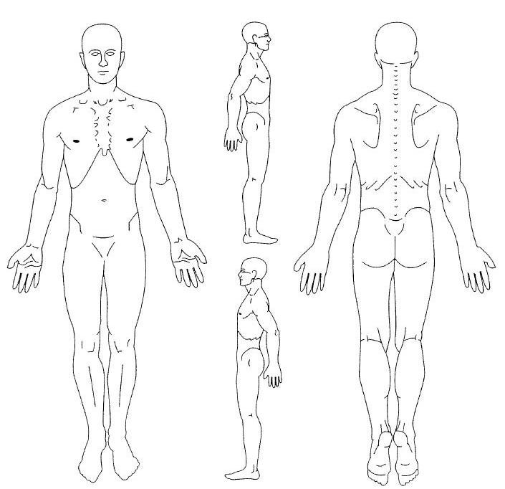
Average Pain Intensity:
Last 24 hours: no pain 0 1 2 3 4 5 6 7 8 9 10 worst pain
Past week: no pain 0 1 2 3 4 5 6 7 8 9 10 worst pain
Does anything improve your pain? Yes No If Yes, please list:

When did your symptoms begin?

How did your symptoms begin?

How often do you experience your symptoms?
Constantly | Frequently | Occasionally | Intermittently
(76-100% of the day) | (51-75% of the day) | (26-50% of the day) | (0-25% of the day)

What describes the nature of your symptoms?
Sharp. | Dull. | Ache | Numb. | Weakness. Shooting
Burning. | Tingling | Throbbing. | Pins and Needles | Other:

How are your symptoms changing? Getting better Not changing Getting worse

Doctor’s Signature . Date:
Patient Name Date

FINANCIAL AGREEMENT AND OFFICE POLICY

Thank you for choosing Algiere Chiropractic as your Chiropractic provider. We are committed to providing you with quality and affordable health care. Due to some of the questions our patients have regarding patient and insurance responsibility for services rendered, we have been advised to develop this payment policy. Please read it, ask any questions you may have, and sign in the space provided below. A copy will be provided to you upon request.

1. INSURANCE. We participate in most insurance plans, including Medicare. If you are not insured by a plan we participate with, payment in full is expected at each visit. If you are insured by a plan we do participate with, but do not have an up-to- date insurance card, payment in full for each visit is required until we can verify your coverage. Knowing your insurance benefits is your responsibility, please contact your insurance company with any questions you may have regarding your coverage. If your insurance company requires a referral it is your responsibility to provide us with a referral dated the day of your first visit from your primary care physician prior to your first visit. We are only able to provide a summary of your chiropractic benefits.
2. CO-PAYMENT AND DEDUCTIBLES. All co-payments and deductibles must be paid at the time of service. This arrangement is part of your contract with your insurance company. Failure on our part to collect co-payments and
deductibles from patients can be considered fraud. Please help us in upholding the law by paying your co-payment at each visit.
3. PROOF OF INSURANCE. All patients must complete out patient information form before seeing the provider. We must
obtain a copy of your most current insurance card and drivers license to provide proof of insurance. If you fail to provide us with the correct insurance information in a timely manner, you may be responsible for the balance of a claim.
4. CLAIM SUBMISSION. We will submit your claims and assist you in any way we reasonably can to help get your claim paid.
Your insurance company may need you to supply certain information directly. It is your responsibility to comply with their request. Please be aware that the balance of your claim is your responsibility whether or not your insurance pays your claim. Your insurance benefits are a contract between you and your insurance company; we are not party to that contract.
5. COVERAGE CHANGES. If your insurance coverage changes, please notify us before your next visit so we can make the appropriate changes to help you receive your maximum benefits. If your insurance company does not pay your claim in 90 days, the balance will automatically be billed to you.
6. MISSED APPOINTMENT. Our policy is to charge $20.00 after one missed appointment not cancelled in advance. The charges will be your responsibility and billed directly to you. Please help us to serve you better by keeping your regular scheduled appointment.
7. CASH POLICY: If we cannot process your insurance, competitive cash plans are available. Cash price for a visit is $40.00 with physiotherapy included , and there will be a $65.00 initial exam charge. Physiotherapy alone has a $10.00 fee.
8. MILITARY/SENIOR CITIZEN DISCOUNT : Present a valid ID credentials for military service, high school/ college school ID, or individual aged 65+ are presented a cash policy at a rate of $30.00/visit and $30.00 new patient exam. Patients wishing for pre-payment options while utilizing this plan will be offered a price reduction to $25.00/visit, (minimum 3 visits pre-paid).

Algiere Chiropractic is committed to providing the best treatment to our patients. Our prices are representative of the usual and customary charges for our area.
I have read and understood the payment policy and agree to abide by its guidelines.

Signature of patient or responsible party Date
Algiere Chiropractic
Benjamin J Algiere, DC
1171 Main Street, Wyoming, RI T: 401-539-1171
F: 401-539-4010

Privacy Policy

Patient data at Algiere Chiropractic will remain confidential.

Every effort will be made by Algiere Chiropractic to respect the confidentiality of our patients,

family members or loved ones.

Algiere Chiropractic will contact providers or insurance companies to gain patient data or to
assist in patient care; with prior authorization from the patient or guardian a mandatory practice at our office.

Our office is HIPPA compliant and was designed with our patient's privacy as a priority.

Our software and data storage is fully HIPPA compliant and digitally secured.

Patient files will be kept for a minimum of 7 years, compliant with federal policies.

Our office is ADA compliant and fully handicapped accessible.

Patient credit cards, billing info, and other financial information will remain confidential.

Pre-Authorization will be obtained prior to any phone, message or text contact is made to the
patient. The patient will clearly state whether pertinent phone calls or messages will be allowed at certain addresses prior to commencement of care.

The patient attests that the data included in this packet is accurate and updated to the best of

their knowledge

Algiere Chiropractic is committed to providing the best treatment to our patients. Your privacy is our highest priority and we will maintain confidentiality at all costs.

-I have read and understood the privacy policy and agree to its terms and conditions.

Signature of patient or responsible party Date
Algiere Chiropractic
Benjamin J Algiere, DC
1171 Main Street, Wyoming, RI T: 401-539-1171
F: 401-539-4010
Authorization and Consent to Chiropractic Care
(Please Initial Where Indicated by “X”)

X Insurance Agreement

X Cash Policy Agreement

Military/65+ Policy
X Pregnancy Release Disclaimer
I declare I am/am not pregnant at the time of initial visit.
X Consent for Benjamin J. Algiere, D.C. To Treat a Minor

X______ I hereby consent to the following procedures performed by Benjamin J Algiere, D.C.
- Examination and Diagnosis
- Chiropractic Manipulative Procedures
- Physiotherapy Modalities
- Soft Tissue Mobilization Procedures
- Ergonomic and Postural Training.
- Nutritional Consultations

I hereby request and consent to the performance of chiropractic treatments (also known as chiropractic adjustments or chiropractic manipulative treatments) and any other associated procedures: physical examination, tests, diagnostic x-rays, physio therapy, physical medicine, physical therapy procedures, on me by the doctor of chiropractic named above and/or other assistants and/or licensed practitioners.
I understand, as with any health care procedures, that there are certain complications, which may arise during chiropractic treatments. Those complications include but are not limited to: fractures, disc injuries, dislocations, muscle strain, Homers’ syndrome, diaphragmatic paralysis, cervical myelopathy and costovertebral strains and separations. Some types of manipulation of the neck have been associated with injuries to the arteries in the neck leading to or contributing to complications including stroke.
I do not expect the doctor to be able to anticipate all risks and complications, and I wish to rely upon the doctor to exercise judgment during the course of the procedure(s) which the doctor feels at the time, based upon the facts then known, that are in my best interest.
I have had an opportunity to discuss with the doctor(s) named above and/or with office personnel the nature, purpose and risks of chiropractic treatments and other recommended procedures. I
have had my questions answered to my satisfaction. I also understand that specific results are not guaranteed.
I have read (or have had read to me) the above explanation of the chiropractic treatments.
X_______By signing below, I state that I have been informed and weighed the risks involved with chiropractic treatment at this health care office. I have decided that it is in my best interest to receive
chiropractic treatment. I hereby give my consent to that treatment. I intend for this consent to
cover the entire course of treatment for my present condition(s) and for any future conditions(s)
for which I seek treatment.
Printed Name of Patient:
___________________________________________________

x
Signature of Patient Date

Algiere Chiropractic
Benjamin J Algiere, DC
1171 Main Street, Wyoming, RI T: 401-539-1171
F: 401-539-4010

Authorization and Consent to Chiropractic Care

I hereby state that I, , have read and consent
to the terms and conditions of care at Algiere Chiropractic on this date, . Care will be rendered by Benjamin J. Algiere, D.C. I acknowledge that some examination and treatment procedures may cause slight discomfort, and have been read the potential side effects and alternatives to care for my current condition.

I have been informed by Algiere Chiropractic on this date that all examination and treatment procedures comply with the accepted chiropractic standards of care.

I state that I have been informed by Benjamin J Algiere, D.C. as to the risks, complications, and expected outcomes of chiropractic care for my specific condition. I hereby declare that I have no further questions regarding my care and I consent to care rendered at Algiere Chiropractic, 1171 Man Street, Wyoming, RI, 02898 with Benjamin J Algiere D.C. as my attending physician. I declare that a thorough examination and report of findings has been conducted in an effort to educate me on my condition, treatment methods, and expected progression.

-I have read and understood the informed consent to care policy and agree to its terms and conditions.

Printed Name of Patient

x
Signature of Patient Date

x
Signature of Representative (if patient is minor or handicapped) Date

x
Witness to Patients’ Signature Date

Doctor:
Date:
