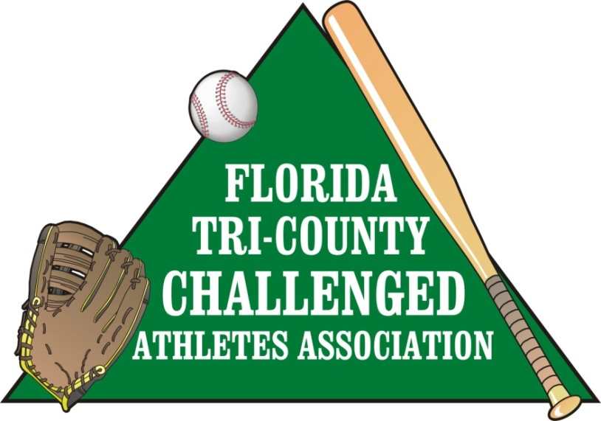

Whom It May Concern:

We would like to first thank you for taking the time to read this flyer. My name is Kathleen Samson; I am the CEO of the Florida Tri-County Challenged Athletes Association. I would like to tell you a little history about our league. We developed the league in 2005. Our children had reached the age of twenty-one and could no longer play under Little League rules. Little League’s age limit for handicapped children was Twenty One years old. Knowing how much these kids enjoyed playing baseball along with the friendship they have formed over the years; we knew we had to do this for them. We are a Non-Profit Tax Exempt League, which symbolizes the American dream of playing baseball for handicap adults. We operate through the generous donations from within our community.

I would like to explain some of the cost we accrue over the season. The league covers the complete cost of each player, because most of our players are on a fixed income that may not allow them to participate in extra curricular activities. We begin each season with paying for the registration fees, insurance, and uniforms for each player and coach, this past year we had over a100 adult players. Then we have equipment, tournament fees and field rental. Last but not least our end of season awards banquet. We anticipate this cost to continue to grow as more teams are added each year.

So I would like to take this time to ask on behalf of our organization if you would like to contribute any size monetary donation or volunteer services. We do not offer specific amount sponsorship because we believe any donations is a blessing.

I would like to personally thank you for taking the time to read this flyer. If you should have any questions please feel free to contact me personally.

Sincerely,

Kathleen Samson
League CEO
239-267-2417

