The PINK Charity Softball Tournament  July 7 – 9th, 2017 – Dorval | 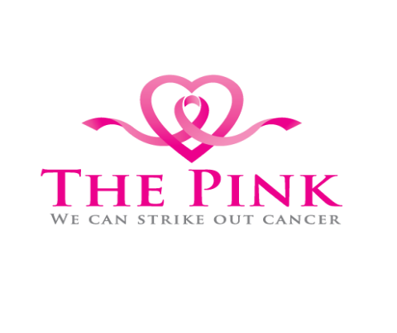

Donation for:

MUHC – Breast Center

Help us support the MUHC Breast Center by donating today. Join us for a fun-filled, informative weekend Description:

Name | Address | Phone Number | Donation
1.
2.
3.
4.
5.
6.
7.
8.
9.
10.
11.
12.

