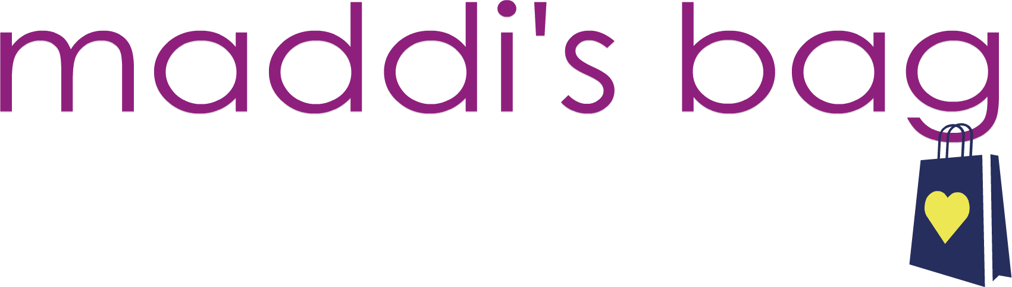

Please join us for our 4th Annual Shop 4 CHOP
Thursday, November 2, 2017
9am-2pm and 5pm-10pm
62 L’Enfant Court, Glen Mills PA 19342
Pop-Up Shops Raffles Light Fare Cocktails
**all under one cozy roof to celebrate extra-ordinary young trauma survivors**

Business Name:_______________________________________________________________
Contact Name:______________________________________________________________
Mailing Address:______________________________________________________________
Phone:_________________________________Email:________________________________
Session(s) committing to attend:
9am – 2pm_____ 5pm – 10pm_____ Both_____
$50 TABLE FEE IF PAYMENT IS RECEIVED WITH REGISTRATION BY September 1
$65 TABLE FEE if payment is submitted after September 1

I hereby register to sell at Maddi’s Bag Shop 4 CHOP pop-up shop event. I agree to donating 10% of total sales from the event to Maddi’s Bag Inc. and to providing one table item to the event raffle. Raffle drawings will occur throughout the event. The deposit of $___ guarantees adequate selling space in which to sell merchandise, inclusion in/on all event advertising, link to business page on the event website and unlimited food & beverage. Maddi’s Bag reserves the right to make final table assignments and last minutes changes. With this form signed and deposit complete, I agree to participate for the times & terms above I have committed to.
Signature_________________________________________________________ Date______________________

Cash, check (payable to Maddi’s Bag), PayPal or credit card payment accepted
*link to pay online can be found on www.maddisbag.com or www.facebook.com/maddisbag*
Please contact Jenny Raimondo with any questions or concerns, 610.715.2587
~~email company logo and/or advertisement to maddisbag@gmail.com~~

Welcome to our 4th Annual Shop 4 CHOP!
We are so excited to be organizing another cozy multi-vendor shopping event for our community. Our event offers an amazing mix of pop-up shops and provides an opportunity to market your business, introduce your product and expand your following! The success of our event has tripled since our first year and we look forward to another incredible event that includes you!

Please read through the enclosed registration contract.
We look forward to spending the day with you!

Know a vendor interested in joining our event?
Please pass on the registration info and my contact…the more the merrier!!

