

May 2017

The PIC Informer

**From the Desk of the Director**

I always push for honesty and openness so I suppose I should do the same. As some of you might know, I’ve been off for a few weeks. It started out as an UTI, while in the hospital they ran some test and found a spot on my lung. It is small cell lung cancer. I will be receiving chemotherapy over the next two or three months. During that time, I will be moving some of my duties over to other people. It should be no concern at all.

I’m hoping to be in the office for a very limited time starting in June. I’m reacting very well with the chemo, which is very good. The whole thing has made me very weak. When you have the physical problems that I already have, any loss of strength is troublesome. As soon as I can gain some of that back I will start back in the office.

*Dan*

**CONGRATULATIONS NEW HIRES**

Agency IT/Accountant - Robert Fava

Life Coach - Allyssa Walton

Life Coach - Jessica Neville

Life Coach - Angela Gazoly

**ANNOUNCING LOGO CONTEST**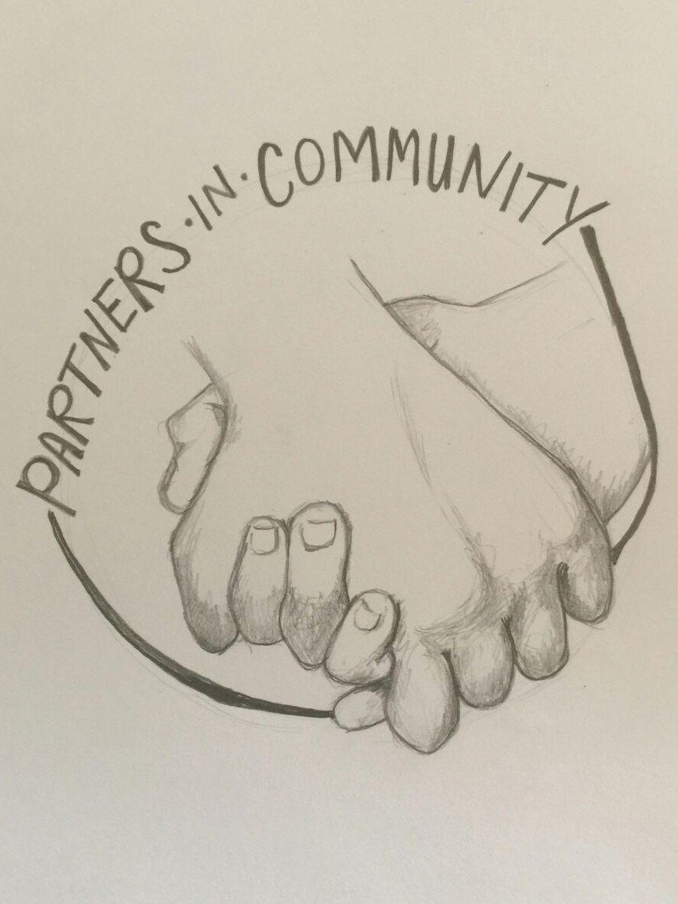

**WINNER – NICOLE BEARD**

We will formally congratulate Nicole at our next northern mandatory Agency training scheduled on:

**June 21st, 2017 – 10A-2P**

**At the Erie County Bldg – Downtown Sandusky**

**Southern Counties Agency Training - TBA**

Open Shifts:

Sandusky – FT Residential

Sandusky – Day Program PRN

Sandusky – PT Bus Driver

Norwalk – PT + PRN

Port Clinton - PT



Partners In Community, Inc.

**Quick Watermelon Cooler Recipe**



2 Cups Watermelon

3 Cups seedless watermelon, coarsely chopped

1 Cup crushed ice

**Directions**: In a blender, combine all ingredients; cover and process until smooth. Pour into chilled glasses; serve immediately. Yield: 4 servings. __________________________________

**Dad's Best Pork Chops Recipe**

* 2 medium tomatoes, chopped
* 1/4 cup chopped onion
* 3 tablespoons minced fresh mint
* 1 jalapeno pepper, chopped
* 2 tablespoons key lime juice
* 1-1/2 teaspoons minced fresh rosemary
* 4 bone-in pork loin chops (3/4 inch thick)
* 1/4 teaspoon salt
* 1/4 teaspoon pepper

**Directions**

1. In a small bowl, combine the first six ingredients. Chill until serving.
2. Sprinkle pork chops with salt and pepper. Grill chops, covered, over medium heat or broil 4-5 in. from the heat for 4-5 minutes on each side or until a thermometer reads 145°. Let meat stand for 5 minutes before serving. Serve with salsa. Yield: 4 servings.

Nutrition

Craving Control: How Taste Makes Us Overeat  
  
Behind your Food Desires…You’ve just finished eating a tasty cinnamon muffin BUT the other two muffins in the pack are winking at you. You can’t shake the thought of how fluffy, nutty, and gorgeous they taste. You want another one! Hormones and gut-brain signals tell you when you’ve had enough. But cravings are much more unpredictable, and even irrational. Cravings are partly explained by the feeling of pleasure that your brain derives from eating calorie-laden food treats. Their effects on our brain reward centers can even be compared to those of a recreational drug. So when you gorge on high-calorie foods, like that tasty cinnamon muffin, you activate the reward system in your brain and it feels GOOD. This is Hedonics or the branch of psychology that deals with pleasurable and un-pleasurable states of consciousness.

Eating Hedonics comes into play the moment your brain receives taste information from your taste cells. When food is highly palatable, taste information activates the reward system in your brain. Specifically, the human brain scans have shown that when you eat palatable foods, it activates regions of your brain, which are involved in: pleasure sensations, reward processing, and addiction. When dieters are exposed to tempting foods, they experience stronger hedonic responses, which is linked to heightened cravings for these foods and a lower ability to resist eating them!  
*Source: © The Health Sciences Academy*



“Don’t cry because it’s over. Smile because it happened.*” –*

*Dr. Seuss*

Partners In Community, Inc.

May 2017



MAY 2017

In Other News…

As part of the events surrounding Gov. John Kasich’s 2017 State of the State address, the Ohio Department of Developmental Disabilities (DODD) visited Erie County to recognize local businesses employing people with developmental disabilities. DODD Director John Martin partnered with Opportunities for Ohioans with Disabilities (OOD) Director Kevin Miller to honor Cedar Point’s Sports Force Parks, Sawmill Creek Resort, and Steak ‘n Shake in Sandusky, Ohio. DODD also joined the Erie County Board of Developmental Disabilities (ECBDD) for a discussion with families using the Early Intervention program and for a luncheon to talk with ECBDD staff members and self-advocates.

**A Rare Success Against Alzheimer’s**

In brief – **Two hundred experimental drugs** intended to treat Alzheimer’s disease have failed in the past 30 years. Without new therapies, the number of patients world-wide will increase dramatically by 2050. **A ray of hope** has come recently from a clinical trial that showed that dementia’s cognitive impairment might be prevented by paying close attention to various health factors. Participants in the study who followed a regiment of health-related steps registered improvements on cognitive measures such as memory and mental-processing speed. Result of this research suffice for health care professionals to begin making a series of recommendations of patients on diet, exercise and levels of social engagements that may help prevent dementia.

*Published in: April 2017, Scientific American*

***LETTER FROM DELAWARE:***

I remember when I first came to live here at Frank’s place and work with Partners In Community. I think that, since then we have become more than just partners. We are now like a family-----a big, crazy family. Being that that is the case, perhaps the company name needs changed. Instead of ‘Partners’ In Community, how about ‘Family’ In Community (or Family in THE Community)? Partners are typically two people who work with each other and have a work relationship but not a real relationship. We have all developed real relationships with each other. It’s not simply ‘staff’ and ‘clients’ anymore. We love each other and take care of one another.

Your friend,

*Mark*

**HR CORNER**

ATTENTION PARTNERS IN COMMUINITY PERSONNEL:

PIC Adult Day Program personnel as well as Supported Employment/Job Coaches should attend the DODD MyLearning training offered at <https://mylearning.dodd.ohio.gov>. There are several trainings offered at this location. Please complete the Community Integration Training and obtain certificate. If you have questions please contact Hallie Griffitts.





Spotlight

*Juli would like everyone to know that she beat Andrea’s Score at bowling. For further details about the win, contact Juli T in Port Clinton.*

**ANNOUNCEMENTS:**

**We have a new Webpage**…

[www.partnersin](http://www.partnersin)community.com

Please visit our webpage and follow us on Facebook. We are moving slowly on Facebook at the present time and most of the pictures posted are from the Adult Day Program so please share your experiences and adventures with us (be aware of obtaining permission first).

**PIC DAY PROGRAM…**

*Shifting gears is such a complicated concept but we are doing just that at the Adult Day Program to maintain compliance with the new DODD Day Rules beginning April 1st.*

*The DODD day program rules have been revised to support community integration and employment. The priorities of the new and amended rules are based on Person Centered Planning, Community Membership, and Community Employment.*

*The PIC Adult Day Program will continue to promote the individual’s membership in the community, enhance opportunities for personal growth, independence, and natural supports, while supporting each individual’s person centered goals/interests.*

*For more information in regards to the new rule or about the Adult Day Program, please contact Hallie Griffitts at 419-502-2373.*



**PROFILE OF THE QUARTER**

**Name**: Daniel Woell, Executive Director

**Education**: Studied at University of Dayton, Otterbein College and obtained Degree from Bowling Green State University

**Employment Status with PIC**: Since 1991

**Favorite Author**: Dan Brown

**Favorite Cake:** Upside Down Pineapple Cake and 2nd Favorite – Carrot Cake

**1st Job**: Umpire for Sandusky Slow Pitch League

**Favorite Movie**: Apocalypse Now



**Favorite TV Show**: NCIS and NCIS LA

Partners In Community, Inc.

PLACE PHOTO HERE,

OTHERWISE DELETE BOX

PLACE PHOTO HERE,

OTHERWISE DELETE BOX

MAY 2017

ph

fx

mo

555.555.5555

555.555.5555

555.555.555

email@address.com

www.webaddress.com