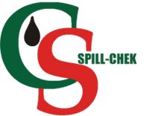
Strut-Lock™ Secondary Containment

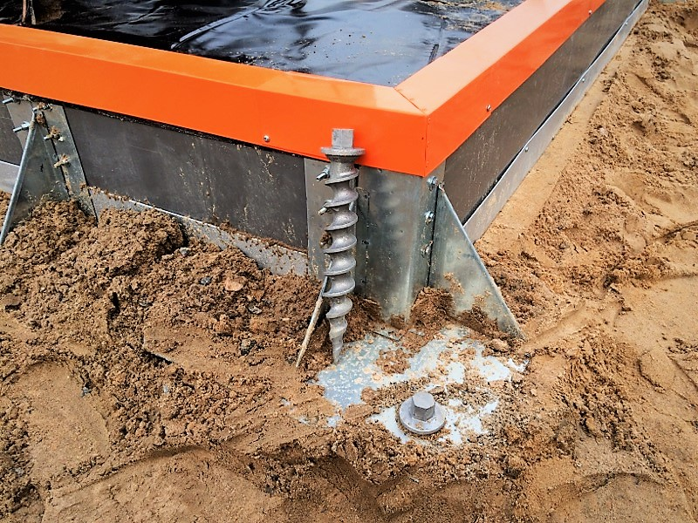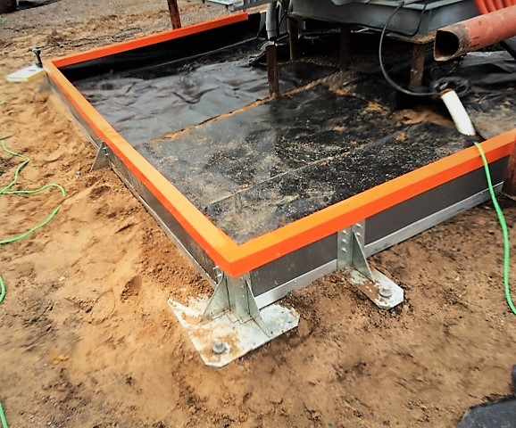
Technical Information

Flat Panel
Panel Thickness: 3”
Panel Height 12” coverage
Panel Length: 8’
Skin Thickness: Standard 40ga
Skin Materials: Galvanized (G90)
Galvalume (Aluminum)
Painted Top Flashing: International Orange
Core Material: Pressure Injected High Temperature Polyurethane.
This product surpasses thermal Testing in with CAN/ULC S705.1-01

HFF Filter Installation

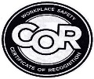
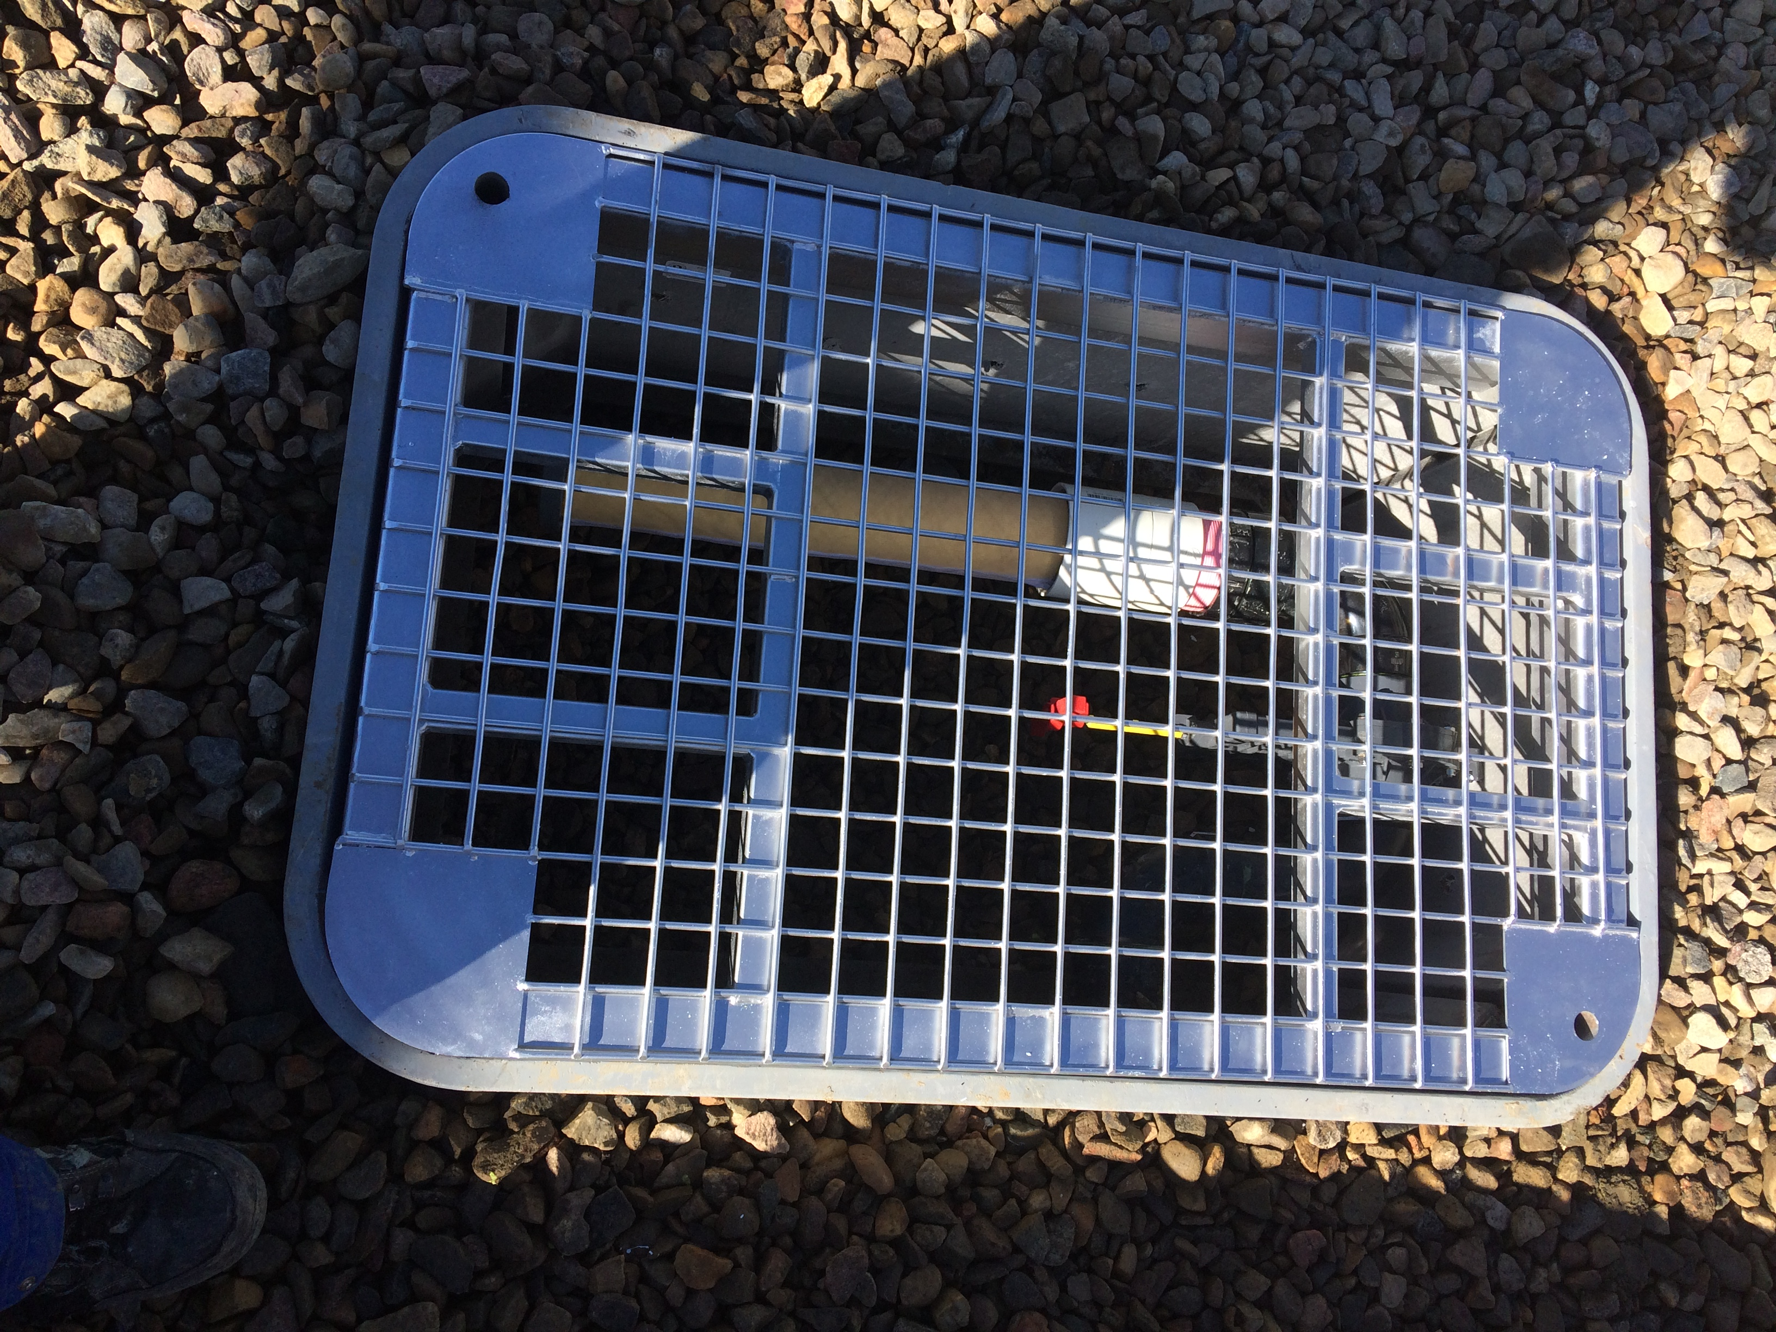

Cross Section and Connections
www.spill-chek.com 1-800-279-4043
Spill-Chek Environmental-Serving Western Canada, the Territories & Alaska

Cross Section and Connections

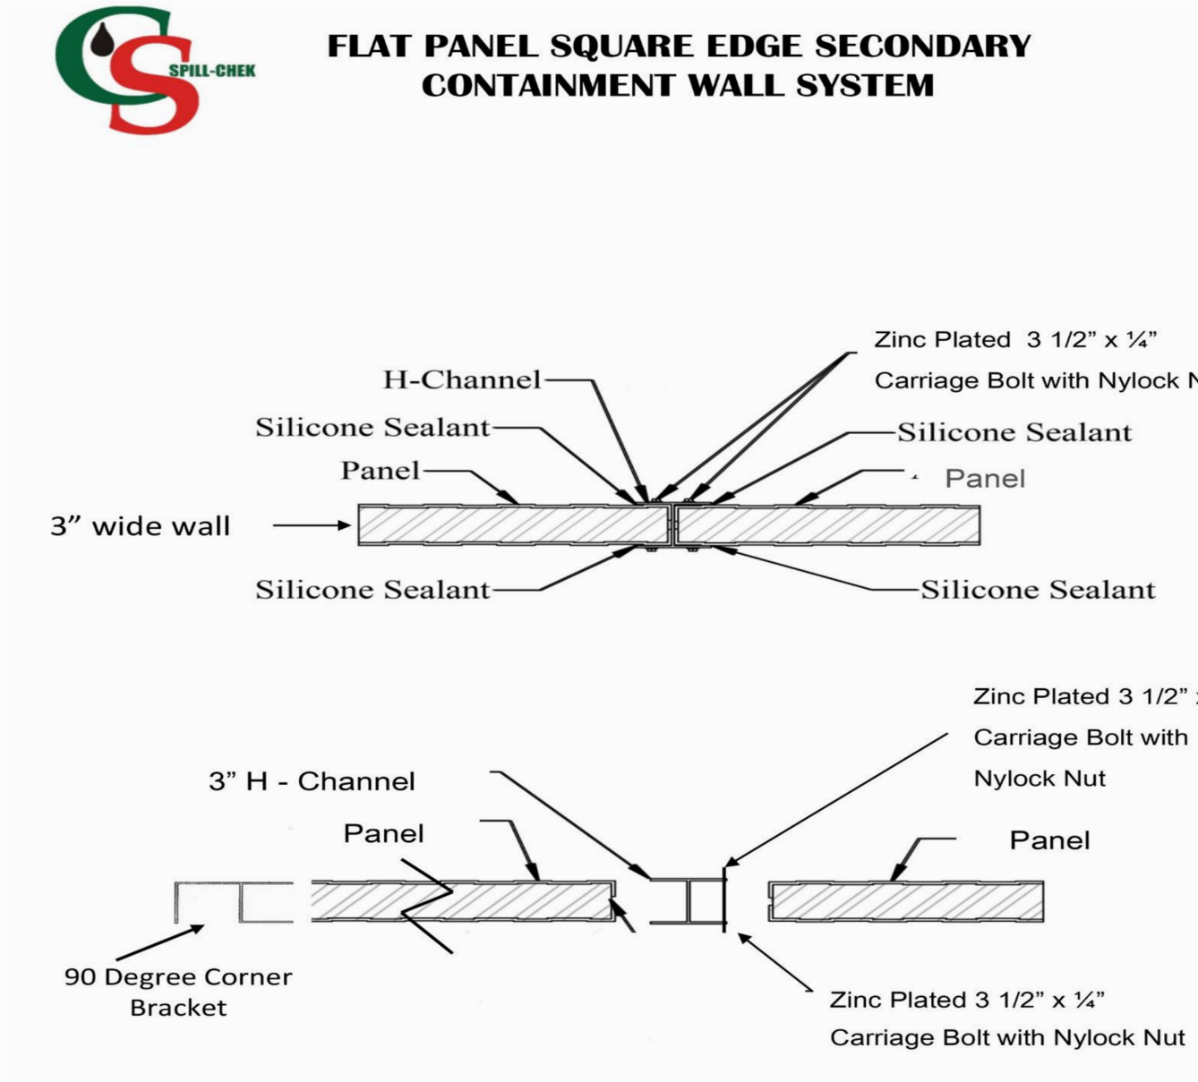

Cross Section and Connections
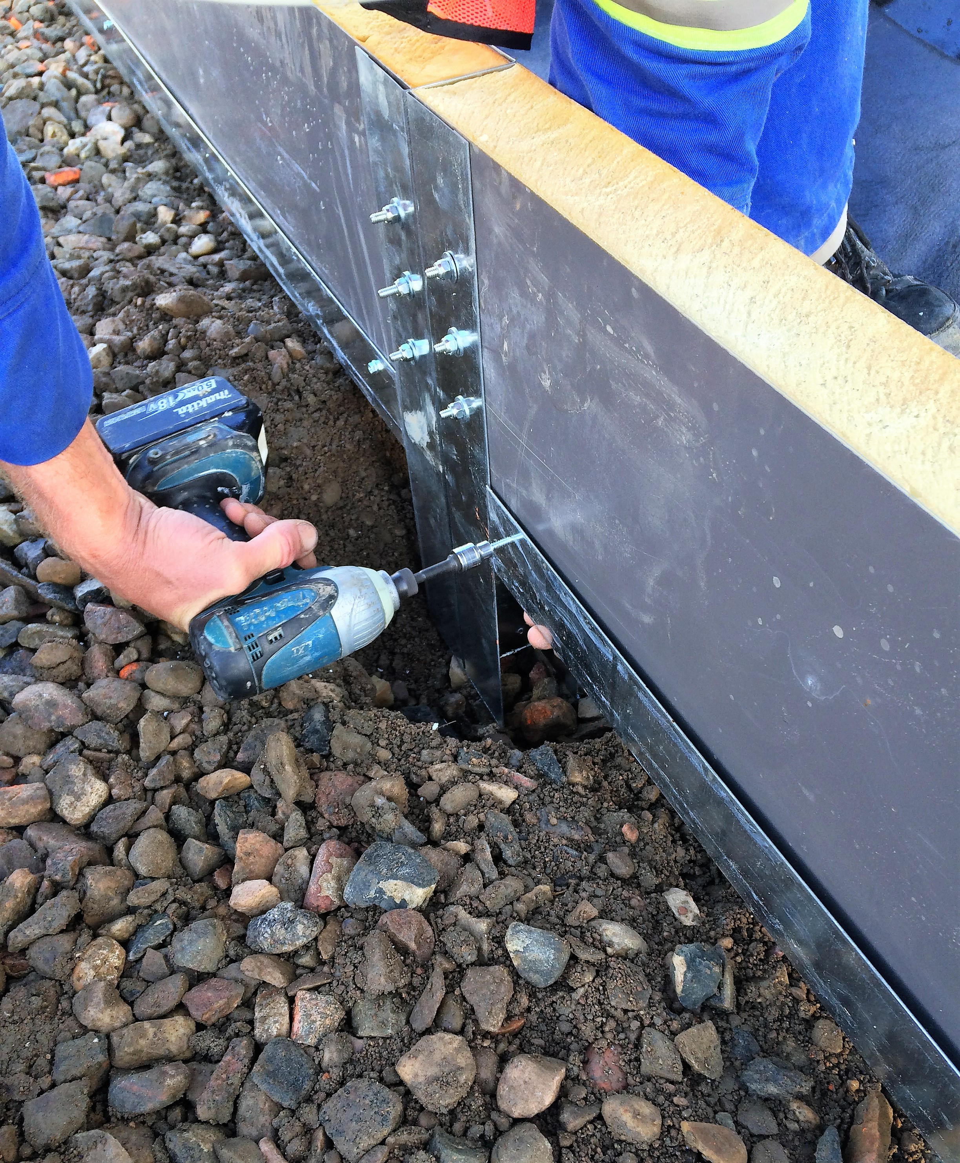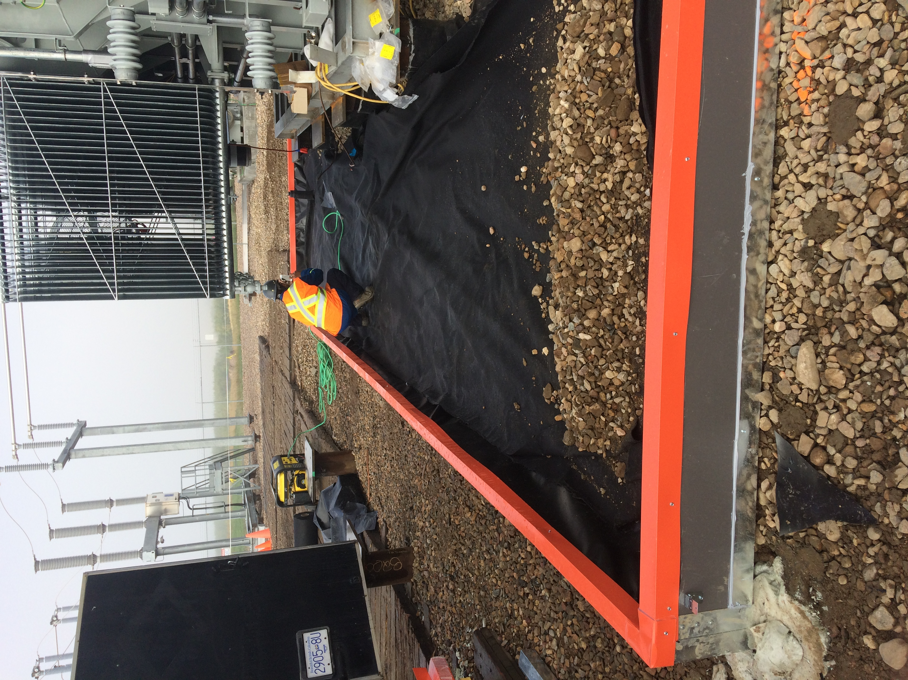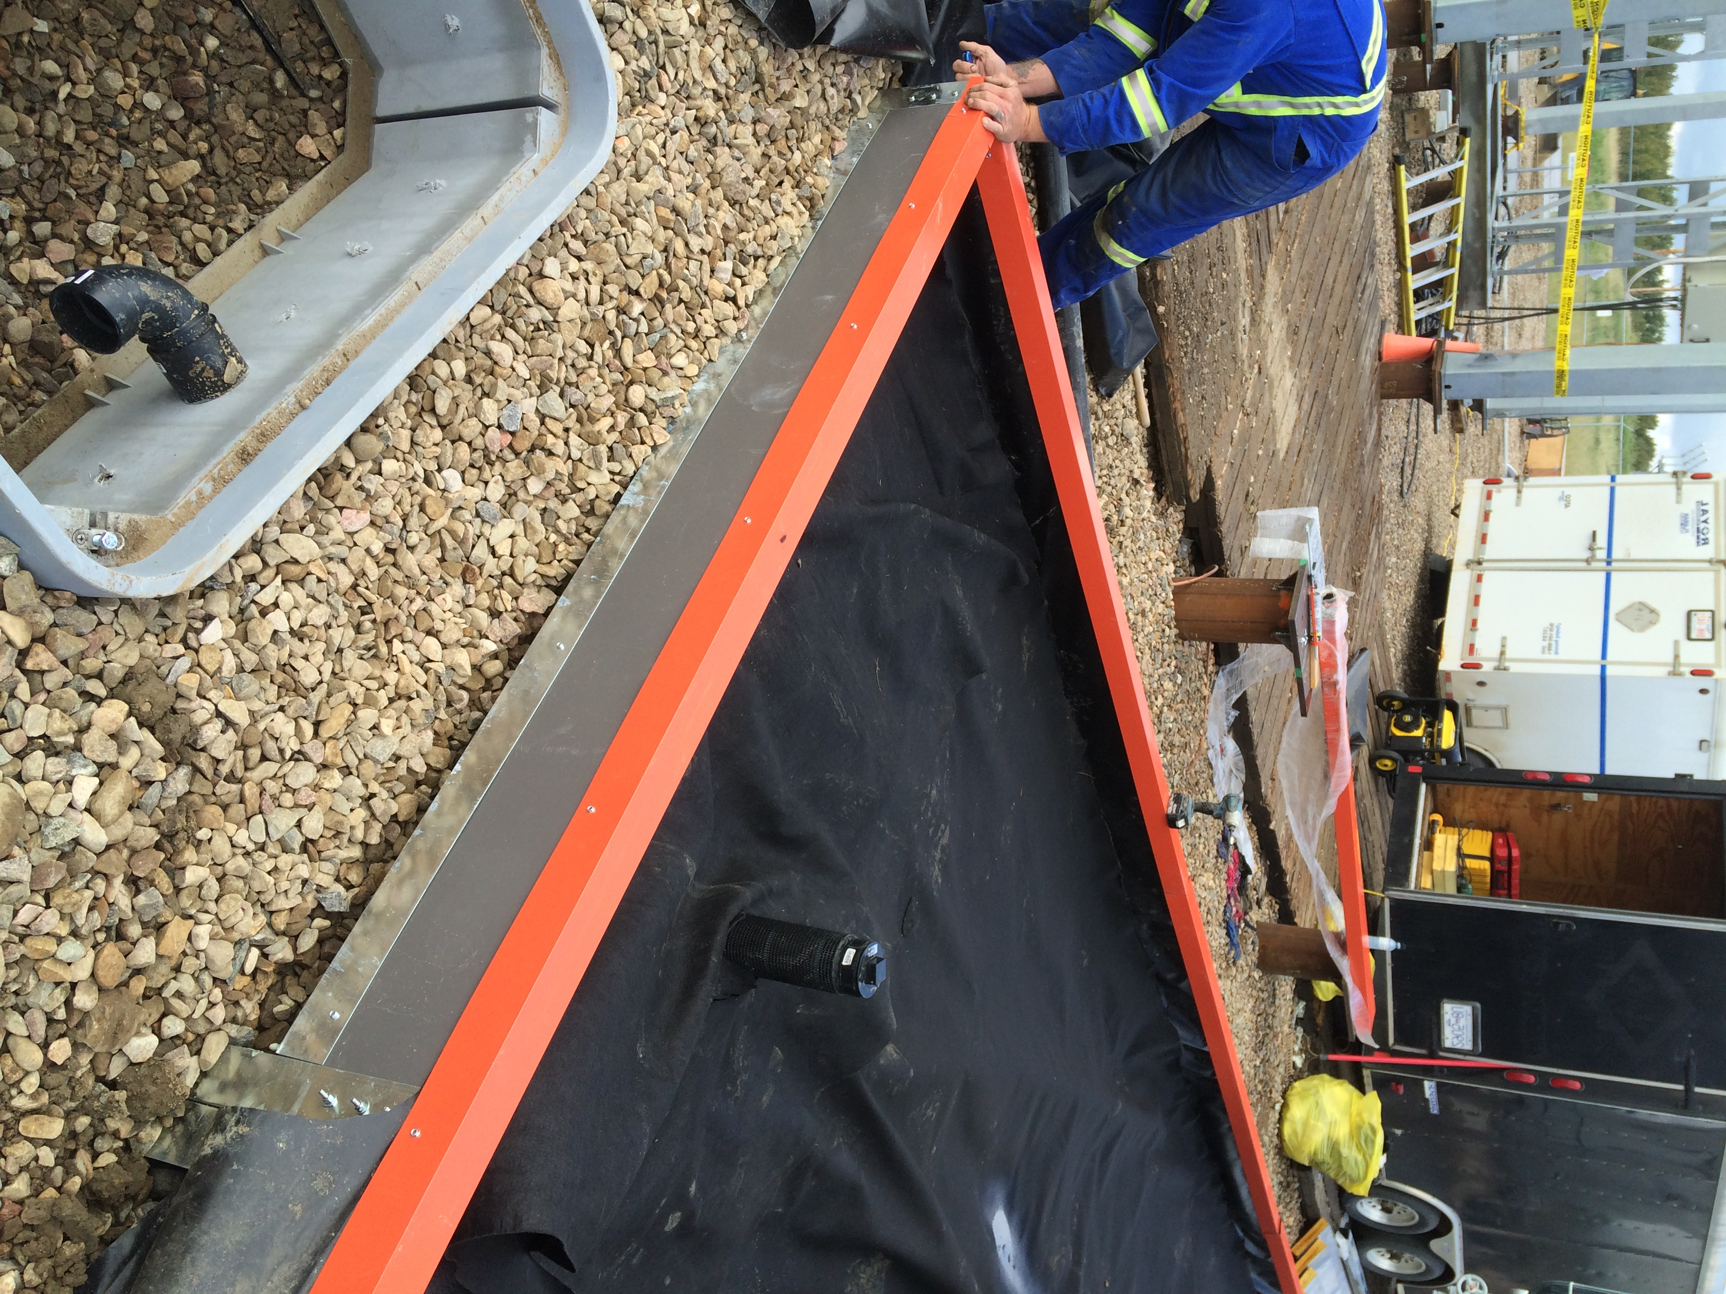
Strut-Lock™ is very easy to install with a two man crew.
Spill-Chek Environmental-Serving Western Canada, the Territories & Alaska

