DISC JOCKEY SERVICES AND EVENT LIGHTING

DJ for entire event– $400.00
DJ with Dance Floor Lighting - $500.00
Includes event lighting around dance floor
DJ with Karaoke - $550.00
Video Slide Show - $100.00
Event Lighting for one room -$575.00
Event Lighting for each additional room -$200.00

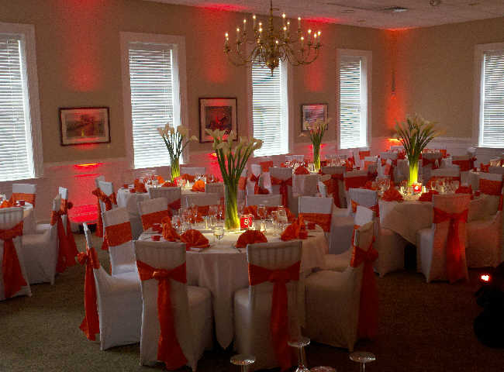

CONTRACT FOR DJ/LIGHTING SERVICES

This contract is subject to the following conditions:

1. The Client agrees to pay for services 30 days before event in cash or by check made payable to Creative Moments Catering and Events. The Client agrees that The DJ can but is not expected to start the music until the time designated in this contract. In addition, the Client understands that The DJ will set up his equipment 30-60 minutes prior to the start-time.

2. The Client agrees to pay the $100.00 as a deposit. This contract must be signed and dated by the Client and the required deposit mailed to: 216 Carriage Hills Circle Martinez, GA 30907. If this contract is not signed and dated by the Client and mailed back with the required deposit 60 days prior the event or otherwise agreed upon between the Client and the DJ, this contract is void.

3. If the Client decides to cancel this contract, the Client agrees to inform the DJ before the 90 days prior of the event. The Client agrees to pay 100% of the gross price agreed upon if cancellation is received within the 90 days prior to the scheduled event.

4. The DJ must have easy access to the entrance closest to the area where services will be performed. The Client understands that the DJ may charge the Client an additional fee for fees resulting from parking if agreed upon before the event and may be factored into agreed price.

5. The Client will be responsible for providing sufficient set-up space for The DJ’s equipment and sufficient power supply. If the event is outside, shelter (in the form of a tent or similar) must be provided. The DJ is not responsible for any mechanical failures due to floor structures, electricity, power outages, etc. at the chosen location site.

6. The DJ will give his best effort to play all of the agreed upon musical play list which was requested by the Client and is appropriate for the event. The DJ will not be responsible if musical selections are not available during the event that was not requested prior. Furthermore the DJ reserves the right to use his professional discretion during an event to ensure a successful event.

7. The DJ is not responsible for providing services in the event that wind, fire, flood, or any act or force of God or man that makes the facilities unavailable at the time, date, and place listed.

8. In the event that the DJ becomes unable to provide his services due to complications beyond his control, the DJ will do his best to provide a reputable replacement at no more than the original price agreed on.

9. The Client may be allowed to hire the DJ for additional time past the contractual agreement at $50 per hour.

10. In the event Client changes the location, date or time of the event after the signing of this contract, the DJ reserves the right to adjust the contract price to reflect such changes, in its sole discretion.

11. The Client agrees to reimburse the DJ for all stolen or damaged property directly caused by the Client and/or guest(s) of the Client. The DJ has the right to terminate services and leave if guests are offensive, inappropriate or a dangerous situation arises.

12. The Client agrees that should this matter be turned over to a collection agency/attorney, for non-payment, the Client will be responsible for all reasonable attorney fees and or documented collection agency fees.

Client Signature______________________________________________________

Name____________________________________

Phone Number_____________________________

Date of Function____________________________

Location__________________________________

Time_____________________________________

