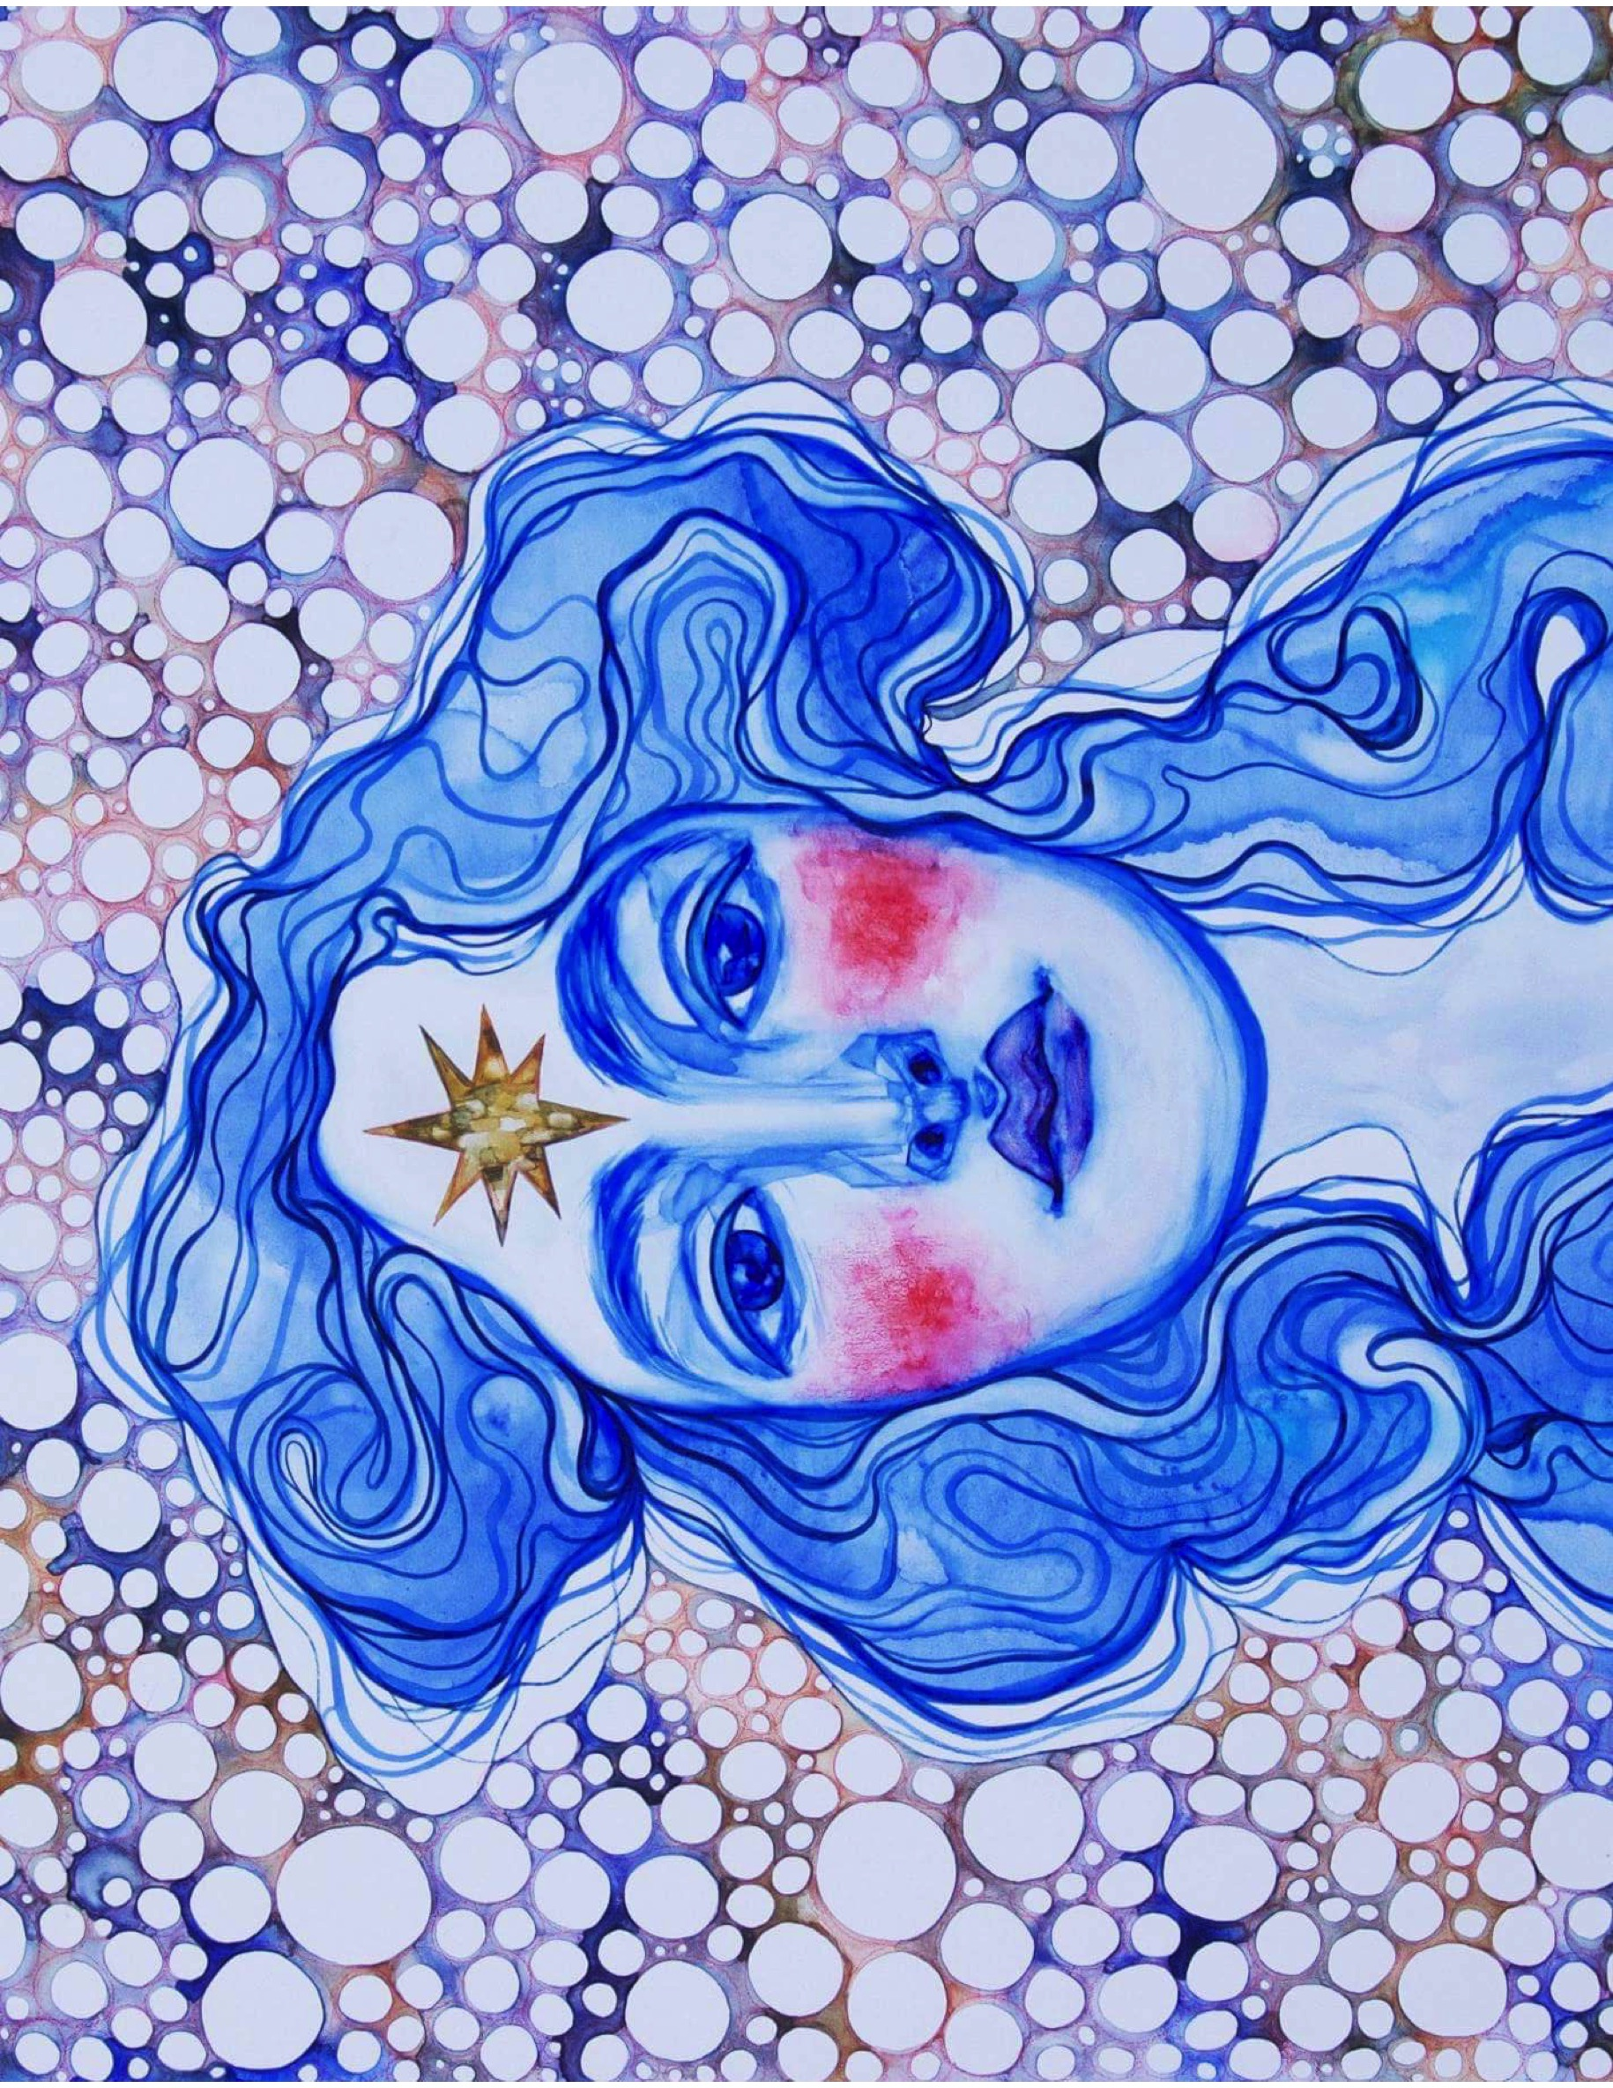
The Black Donkey Project, “Via Ottimista” Nebbiolo 2013,
Bee Sweet Vineyard, Edna Valley, CA

News from the PMC

A wine made to Cure,

This wine was conceived by restaurateur Bertil Jean-Chronberg of The Beehive and Beat Brasserie, wine importer/wholesaler Todd Verhoeven of Café Europa and winemaker Stephen Dooley of Stephen Ross Wine Cellars.

Their intent was to use their years of experience in the wine business to make a top-notch wine where most of the proceeds (65%) will support directly the PMC for Pediatric Hematology and Oncology Research through “Team Path to the Cure”.

Bertil and Todd are PMC riders for Team Path. “Via Ottimista” (the path of the Optimist) is also their way of sharing their passion with you for the noble and difficult Nebbiolo varietal.

Concentrated and bright garnet in color, the “Via Ottimista” offers aromas and flavors of violet, rose, tea, and red fruits undercut by savory herbs. Delicious and accessible, it is made in a softer style, showing more texture on the palate. It is a great introduction to the Nebbiolo grape that will no doubt please you and a broader range of your wine drinking friends. Sharing this wine will provoke discussions of curiosity and passion. It will be the subject of all your summer dinners, casual or sophisticated. (You can drink it now, or until 2025)
Local artist Jordan Piantedosi was commissioned to design the label. Jordan is an interdisciplinary artist based in Boston.

150 cases were produced; Only a very limited quantity (around 40 cases) are still available for purchase by PMC supporters through their favorite wine shop. It is for sale by the case only, at $250/case (case of 12 bottles)

Find our wine at:

Charles Street Liquors
143 Charles Street
Boston, MA
02114

617-523-5051

Bin Ends – Needham
65 Crawford Street
Needham, MA 02492

781- 400-2086

http://www.binendswine.com/product/2614

The Wine Emporium
607 Tremont St.
Boston, MA
02118

617-262-0379

Bin Ends – Braintree
236 Wood Road
Braintree, MA 02184

781-817-1212

http://www.binendswine.com/product/2614

Yankee Spirits
376 Main Street
Sturbridge, MA 01566

508-347-2231

