AA DOORS Ltd

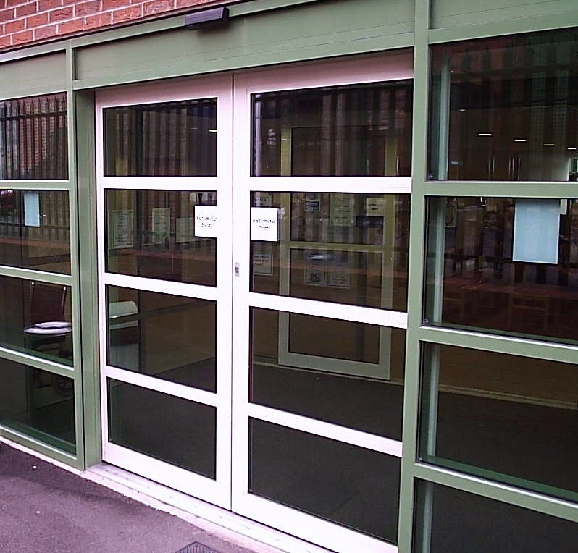Units C4 – C5
Canklow Meadows Industrial Estate
West Bawtry Road
Rotherham
S60 2XL

Phone: 01709 830 090
Fax: 01709 830990

Email: steve.green31@btinternet.com

AA INDUSTRIAL DOOR COMPANY LIMITED

SERVICING THE INDUSTRIAL & COMMERCIAL DOOR INDUSTRY SINCE 1991

Industrial & Pedestrian Door Repairs

We are a local industrial/pedestrian door company offering a reliable, local and national service at reasonable rates.

A.A. Dooors was established in 1991 to repair and service all types of roller shutters, fire shutters, sectional doors, PVC strip curtain and crash doors. In 2007 due to requests from our customers we expanded our business into the Automatic and Manual Pedestrian Door business.

Our clients include leading national supermarket chains, local authorities, health authorities, police authorities, facilities management companies & local businesses.

We carry out installations, repairs and maintenance on all types of industrial doors, pedestrian automatic sliding doors, swing doors, folding doors and balanced doors. We also carry out installations, repairs and maintenance on aluminium, glass and steel manual pedestrian doors & fire exit doors.

If you have shutters/doors fitted to your premises, as the occupier of the building you are responsible for the safe operation and maintenance of the doors.

In general terms Provision and Use of Work Equipment Regulations 1998 requires that equipment provided for use at work is:
- Suitable for the intended use,
- Safe for use, maintained in a safe condition and inspected to ensure this remains the case,
- Accompanied by suitable safety measures, e.g. protective devices, markings & warnings.

In accordance with BS7036: 1998, and BS/EN 16005 all types of pedestrian automatic doors should be tested by a technician authorised by Automatic Door Suppliers Association (ADSA), at least annually.

We can also offer a range of additional extras (Subject to the type and model of operator) to give you increased benefits from your shutter/door, such as:

- Converting manual doors to electrically operated
- Additional safety sensors.
- Additional activation sensors/buttons.
- Control panel lock- prevents unauthorised tampering with door operation.
- Fingerguards to prevent entrapment in the hinge side of the door/frame of swing doors

We can arrange to come and give you a free site survey to advise you on what servicing/maintenance is required for your site to meet the requirements of H.S.E. Provision and Use of Work Equipment Regulations 1998 (PUWER) and BS7036: 1996.

If you require a free site survey or any further information, please do not hesitate to contact me on the telephone number above.

Yours faithfully,

Steve Green
Auto Door Project Manager

