AMATEUR DIVISION
Beauregard Watermelon Festival Idol Contest
Official Entry Form
Show Date & Time: June 24, 2017 at 7:00 pm
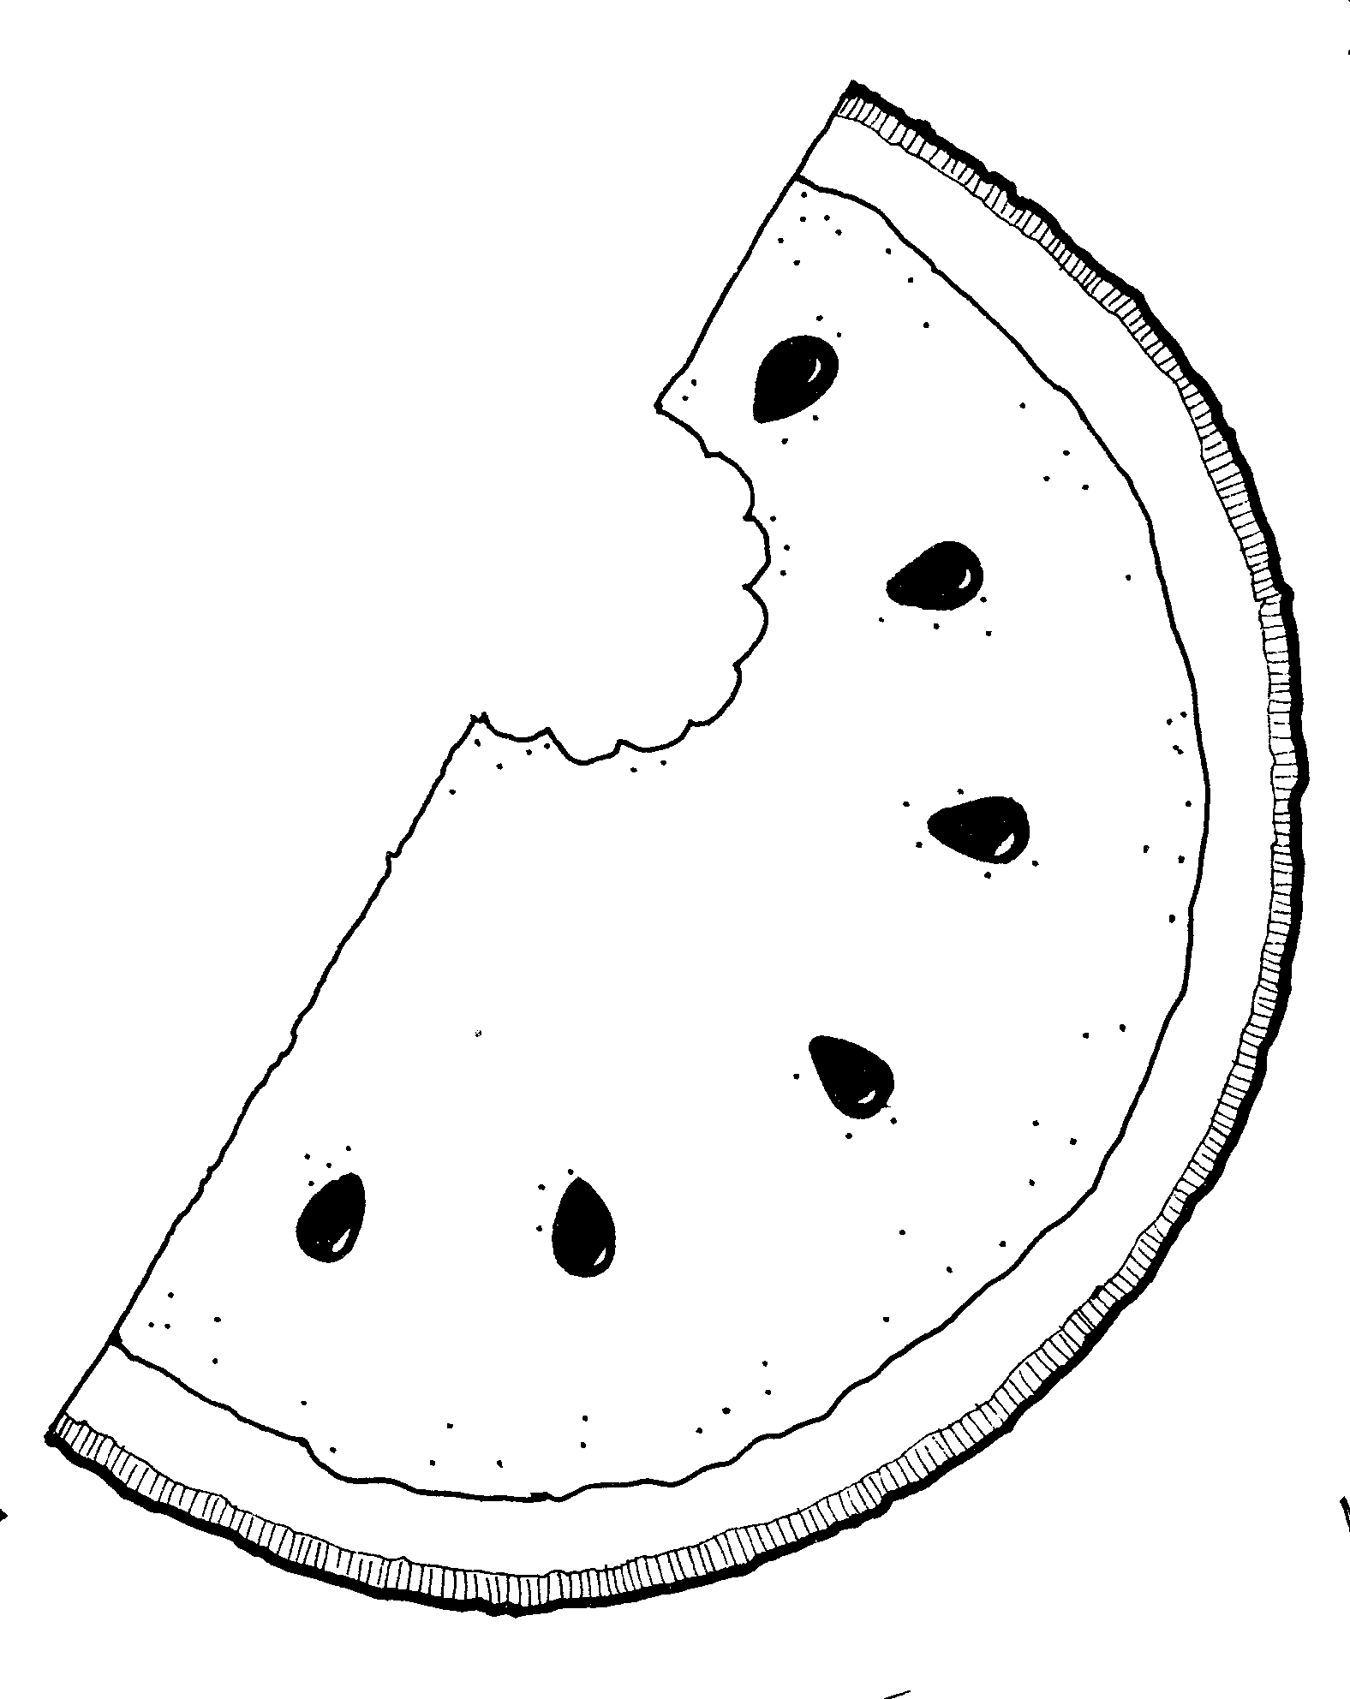
Beauregard Fairground Indoor Pavilion

Name: ____________________________________ Age: ___________
Address: __________________________________________________
City: _________________________________ Zip: ______________
Phone: _________________________ Or: _____________________
Name of Song (#1): _____________________________________________
Artist: ____________________________________________________
Name of Song (#2): _____________________________________________
Artist: _______________________________________________________
Will you be performing with the aid of CD? ________Yes _______ No
If yes, one song per CD (please label with name & song information).

Amateur level - FREE ________

There will be no equipment available for cassette tape accompaniment.
Each contestant should be prepared by selecting (2) song’s; 1st song to be sang during the contest. The 2nd song will only be performed in case a tie breaker is needed.

ALL CONTESTANTS MUST PROVIDE A COPY OF LYRICS TO BE PRE-APPROVED BY THE FESTIVAL BOARD. EMAIL A COPY OF LYRICS TO beautour@bellsouth.net IN ADVANCE.

Rules:

1. All contestants must be on fairgrounds 30 minutes prior to show, and must report to stage to sign in.
2. All contestants must be dressed appropriately, No flip-flops please.
3. No more than two people to register per performance. No groups.
4. Contestants may only appear once in any given event that night.
5. NO bands are allowed to compete.
6. There is no residency requirement.
7. No CD may have the singer on it at all. Background voices cannot exceed more that 50% of the tape.
Divisions:
17 and under 18 and over
1st place…..Trophy 1st place…..Trophy + Cash
2nd place…..Certificate & T-shirt 2nd place…..Certificate & T-shirt

Scoring:
Talent ....................50
Showmanship ........30
Costume/Staging….20
Total Points ..........100

** Each registered participant will be given a certificate of participation **

Please remit form to:
Beauregard Tourist Commission
P.O. Box 1174
DeRidder, La 70634

Or for more info contact:
Beauregard Tourist Commission
337-463-5534 or 1-800-738-5534

