Artist Statement

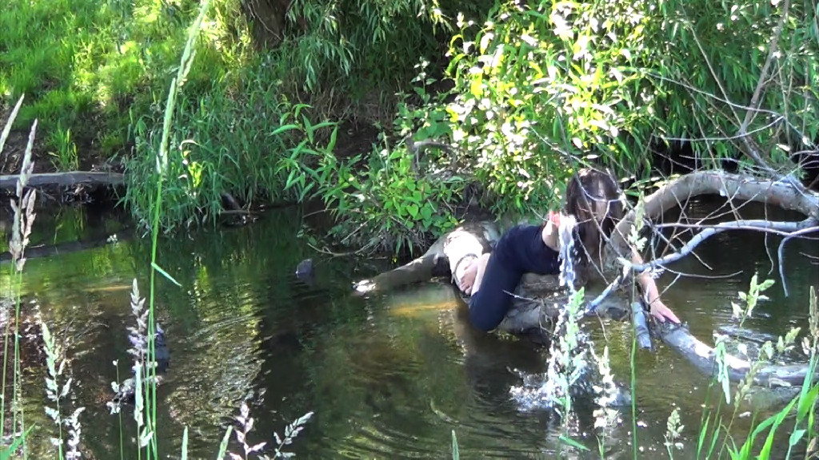

Art makes a better world. I would like to be an artist who can offer viewers a new perspective of life and enrich their lives. I am proactive in outreaching to the communities as I believe that art is for everybody to experience. I like to create art that has the power to transcend. Art is a celebration of life that evolves around people and the society.

I am a visual and performance artist, experimenting with the concepts of motion, energy, and space. I started from drawing and painting emphasis and now I am expanding my horizon to multimedia and combining my passion for modern dance. I like to create art that viewers can experience with all the senses. When I work with 2D media, I create art for viewers to virtually participate in my art world.

Real time interactive performance allows me to invite viewers to move through the enchanted space I create and experience my vision. Using myself as a media, since physicality is the main factor of art making, viewers’ participation energizes and enlightens my art and I am grateful and thrilled about communicating with viewers.

I invite viewers to experience my art at an emotional level as well. I want viewers to be more than viewers; I like them to be participants in the dance. I would like them to be involved in my painting and I want my art to become part of their lives. As an artist, I love to share my art with viewers.
Peace,
2013

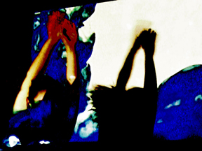

New Media Art allows me to expand my horizon as a visual and performance artist. In my art making, process of physicality is as important, often more important, as the followed result. Viewers frequently asked me what I was feeling and thinking while painting. “Energy, space and movement” as my theme, it made me a perfect sense when I started to make an installation of layered projection of the movement of colors. Also from a perspective as a dancer, it made an excellent sense to make drawings and paintings using your entire body, because that is how I make my art. And I love viewers to experience my art and share the process of art making.

Hiromi Okumura
2012

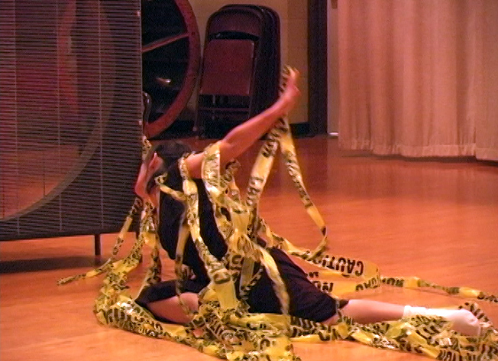

As an artist I would like to save the world with my art ... at least a part of it. I would like to change the way people perceive life and experience the world. Painting is my contribution to a world where art and life come together as a holistic journey. I would like my art to lift people's spirits; it should be should be love songs and cheers to human life.

Painting for me is dancing. Dancers create their fantastic world with bodies and emotions, as painters do with colors, paints and brushes. I paint because painting is physically direct; this is a quality it shares with dance. Physicality is an important factor to me in art making, and I love the direct response of paint. As a painter, I try to let colors sing and vibrate to express energy, movement, and space. Like the dancer, music drives my creative force and helps move my brushes. If you could see me paint, you might think I am dancing -- my feet and my brushes move rhythmically. In fact, I love to dance, and dance, improvisational dance in particular, informs my painting.

Dance is energy and movement through space. Similarly, as a painter, I am very interested in movement in space; my forms come in and out of space as they move throughout the picture plane. Color transitions produce the foreground space and push the deep space away allowing new forms to emerge from it. The dynamics of my design create an interplay between the background and the figures that invites the viewer to enter the space. I think of this dynamic as 'lost and found.' Through the layers of colors and brushstrokes, I pull forward forms and colors. At the same time, I respond with colors and forms according to what has happened on the canvas, just as improvisational dance, responding to others' movements; it is action and reaction.

I want viewers to experience my art at an emotional level. I want viewers to be more than viewers; I like them to be participants in the dance. I would like them to get into my painting and I want my art to be a part of their lives.

-- Hiromi Okumura
May ,2009

