Smooth Move Smoothie
2 Servings
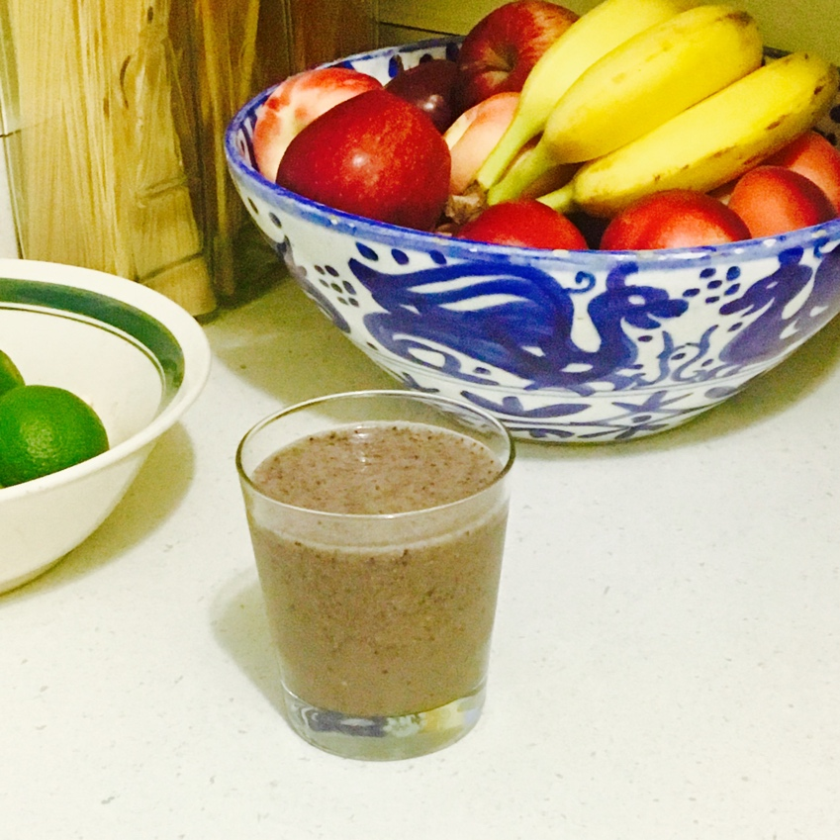

Ingredients
½ Cup prune juice
1 cup almond milk or cashew milk
1 frozen banana
¼ Cup frozen blueberries
1-2 Tbsp. Chia seeds
1 Tbsp. Oats
1 tsp. Matcha powder (optional)
½ tsp. Cinnamon powder
¼ tsp. Ground ginger
Directions
Take all of the ingredients and place them in a blender. Blend on high for about a 30 seconds. Pour into desired serving glasses and enjoy.

