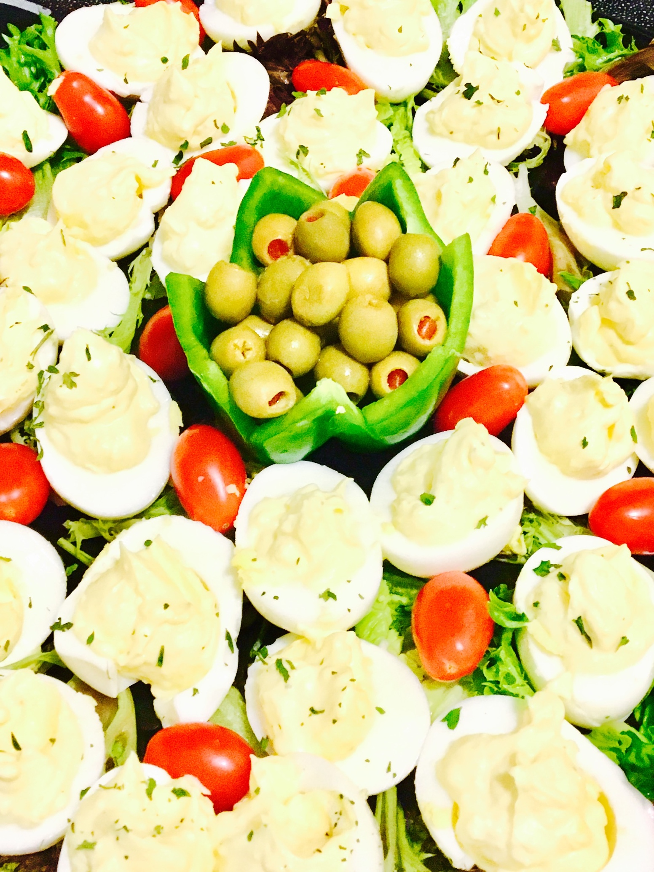
Angeled egg platter

Ingredients
2 Dozen ready to go angel eggs (deviled eggs if you please)
1 Package of organic grape tomatoes
1 Large green pepper
1 Head of red leaf lettuce
1 Head of Green leaf lettuce
1 Jar of pimento olives (or your olive of choice)
Ground parsley to decorate

Directions
Take your lettuces, grape tomatoes and pepper and wash them really well with water. Make sure you dry the lettuce well so it won't be too soggy for the platter. Cut the very top off of your green pepper, and take the seeds out of the middle. Then take the knife and cut a v shape in the top part of your pepper. Continue cutting v’s until you have made it to the other side. The pepper will kind of look like a flower when your done. Next take your lettuce and arrange it on your tray or platter, making sure to mix the red and green all around. You probably won't need all of the lettuce, you just need to cover the whole tray well enough not to see the bottom of it. Next place your pepper in the middle of the platter and fill it with the olives minus the juice. Then arrange the eggs all around the tray or platter. In between the eggs place the grape tomatoes, ensuring that they are evenly distributed throughout the eggs. Lastly take your parsley and sprinkle it over the top of the eggs. There you have it! Your very own professional platter.
Note: Most of the creations or displays will not have a recipe for them, as they are more geared towards showing you how to assemble. In some of the upcoming displays, if necessary and the demand is there, we will add the recipe along with the creation or display. Also feel free to send a message and we can send you a recipe if you need one.

