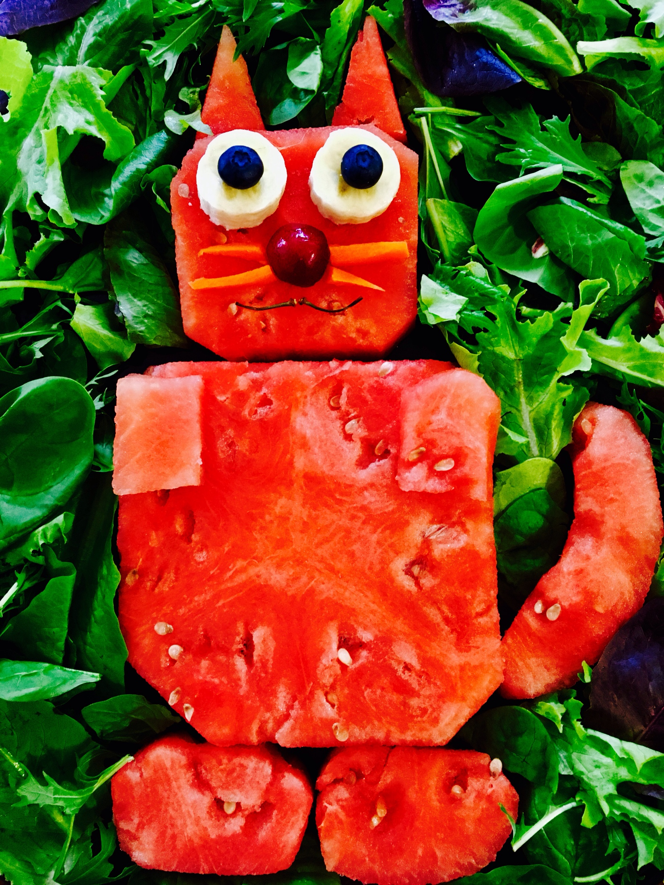
Watermelon cat

Ingredients
1 Whole seedless watermelon
2 Blueberries
2 pieces of sliced bananas
½ of a pitted cherry
2 cherry stems
4 pieces of small thinly sliced carrots
Utensils:
1 large chef’s knife
I small knife i.e. paring
I extra large plate or a tray
Cutting board

Directions
Start by washing the watermelon with warm water to reduce cross contamination. Then after it’s washed place it on the cutting board and cut it in half. It will take a little sawing until you get all the way through. Then take one half and place the flesh side on the fitting board. Cutting sideways, cut off the tip of the watermelon to expose the flesh. Then cut down the the sides until you have completely exposed all of the flesh. After you have done that take your knife and slice about 2” sections just like when you cut off the tip. Repeat with the other half. Starting with the big end and using your small knife cut out a sort of mildly square shape for the bottom. It can be as big or as little as you would like. Next you will cut out a smaller one for the head. Then cut out matching triangles for the ears. You might want to slice them smaller if the width is too big. Next cut out two small square like pieces for the arms, then two slightly bigger oval shaped pieces for the feet. Next is where it gets a little tricky. The tale is a little curved. You can shape it how you want but try to make sure it fits to the cat. After you have cut out all of your pieces, then comes the assembling. Place your big piece towards the bottom, then put the feet pieces on the very bottom under the body. Then put on the head. Now put on the paws on top of the body part right at the top. Next put on the ears and the tale. After you have assembled the body, then place the banana slices for eyes, and place the blueberries on top of the banana slices. Then place the half of the cherry on for the nose. Next put your carrot slices on for whiskers. Finally place the stems on for the mouth, curving them a little and and placing them together under the nose.
For garnishment you can either add salad on the plate for a nice green contrast, or make it a total fruit tray and arrange pineapples, cantaloupe, strawberries, kiwi, and more blueberries if you would like. That will make for a gorgeous tray. Now you are ready for your party, enjoy!

