Coconut cream pumpkin dream popsicle
4 Servings|10 Minutes Prep|4 ½ -5 Hours

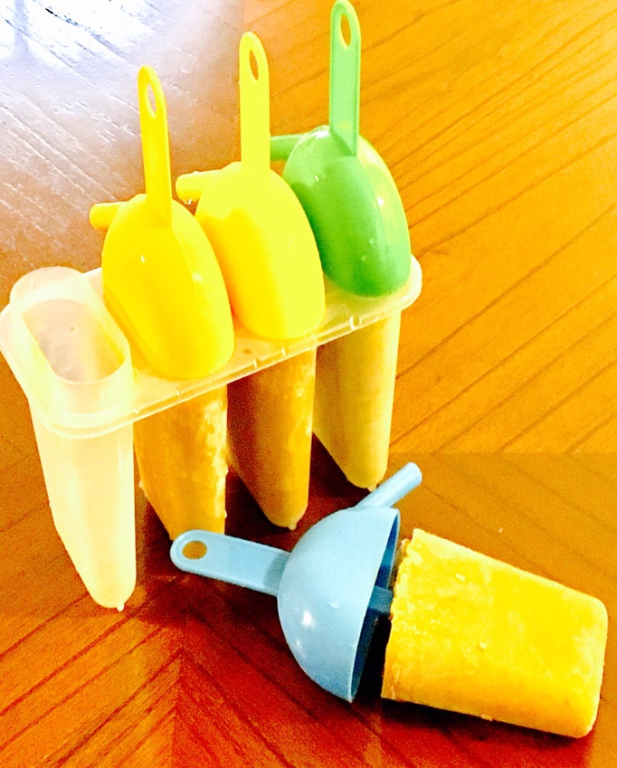
Ingredients
½ Cup of canned pumpkin
Cream from 1 can of full fat coconut milk
3 Tbsp. Raw honey or brown sugar
1 tsp. Ground cinnamon
½ tsp. Ginger
½ tsp. Ground nutmeg
¼ tsp. Ground cloves
1 tsp. Pure vanilla extract
Place all of the ingredients in a blender and blend on high for about 2 minutes or until velvety smooth and creamy. Pour into molds and freeze up to 5 hours. Note: If too thick add a Tbsp or two of the coconut water from the coconut milk can or use regular water.

