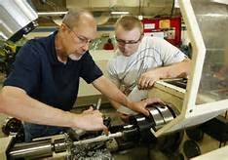 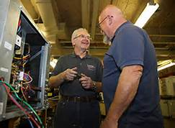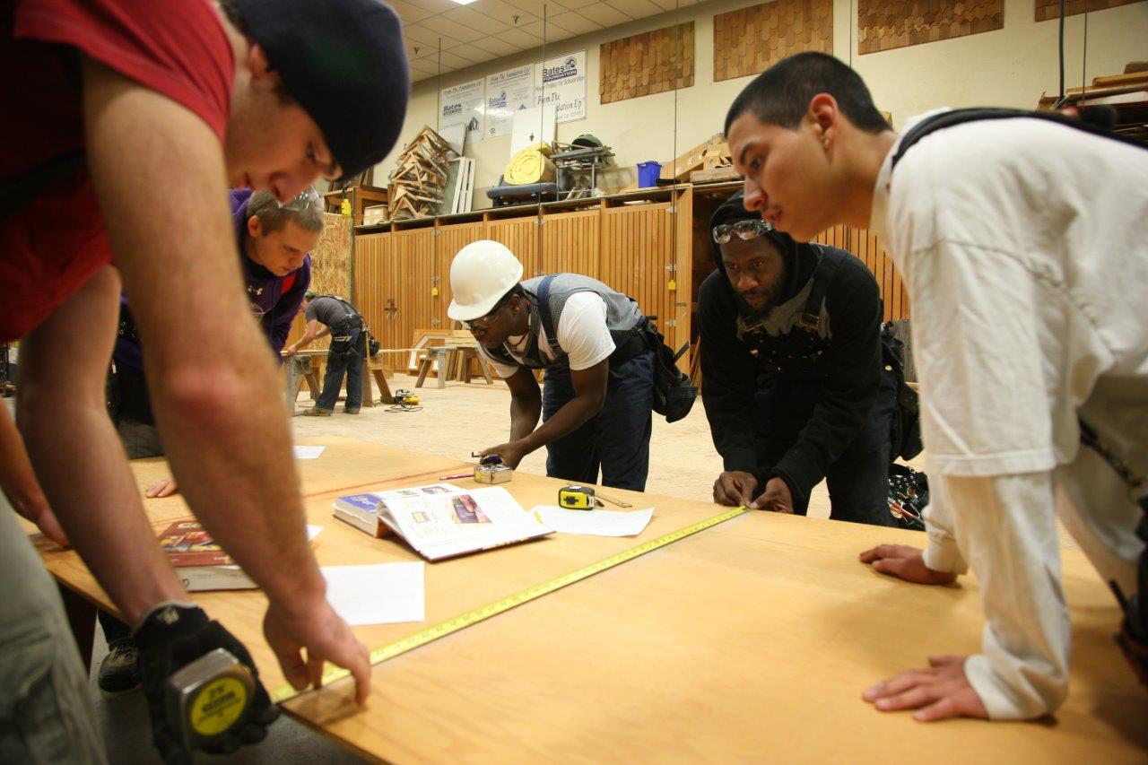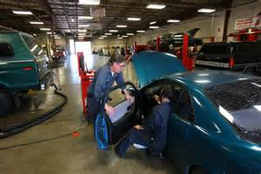

Michael Hyink

14510 McIntosh Ln. SE, Tenino, WA 98589  
Michael_hyink@msn.com

Questions?

Contact the PNTC Scholarship Chair

#### Go to [www.tooltimer.com](http://www.tooltimer.com)

#### Click on “PNTC”

#### Then click on “PNTC scholarship Information”

Get your application started today!

Purpose

The Pacific Northwest Tool Club’s scholarships are intended to financially support students enrolled in educational programs leading to employment in trades that use traditional tools, similar to those collected by members of our club.

*PTNC*

*Scholarship*

*Program*

Photos courtesy of Bates Technical College

PNTC Scholarship Requirements

**Eligible training programs must use traditional tools and equipment!**

* Wood Workers: Boat Builders, Cabinet Makers, Carpentry, etc.
* Dental Laboratory Technician
* Electrician
* Engineering Technicians: Electrical, FPET, Mechanical, Structural, Civil, Survey, etc.
* Mechanic: Auto, Marine, Diesel, Aviation, etc.
* Metal Fabrication Arts: Sheet Metal Tech, Welding, Tool and Die maker or Machinist
* Watch and Clock Repair
* Other trades using traditional tools.

Regional Requirement

Applicants must also provide evidence of a connection to Oregon, Washington State, or British Columbia.

* by living here, or
* by training here, or
* by working here